**College of Administrative and Financial Sciences**

**Assignment 2**

**Project Management**

**Instructions – PLEASE READ THEM CAREFULLY**

* The Assignment must be submitted on Blackboard (**WORD format only**) via allocated folder.
* Students are advised to make their work clear and well presented, marks may be reduced for poor presentation. This includes filling your information on the cover page.
* Students must mention question number clearly in their answer.
* Avoid plagiarism, the work should be in your own words, copying from students or other resources without proper referencing will result in ZERO marks. No exceptions.
* All answered must be typed using **Times New Roman (size 12, double-spaced)** font.

***Assignment Workload:***

* This Assignment comprise of a Case Study.
* Assignment is to be submitted by each student individually.

***Assignment Purposes/Learning Outcomes:***

After completion of **Assignment-2** students will able to understand the

1. Demonstrate a deep understanding of project management concepts and theories as well as approaches to project management (L.O-1.1)
2. Demonstrate an understanding of the project planning process (L.O-1.6)
3. Demonstrate an understanding of the project budgeting and cost control in project management –(L.O-1.6, 4.1)
4. The ability to write a coherent report on project management case studies or new themes. (L.O-4.5)

***Assignment-2-Case Study***

**Assignment Question: (Marks 5)**

Please read the Case-7.1 “**Alaska Fly-Fishing Expedition**.” from **Chapter 7 “Managing Risk”** given in your textbook – Project Management: The Managerial Process 8th edition by Larson and Gray page no: 241 alsorefer to specific concepts you have learned from the chapter to support your answers. Answer the questions asked in case study as deliverables where you should **consider the milestones and technical requirements**. Also refer to the figures from textbook mentioned in the case study. Answers to the deliverables should bewithin650 Words limit.

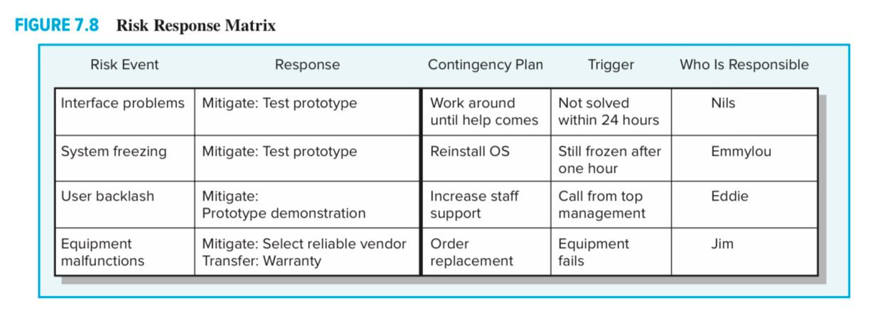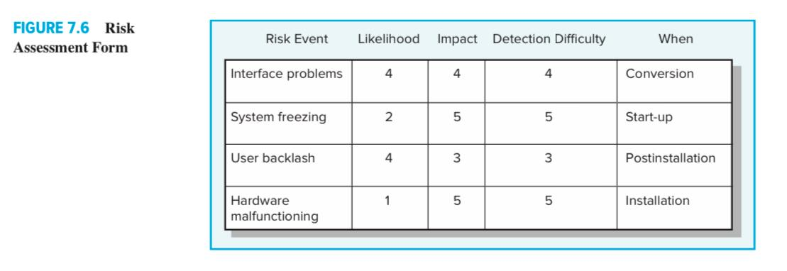

**Answers:**

**1.**

**2.**

**3.**