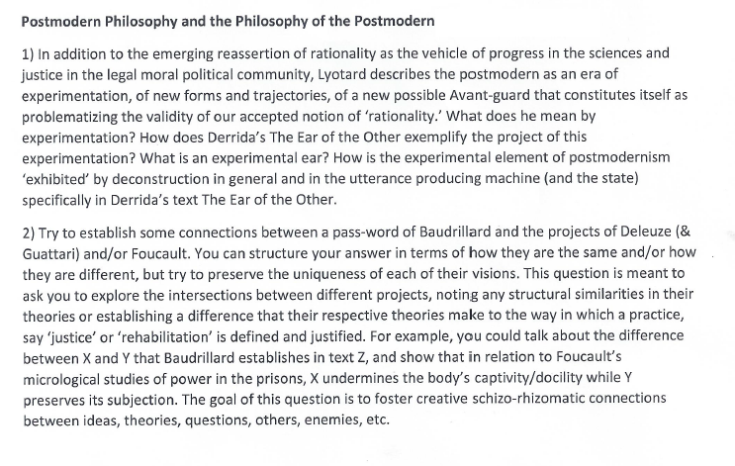

* **Write 3-4 pages answering the questions double space**
* **There are 3 sources that you should use this link below and the other are 2 pdf files. Also, I show which source for what question:**

<https://books.google.com/books?id=D9Prl2FIW8AC&printsec=frontcover&dq=passwords+by+jean+baudrillard&hl=en&sa=X&ved=0ahUKEwiwxuz86ejaAhUS3lQKHdv9A6YQ6AEIKTAA#v=onepage&q=passwords%20by%20jean%20baudrillard&f=false>

(For question 2)

**Important notes:**

* **You may use other sources that helps you to answer the questions (focus about things that the question asks about)**
* **However, you should use at least 2 quotes from each of the 3 sources I sent you.**
* **Right simply.**