The serial number of E-600 is 228215

The serial number of SHP-360 is PR245095

The serial number of FH-40G is 030652

The serial number of Thermo Radeye Personal Dosimeter is 19649

The serial number of H-810 is 0920

The serial number of E-Perm S-chamber is SJX933

At lab before going outside for sampling

Wear gloves and Use tweezers to pick up filters

The weight of the clean filter was measured (0.1358g)

SHP-360 and SHP-360 was settle as figure showed

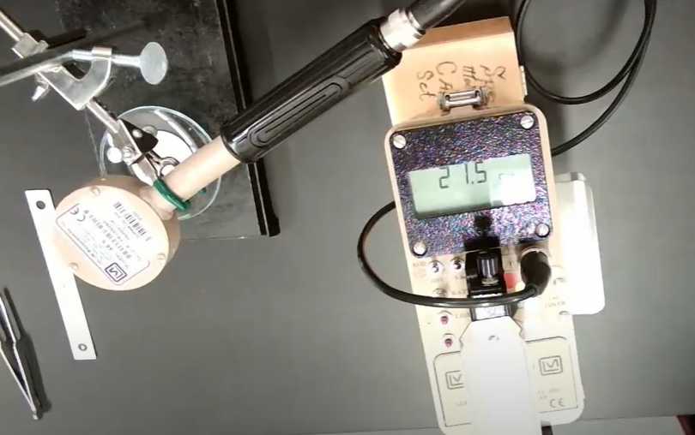

Filter was placed under SHP-360 probe to get background readings.

Take the reading of the detector every ten seconds ten times.

Take the filter and assemble it in Cartridge

Put the Cartridge  in a zip-lock bag to make sure does not get contaminated in our way to sampling location.

Going out to sample location

We used Thermo Radeye Personal Dosimeter (EPD), FH-40G, and E-600 with SHP-360 probe, in the same way, was used in lab 1 (page 54 lab manual)

Take Brand new chain of custody, worksheet 1, 2, 3 and 4 was brought with us.

Before get into contaminated area background reading was taken by FH-40G, Thermo Radeye and E-600 with SHP-360 (ground level and waist level, face up and face down) The reading was written it down on worksheet 1 and 2

Position of the previous reading was recorded (latitude and longitude)

At contaminated area, air direction was determined by seeing grass, tree leave or water in the lake movement.

Wear gloves

Settle H-810 on Tripod and place it against the air direction

Take out Cartridge out of zip-lock and screw it on H-810.

Place the power generator behind and far from H-810 to make sure nothing coming from the generator into the filter.

Turn power generator on.

Turn H-810 on and clear the reading then press the set button and then set the target volume at 1500L then enter then start.

When reach 1500L will stop automatically.

 At contaminated area while waiting for air sample collection, reading of FH-40G, Thermo Radeye, and E-600 with SHP-360 (ground level and waist level, face up and face down) was taken. The reading was wrote it down on worksheet 1 and 2

 Position of previous reading was recorded (latitude and longitude)

After 1500L reached the reading was recorded on worksheet 4.

Unscrew Cartridge out and put it in a zip-lock bag.

date of the experiment, name of sampler and air sample 1 wrote it on the zip-lock bag

before getting out of a contaminated area use E-600 with SHP-360 to check that all material and group members are not contaminated.

(<https://www.youtube.com/watch?v=LeXTn8Cw5nc>) after 18:55

Redo background measurement outside contaminated area by FH-40G, Thermo Radeye, and E-600 with SHP-360 (ground level and waist level, face up and face down) The reading was writing it down on worksheet 1 and 2 and take Position (latitude and longitude)

Went back to the lab

Wear gloves and Use tweezers to pick up filters

Unassembled the Cartridge and carefully remove the filter by tweezer. Sometimes stuck in due to wind

Reweight the used filter (0.1367g)

Filter was placed under SHP-360 probe



Take the reading of the detector every ten seconds ten times.

Radon testing (see lab manual)

The initial reading was taken in the lab (522volts)

 location was basement of ERC building at the Ontario tech university campus.

S-chamber was left at pre-selected location on October 28th, @ 5:00 PM

Returned to end the sampling on November 2nd, @ 1:15 PM

Ending Voltage - 490 Volts.