**Proposal of an Organization Design on Gender Equality**

**Introduction**

The proposal below will require developing organizational designs and culture to influence and support the female gender in leadership and workplaces. The above is due to the challenges that women have faced in the different organizations across the globe. Due to stereotypes and negative perceptions, most organization leaders or stakeholders have against them. Some of the current issues related to women in leadership include discrimination, prejudice, family demands, and lack of opportunities. Women are discriminated against as most of the companies associate the male gender with success and great achievement. The characteristics associated with male leadership and management include assertiveness, aggressiveness, and task-oriented abilities. In our company, mostly men hold the senior positions who are five in number while women who are two and the overall CEO of the company is male. Therefore most of the company's management positions are dominated by men.

The wage disparity between the male and the female is wide, with female employees paid less, thus discouraging them from up scaling to senior leadership positions where their salary does not match the roles they execute (Mihăilă, 2016). The above wide difference occurs even if females are qualified just like men; they are always subjected to lower salaries than their male counterparts, who are in the same positions. Many women have been unable to accept the culture shock and fail in the new environment they move in, making them not execute their duties well, leading to low delivery. The occupational segregation, vertical segregation, and ineffective pay legislation make the wage disparity for women low since culture is created, making sure that they have entry barriers.

The dominance of male leadership in some industries has led to the failure of recognition that women cannot lead in the right manner. All the time, male leadership skills and strategies are believed to bring success to the company where women are not given chances to lead. In the company, most of the roles are for men because it is an aerospace company where most of the careers in this industry are male-dominated due to the technicality of accomplishing the tasks (Ronay et al., 2020). The dominance of men in some industries makes it easy for the exemplary execution of duties since their quality of delivery is always high compared to women. Due to the engaging activities and roles, some industries' overwhelming tasks make them always remain male-dominated. However, some women have gained leadership positions due to relationships with the stakeholders or the top leaderships. The relationship between Donna and the company’s previous owner has provided her a great job via our company's connection.

The impostor syndrome caused by gender inequality has made it difficult for them to perform well and get promoted to top leadership positions (Rhode, 2017). The demoralization and harassment women face interferes with their ability and confidentiality in accomplishing their tasks. Men’s ambition and commitment, on the other hand, is always considered high, thus making the company's management have confidence in them with the belief that all activities and roles assigned to them will be executed in the right manner. The prejudice against women that they cannot rely on their own as they are always perceived to be a positive attribute demoralizes them from perceiving their ambitions in male-dominated jobs. The stereotype hinders them from achieving their full potential.

In conclusion, prejudice, discrimination, stereotypes, family demands, and lack of opportunities have hindered women's progress in their workplace, more so in climbing to the leadership positions. Women are discriminated against as most of the companies always associate men with success and great achievement. The wage disparity between males and females is wide, making them not engage in senior leadership positions.

**About the Organization**

I currently work for an aerospace company that produces heating and cooling systems for various airplanes and helicopters. The location in Oklahoma was recently purchased by a corporation, thus bringing about many changes. Before COVID affected business, there were roughly 230 employees; after a couple of rounds of lay-offs, the employee count is down to around 175. The Executive Team consists of 5 men and two women who are led by a male CEO. Men predominantly hold management positions with two female supervisors. One of the Executive positions held by a female is the Director of Human Resources. Initially, I began my employment in the H.R. department but after one year moved to the Engineering department as a Configuration Management Administrator. My Director now is a man. The new corporation is based in France, and it seems more open to women in leadership roles.

Within the organization, there are roughly 23 different departments, and each has an Executive Director. Some Executive Directors have many departments, while some have one or two. There are Manager, Supervisor, and Lead roles in various departments but not in all. Other than production, the Engineering department has the largest number of employees. There are roughly 46 engineers in the department, including six women. There are two managers; both are men. The individual I answer to daily tasks is one of the only women considered somewhat of a leadership role. She is a Lead for Configuration Management. Before she moved into this role, she and I shared a Supervisor that was a man. It is not easily accepted for women to be in leadership roles within this company. Of course, they have stated otherwise, but the statistics speak for themselves.

However, the company was recently purchased by a French Corporation, and it has been perceived that their viewpoint is not only to allow women leaders but also to develop them. Although the change occurred over a year ago, we have just begun to see actual changes within our location. For instance, new cameras were placed throughout the facility, and all employees were informed of their purpose. Additionally, a new CEO has been selected, and he is from France.

**1. Description of the Design**

The goal of the new organization design is to align the organization with the goal and objective of incorporating women in the organization's leadership. The above will require drastic changes in the organization's operations' structure and alignment, starting from normal workers to the organization's top leadership management. The above design will require several steps that will work for the advantage of women getting equal opportunity just like their male counterparts in the organization's operations and management (Gipson et al., 2017). It is important to note that this drastic change will work to the organization's advantage since there will be an increase in effectiveness and efficiency in the organization's day-to-day running and general operations.

Roles and responsibilities allocated to different organization workers will also change since women's incorporation in the organization's leadership and management requires certain alignment. To instill competitive nature in the organization's workforce will require the type of a design that will formulate prepositions that will include a female and a male employee. Starting from the list ranked employees to the top management of the organization.

The organization design shown below under the graphical representation demonstrates the new organization design under the proposal that should be implemented to achieve the required goal and objective. The topmost management will be the CEO, which can be either of the genders, while the managers must be two, comprising production or marketing, each held by a different gender. However, the salary must be paid according to the responsibility bestowed on each position without discriminating against the female manager based on gender. The above hierarchy will trickle down to the lowest-ranked employees, comprising both male and female gender in the organization.

The second figure shows the level of concentration of both male and female employees in each segment, starting from strategic management to tactical management and lastly operational management. The above design will require an equal representation of both genders in each of the above segments to give equal opportunity to all the place without discriminating against female employees in the organization. It will also create positive competition since every employee will be working hard to give a better result in the responsibility bestowed upon them.

The third figure will be the point of reference in areas that require changes in the design since it shows the concentration of male employees on the top leadership management. At the same time, the female is given the lowest level of management. Showing clear discrimination in the workplace is one of the main objectives that the proposal is trying to dismantle to support and uplift women in the organization's top leadership. It shows the past organization design that had top management dominated by male employees.

**2. Graphical representation of the design**

**Figure 1**

***Graphical Representation***

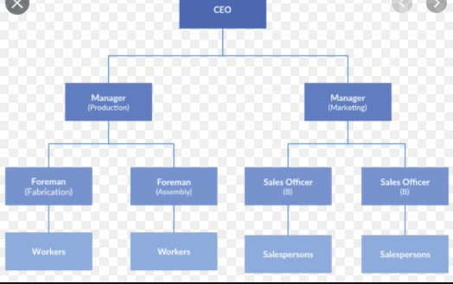

**FIGURE 2**

**Representation**

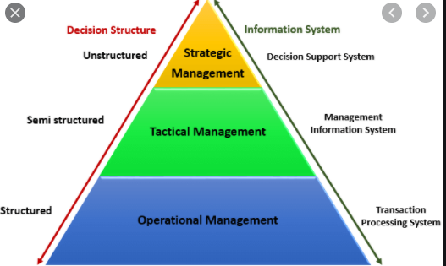

**Figure 3**

***Representation***

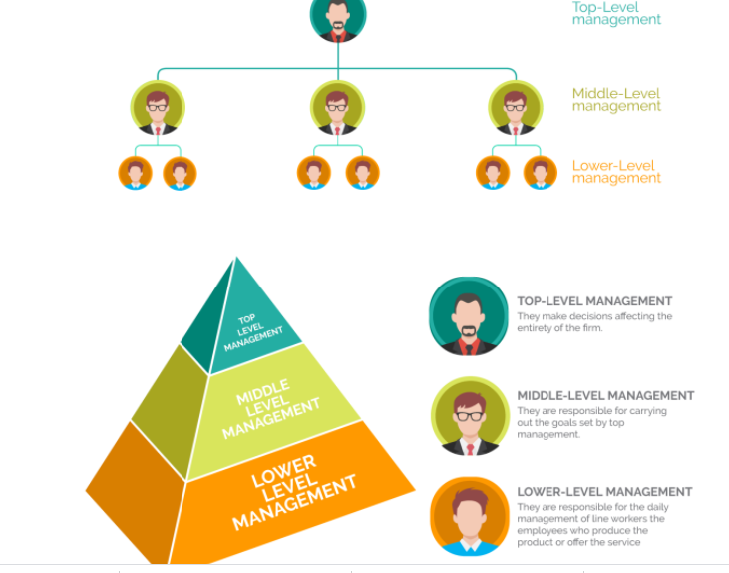

**3. Cultural elements**

The organization's new culture should incorporate certain elements, and they develop them to become a common practice of the organization and associated with the organization. The culture development proposed in the proposal heavily relies on supporting women in the organization, starting from the lowest rank to the highest rank and equal treatment of all organization workers without discriminating against a certain worker based on his or her gender (Thabhiranrak & Jermsittiparsert, 2019). It will also introduce a new culture of women's inclusion in the top managerial positions just like their male counterparts. The following are the areas that will require a cultural change in the organization to fulfill the goal and objective. Encouraging women in the top hierarchy and giving them equal opportunities and starting from responsibility assigned to workers in the organization to the organization's general salary.

**Purpose**

The organization must develop a new culture of aligning its purpose and objective with gender equality in the organization and equal representation of all gender at all levels of management. The above will bring positive drive and competition between the two genders, increasing all employees' efficiency and effectiveness. Resulting in the accomplishment of the goal and objective of the organization. Development of the above culture will also help create a good picture of the organization and receive support from all the organization's stakeholders.

**Ownership**

The organization's ownership must accept and give a go-ahead on the new proposal that will incorporate women in the organization's managerial positions. The above will give full authority to the implementation of the proposal as required. The management will also have an easy time incorporating the new proposals of equal representation of all gender at all levels of management in the organization.

**Community**

The community is some of the organization's key stakeholders, and the general perception previously practiced culture of discriminating women in the top managerial position must also incorporate change from the community. Failure to incorporate change from the community will still give women leadership positions an easy time since they will face acceptance challenges by the community they serve. The new change of culture will explain and convince the community at large on the reason and importance of accepting gender representation at all managerial positions in the organization.

**Effective Communication**

New cultural development will require effective communication at all levels in the organization to incorporate the changes. Therefore the communication channels that the organization will set will have to be in line with the new cultural change of equal gender representation in the organization (Daft, 2021). However, it is important to note that for a long time in the organization has had good effective communication comprising of female employees as the majority in the department.

**Good Leadership**

To bring the cultural change that has been proposed, the organization must have good leadership that will accept the changes and implements them according to the proposal to bring the changes recommended. Nevertheless, good leadership will also bring positive changes to the organization since the main goal is to fulfill its objectives and goals.

**4. Rationale for Including the Supporting Elements for the Design**

Including the organization's design element is to set a clear example for all the organization employees on the changes that will occur. The above will prepare them psychologically for the drastically changing since the organization's new design aims to encourage women in management positions and further support women to manage certain departments in the organization. The design elements will help eradicate the negative perceptions that male employees have against female employees (Fritz & Van, 2017). That has been a stumbling block for women to gain full confidence in the managerial positions and control the organization's operations fully as required by the stakeholders. Therefore, most women will be working just like their male counterparts since they will be assured or the backup if they face some challenges due to the new organization design that favors them in the organization.

The organization design elements will also help the management implement the new proposals to bring about the changes recommended. Therefore, the management will have a clear goal and objective of encouraging women to hold even managerial positions just like their male counterparts. Likewise, the treatment and general perceptions that men have been afforded will be reciprocated to women, too, since the new organization design aims to eradicate discrimination against women in the workplace.

Nevertheless, the supporting elements of the design under the chain of command will help bring order in the organization management and align the chain of command according to the required order incorporating women at the higher level in the hierarchy (Stouten et al., 2018).  Every department will balance male and female gender in the organization, and like before, male gender dominated departmental heads. The above will trickle down to the lowest-ranked employee in the organization to achieve equality in the organization.

The element of specialization in the organization's new design will incorporate women employees since previously, their number was minimal and imbalanced compared to the male specialist in the organization. The second is on the departmentalization and compartment. Male employees previously dominated will have to comply with the new design by incorporating the female employees in most departments and giving them equal opportunities just like their male counterparts.

In conclusion, the proposal's main agenda is to incorporate women in leadership positions, starting from the least ranked in the employees to the highest top management. It will involve drastic changes in the organization's structure, and design says certain new development must be incorporated in the organization. It will also require cultural change since the perception that most people have against women employees more so in managerial positions. The above cultural and design changes will bring effectiveness and efficiency in the organization's management, resulting in accomplishing its goals and objectives.

**References**

Daft, R. L. (2021). Management. Cengage Learning. [https://books.google.co.ke/books?hl=en&lr=&id=HBQcEAAAQBAJ&oi=fnd&pg=PP1&dq=organizational+design+elements+incorporating+women+in+the+management&ots=4-nEKpFQ-w&sig=axnbL4gk0excBi1aRSG1mhA4NzY&redir_esc=y#v=onepage&q&f=false](https://books.google.co.ke/books?hl=en&lr=&id=HBQcEAAAQBAJ&oi=fnd&pg=PP1&dq=organizational+design+elements+incorporating+women+in+the+management&ots=4-nEKpFQ-w&sig=axnbL4gk0excBi1aRSG1mhA4NzY&redir_esc=y" \l "v=onepage&q&f=false)

Fritz, C., & Van Knippenberg, D. (2017). Gender and leadership aspiration: the impact of organizational identification. Leadership & Organization Development Journal. <https://www.emerald.com/insight/content/doi/10.1108/LODJ-05-2016-0120/full/html>

Gipson, A. N., Pfaff, D. L., Mendelsohn, D. B., Catenacci, L. T., & Burke, W. W. (2017). Women and leadership: Selection, development, leadership style, and performance. *The Journal of Applied Behavioral Science*, *53*(1), 32-65. <https://journals.sagepub.com/doi/abs/10.1177/0021886316687247>

Mihăilă, R. (2016). Female labor force participation and gender wage discrimination. *Journal of Research in Gender Studies*, *6*(1), 262-268. <https://www.ceeol.com/search/article-detail?id=412618>

Rhode, D. L. (2017). *Women and leadership*. Oxford University Press. [https://books.google.co.ke/books?hl=en&lr=&id=JQkBDQAAQBAJ&oi=fnd&pg=PP1&dq=current+issues+related+to+women+in+leadership&ots=LoNG3TX46D&sig=VO04w9J9r2HHUOY1qTncljRMMQ8&redir_esc=y#v=onepage&q=current%20issues%20related%20to%20women%20in%20leadership&f=false](https://books.google.co.ke/books?hl=en&lr=&id=JQkBDQAAQBAJ&oi=fnd&pg=PP1&dq=current+issues+related+to+women+in+leadership&ots=LoNG3TX46D&sig=VO04w9J9r2HHUOY1qTncljRMMQ8&redir_esc=y" \l "v=onepage&q=current%20issues%20related%20to%20women%20in%20leadership&f=false)

Ronay, R., Maddux, W. W., & von Hippel, W. (2020). Inequality rules: Resource distribution and the evolution of dominance-and prestige-based leadership. *The Leadership Quarterly*, *31*(2), 101246. <https://www.sciencedirect.com/science/article/pii/S1048984318300043>

Stouten, J., Rousseau, D. M., & De Cremer, D. (2018). Successful organizational change: Integrating the management practice and scholarly literature. Academy of Management Annals, 12(2), 752-788. https://journals.aom.org/doi/abs/10.5465/annals.2016.0095

Thabhiranrak, T., & Jermsittiparsert, K. (2019). TOWARDS SUSTAINABLE FUNCTIONING OF ORGANIZATION: WOMEN EMPOWERMENT AND CORPORATE MANAGEMENT CULTURE. Journal of Security & Sustainability Issues, 9(1). <https://web.b.ebscohost.com/abstract?direct=true&profile=ehost&scope=site&authtype=crawler&jrnl=20297017&AN=139006028&h=n8mMgASMg3gcCDAS4r7K5gXMiU3xTw7MK%2fxRZc3BJtl%2fZ5o3b4v%2bMaBpVy7vTRn9Z8VXJvdH670TgCck%2f7ubRA%3d%3d&crl=c&resultNs=AdminWebAuth&resultLocal=ErrCrlNotAuth&crlhashurl=login.aspx%3fdirect%3dtrue%26profile%3dehost%26scope%3dsite%26authtype%3dcrawler%26jrnl%3d20297017%26AN%3d139006028>