Discussion #3: Chapter 5 - The Roman World Empire

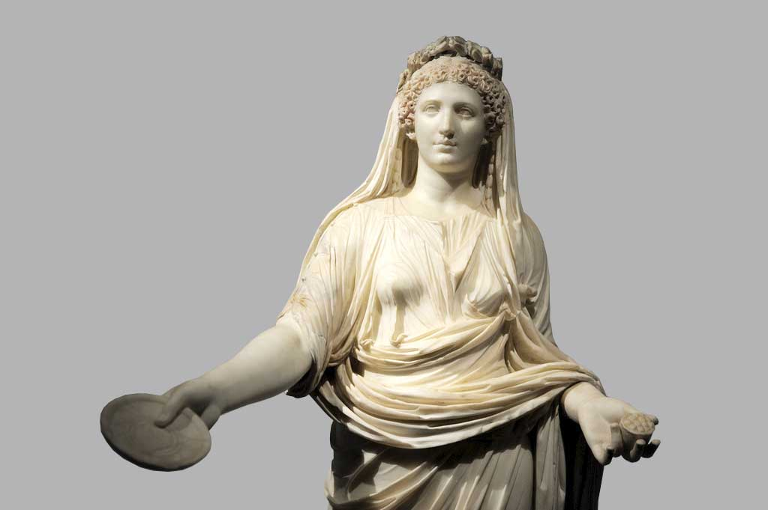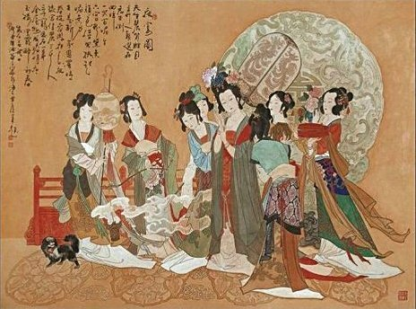

According to your textbook, at the heart of the Roman social structure stood the family, headed by the paterfamilias - the dominant male. The household also included the wife, sons with their wives and children, unmarried daughters, and slaves. Like the Greeks, Roman males believed that females needed male guardians. The paterfamilias exercised that authority, on his death, sons or nearest male relatives assumed the role of guardians. Please read carefully pages 141-142 and then read the two primary sources on page 143. The two primary sources reflect the views of a male Roman philosopher and a female writer in Han China. What were the Romans' viewpoint(s) of women and their roles in ancient Rome? Why do you think that they viewed women this way? How were the Romans' viewpoints similar to that of the Han? Do you think that the roles of women and their position in society in ancient Rome and China were any different than other civilizations during this period in early Africa, Mesopotamia, the Fertile Crescent, or India? Why or why not? And, finally, have the views toward women changed today? How? Please be specific and refer to the textbook in your response.