Decision Summary

|  |  |  |  |  |
| --- | --- | --- | --- | --- |
| **Fares** |  | **Quarter 3** |  | **Quarter 4** |
| Fare per Mile |  | 40 Cents |  | 48 Cents |
| Fare Structure |  | Normal |  | Luxury |
| Cabin/Food Service |  | Free soft drinks, snacks, and small snack meal for certain flights. Cost: $2.00 per passenger |  | Free drinks & hors d'oeuvres on or before all flights. Meal service as required. Cost: $5.00 per passenger |
|  | | | | |
| **Marketing** |  | **Quarter 3** |  | **Quarter 4** |
| Promotion Budget |  | $10,000 |  | $5,000 |
| Advertising Budget |  | $10,000 |  | $5,000 |
| In-Flight Magazine |  | Yes |  | Yes |
| Cargo Marketing Budget |  | $10,000 |  | $10,000 |
| Current Sales Force Size |  | 4 |  | 4 |
| Salespersons Hired |  | 0 |  | 0 |
| Estimated Sales Force Cost |  | $48,000 |  | $48,000 |
| Social Performance Budget |  | $5,000 |  | $5,000 |
| Social Responsibility Area |  | Health and family care issues |  | Health and family care issues |
|  | | | | |
| **Reports** |  | **Quarter 3** |  | **Quarter 4** |
| Operating Statistics |  | Not purchased |  | Purchased |
| Human Resources |  | Not purchased |  | Not purchased |
| Fares |  | Not purchased |  | Purchased |
| Sales |  | Not purchased |  | Not purchased |
| Marketing |  | Not purchased |  | Purchased |
|  | | | | |
| **Fleet** |  | **Quarter 3** |  | **Quarter 4** |
| Maintenance |  | Level 3: more frequent cleaning and full preventive maintenance. Cost: $5,000 per aircraft per quarter. |  | Level 3: more frequent cleaning and full preventive maintenance. Cost: $5,000 per aircraft per quarter. |
| Fuel Contract |  | All fuel purchased on the spot market this quarter |  | All fuel purchased on the spot market this quarter |
| Acquisitions |  | No acquisitions have been made. |  | No acquisitions have been made. |
| Disposals |  | No aircraft disposals. |  | No aircraft disposals. |
|  | | | | |
| **Scheduling** | | | | |
| |  |  |  |  |  | | --- | --- | --- | --- | --- | | **Route** | **Aircraft** | **Flights** | **Seats** | **Fare Sale** | | 1A - 600 Miles | 2 TP-300 (Normal)  2 TP-450 (Normal) | 4 | 150 | Regular Fare | | 1B - 400 Miles | 3 TP-300 (Normal)  1 TP-450 (Normal)  1 RJ-500 (Normal) | 5 | 185 | Regular Fare | | 1C - 340 Miles | 3 TP-300 (Normal)  2 TP-450 (Normal)  2 RJ-500 (Normal) | 7 | 280 | Regular Fare | | 1D - 360 Miles | 3 TP-300 (Normal)  2 TP-450 (Normal)  2 RJ-500 (Normal) | 7 | 280 | Regular Fare | | 1E2 - 400 Miles | 3 TP-300 (Normal)  2 TP-450 (Normal)  2 RJ-500 (Normal) | 7 | 280 | Regular Fare | | | | | |
|  | | | | |
| **Human Resources** |  | **Quarter 3** |  | **Quarter 4** |
| Quality & Training Budget |  | $100,000 |  | $100,000 |
| Compensation Policy |  | 0.20% above prevailing wage + stock-bonus for all employees. |  | 0.20% above prevailing wage + stock-bonus for all employees. |
|  | | | | |
| **Financing** |  | **Quarter 3** |  | **Quarter 4** |
| Purchase 3-month CD |  | $0 |  | $0 |
| Short-Term Loan |  | $0 |  | $0 |
| Long-Term Loan |  | $0 |  | $0 |
| Stock Sold |  | $0 |  | $0 |
| Dividend Paid |  | $0 |  | $0 |
| Stock Dividend |  | No |  | No |
|  | | | | |
| |  |  |  |  |  | | --- | --- | --- | --- | --- | | **Special Decision** |  | **Quarter 3** |  | **Quarter 4** | | Incident |  | Competitor's Safety Problem |  | Diversification—Auto Rental | | Choice |  | None Selected |  | Begin the auto rental business. | |  | | | | | | | | | |

**Quarter**

* Start
* 1
* 2
* 3
* 4
* 5

## Pro-Forma

Top of Form

ForecastReport

|  |  |
| --- | --- |
| **Projected Revenue** | |
| Net Passenger Revenue | $6,450,653 |
| Other Revenue | $0 |
| **Total Revenue** | **$6,458,166** |
|  | |
| **Projected Expenses** | |
| Operating Expense | $6,955,193 |
| Other Expense | $5,000 |
| Interest Expense | $50,548 |
| Interest Income | $0 |
| **Total Expenses** | **$6,995,741** |
|  | |
| **Projected Profit Before Tax** | **$(547,575)** |
| **Less Income Tax (40.0%)** | **$0** |
| **Projected Net Profit** | **$(547,575)** |

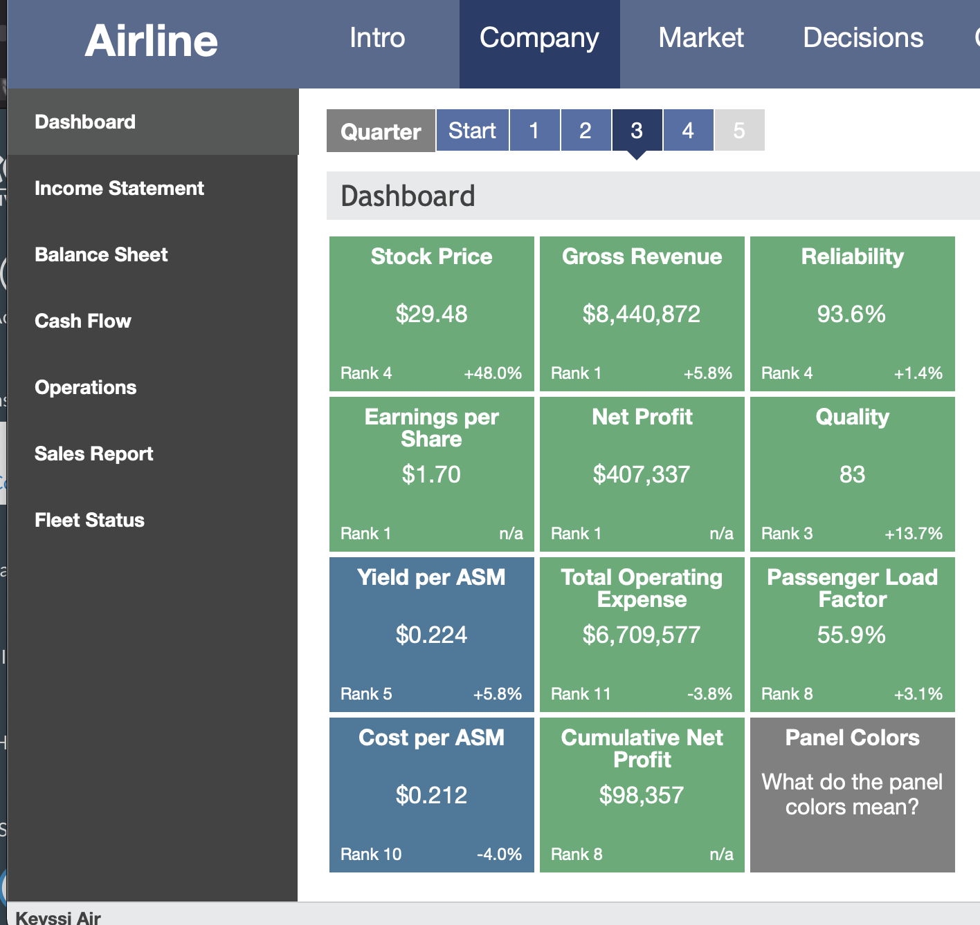Bottom of Form