**Six reasons why you should support social enterprise**

(Post sponsored by [TOMS Shoes](https://www.toms.com/new-arrivals?&utm_source=google&utm_medium=cpc&utm_term=toms%20shoes&utm_campaign=Google%7CSearch%7CUS%7CBrand%7CShoes%7CExact%7CAC_PP&utm_content=s8mE1PQTg_dc%7Cpcrid%7C341479124349%7Cpkw%7Ctoms%20shoes%7Cpmt%7Ce%7C&utm_source=google&utm_medium=cpc&utm_term=toms%20shoes&utm_campaign=Google%7CSearch%7CUS%7CBrand%7CShoes%7CExact%7CAC_PP&utm_content=s8mE1PQTg_dc%7Cpcrid%7C341479124349%7Cpkw%7Ctoms%20shoes%7Cpmt%7Ce%7Cslid%7C%7C&pgrid=67432499279&ptaid=kwd-3146487510&gclid=Cj0KCQjww7HsBRDkARIsAARsIT4kzFtU9R4Pgvz07JUD6LJSp4O7DQgzoPs9PpxV2BDhMChwxFbNDIEaAiCSEALw_wcB))

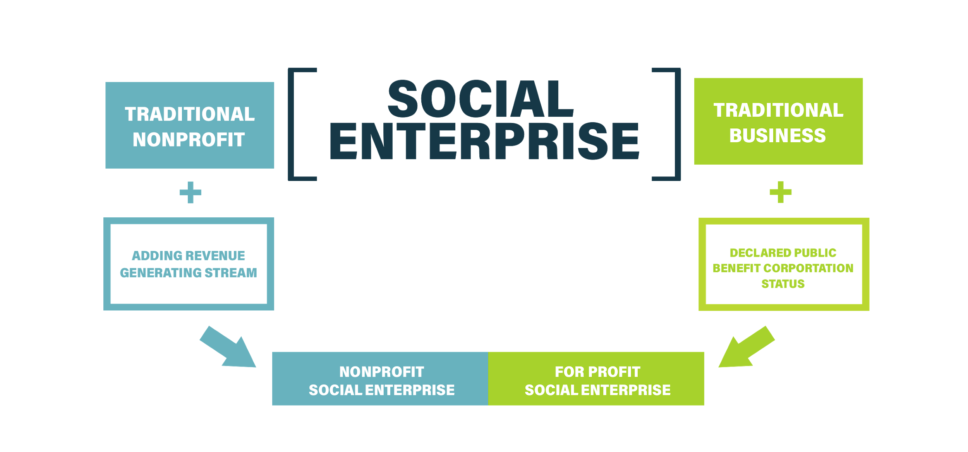

**What is a social enterprise?**

A[social enterprise](https://www.youtube.com/watch?v=1ecKK3S8DOE) refers to a business with motivation other than profit. Social entrepreneurs create sustainable businesses that make money and a difference [socially, environmentally and politically.](https://www.redbull.com/us-en/social-enterprise-stats)

While social enterprises remain legally undefined in the United States, their business model represents various statutory categories including: benefit corporation, social purpose corporation (SPC), low-profit limited liability company (L3C) and benefit limited liability company (BLLC). The [Grunin Center for Law and Social Entrepreneurship](https://socentlawtracker.org/wp-content/uploads/2019/05/Grunin-Tepper-Report_5_30_B.pdf) explores legislative updates for establishment of legal classifications of social enterprise sectors by state through their [Social Enterprise Law Tracker.](https://socentlawtracker.org/#/spcs)

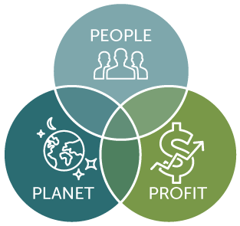

**Why should you support social enterprise?**

Social enterprises establish the idea of a [“triple bottom line”](https://www.economist.com/news/2009/11/17/triple-bottom-line) and reject the strictly revenue-focused intent of traditional companies. Instead, they reform business goals to benefit people, planet and profit in order to create and maintain a sustainable organization.

Not only are social enterprises rapidly growing and committed to making a difference, but they offer stylish and innovate products you can’t find anywhere else!

**1. Rapid growth**

Sustainable businesses represent a fast-growing sector of the economy. According to a census by the [Social Enterprise Alliance](https://socialenterprise.us/), 60 percent of United States social enterprises formed after 2006. In turn, this growth supports [positive financial returns](https://www.emerald.com/insight/content/doi/10.1108/SEJ-02-2017-0006/full/html) and innovative business practices for consumers as a result of social entrepreneurship’s adaptability in the face of a changing market.

For example, a popular social enterprise model, [“buy one, give one,” was pioneered by TOMS Shoes in 2006 to help children in need.](https://www.toms.com/corporate-responsibility/) This shoe company goes the extra mile by donating one pair of shoes for every pair purchased. In just ten years, [TOMS Shoes donated 60 million pairs to children worldwide.](https://www.businessinsider.com/toms-blake-mycoskie-talks-growing-a-business-while-balancing-profit-with-purpose-2016-6)

**2. Financial impact**

Unlike their more socially frugal company counterparts, social enterprises use their profits for good.

A dollar goes further supporting a business with sustainable production, distribution and sourcing methods. In fact, these triple bottom line businesses have [“a strong social return on investment](https://socialimpactarchitects.com/sroi/),” saving taxpayers $1.31 for every dollar spent.

Socially-conscious organizations also play a substantial role in the economic health of entire countries. A [Great British Council report](https://www.britishcouncil.org/sites/default/files/british_council_-_seuk_think_global_report_graph4.pdf) found that social enterprises accounted for 3.5 percent of the United States’ Gross Domestic Product, which represents “more than the contribution of Silicon Valley.”

Organizations like [TOMS Shoes inspire this economic growth](https://www.forbes.com/sites/simonmainwaring/2018/12/13/purpose-at-work-lessons-from-toms-on-how-to-lead-with-purpose/#5bbc88543e81) in other countries by donating shoes for school uniforms. As a result, TOMS Shoes helps children realize their potential and use their education to make a positive financial impact at home.

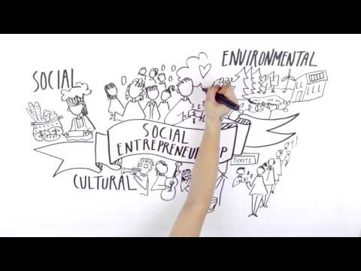

https://www.youtube.com/watch?v=9_g5RqwW51I&t=135s

**3. Making a difference**

[Social entrepreneurs are famous for making a difference on a local and global scale.](https://techcrunch.com/2016/04/25/how-social-entrepreneurship-is-making-a-difference-in-the-world/) You can back a cause you are passionate about in order to directly or indirectly reinforce your values.

TOMS Shoes [protects kids from soil-transmitted diseases, cuts and sores and supports their education.](https://www.cdc.gov/parasites/sth/index.html) Every [TOMS Shoes](https://www.toms.com/women/womens-shoes) customer is able to “put their best foot forward” and make a difference in the lives of others through their purchase. TOMS customers are dedicated to making the world a better place with every stylish step.

**4. Creating job opportunities**

A socially-conscious organizational structure develops employment opportunities. A 2017 [Social Enterprise Market Trends report](https://assets.publishing.service.gov.uk/government/uploads/system/uploads/attachment_data/file/644266/MarketTrends2017report_final_sept2017.pdf) found social enterprises employ 1.44 million people in the United Kingdom. In the United States, this trend continues as [social enterprises were found to employ approximately 10 million people](https://www.huffpost.com/entry/social-enterprise_b_2090144) throughout the country.

People, planet and profit focused organizations provide skills training and work experience. They also employ those deemed “unemployable” by society, providing them with the [opportunity to support themselves.](https://www.toms.com/supply-chain-transparency)

**5. Environmentally focused**

The 2012 [Great Social Enterprise Census](https://www.huffpost.com/entry/social-enterprise_b_2090144) reports that 12 percent of social enterprises target the environment. Their focus on sustainable practices and material sourcing lessen the harmful impact of purchasing disposable products. [Discover a list of 17 social enterprises that fight climate change by Seforis.](http://www.seforis.eu/news/2015/12/27/discover-17-social-enterprises-that-fight-climate-change)

**6. Stylish and trendy products**

Social enterprises, like [TOMS Shoes](https://www.toms.com/women/womens-shoes), offer consumers stylish and innovative products unlike anything else on the market. They create footwear that merge trendy fashion and durable design to make their iconic shoes. In fact, [many celebrities love wearing TOMS Shoes.](https://footwearnews.com/2016/fashion/designers/celebrities-love-wearing-toms-shoes-photos-226557/)

**Meta-description:**

Social enterprises or businesses with triple bottom lines are rapidly growing, providing financial and job opportunities, as well as allowing consumers to make a difference globally. [TOMS Shoes](https://www.toms.com/women/womens-shoes) provides customers with stylish shoes and develops a larger community committed to making the world a better place.