**Message Point 1:** Columbus, Ohio is for coffee lovers.

Support: Tourism Ohio created a Columbus coffee trail featuring 17 local coffee shops.

<http://www.cbuscoffee.com/locations>

Example: Sprudge: an online publication dedicated to coffee news, rated Columbus one of the top five underrated coffee cities.

<https://sprudge.com/5-underrated-coffee-cities-49595.html>

**Message Point 2:** Support local businesses to help the local economy.

Ex.: Stauf’s supports other local businesses and artists in Columbus (Glenn Ave Soap, Aunt Flow, Pattycake, etc.)

Support: After price discounts, millennials look to other factors to influence their spending such as authenticity, local sourcing, ethical production, a great shopping experience, and giving back to society.

<https://www.agencyascend.com/blog/millennial-consumer-how-they-shop-why-they-buy>

**Message Point 3:** Stauf’s fosters community.

Support: Yelp reviews <https://www.yelp.com/biz/staufs-coffee-roasters-columbus-2>

Example: According to communications manager, Lili Korcok, Stauf’s donates to at least two local organizations and/or events each month.

**The Six Types of People You’ll Find at Stauf’s Coffee Roasters**

[Stauf’s Coffee Roasters](https://www.staufs.com/) is a locally-owned and operated coffee roasting company in Columbus, Ohio. It offers a wide array of freshly-roasted coffee beans and coffee beverages served in their cafes that attract a variety of people for all kinds of different reasons. Whether it’s the award-winning beverages, decadent pastries or dedication to serving Columbus and its citizens, people of all trades are coming to Stauf’s on the daily.

At any given moment these are the six types of people you’ll be sure to find at Stauf’s!

1. **The Student**



Columbus is home to over 50 universities and colleges – this makes Stauf’s a hot spot for study sessions, group project meetups or even just refueling for class. Take a look around and you’ll find a good mix of undergrad, grad, medical or law students hammering away on their laptop while sipping on some hand-crafted coffee beverages. The Student can feel comfortable knowing that their local coffee roaster is there for them through all the long nights of studying and early morning caffeine needs. Stauf’s even stays open late during exam times!

1. **The Columbus Local**

Columbus locals love supporting other Columbus locals, so why wouldn’t they get their coffee fix from a local roastery? In addition to supporting their local Columbus coffee company, customers can purchase locally made candles from [The Candle Lab](https://www.thecandlelab.com/), munch on pastries from [Pattycake Bakery](http://www.pattycakeveganbakery.com/) or indulge in the sweet scent of [Glenn Avenue Soap Company](https://www.glennavesoap.com/) in the bathrooms. Columbus locals support local businesses and Stauf’s is proud to do the same!

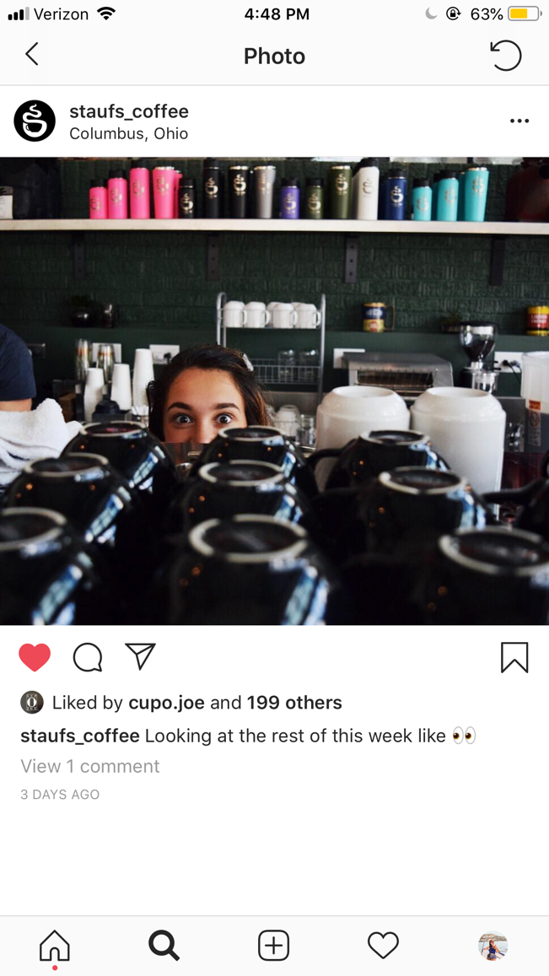

1. **The Columbus First-Timer**

Stauf’s is the oldest coffee roaster in Columbus so it’s pretty well-known around Central Ohio. (Take a look at their 30th anniversary story by Columbus Monthly [here](http://www.columbusmonthly.com/lifestyle/20181106/drink-staufs-coffee-roasters-turns-30)!) It has won countless awards in Columbus-based magazines “best of” categories and sponsors [Columbus Coffee Fest](http://www.columbuscoffeefest.com/), as well as other events around the city. Stauf’s even holds five of the stops on the [Columbus Coffee Trail](http://www.cbuscoffee.com/columbus-coffee-trail/) in each of its locations in various bustling neighborhoods. So, chances are if you’re The Columbus First-Timer and making your way around town, you’ve been near Stauf’s at least once!

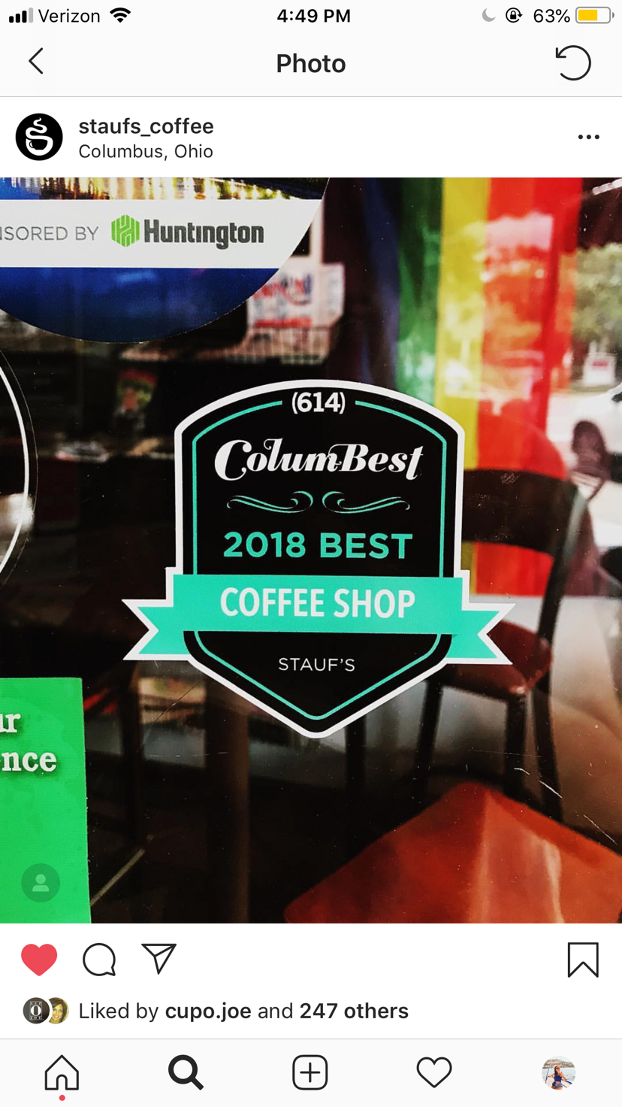

1. 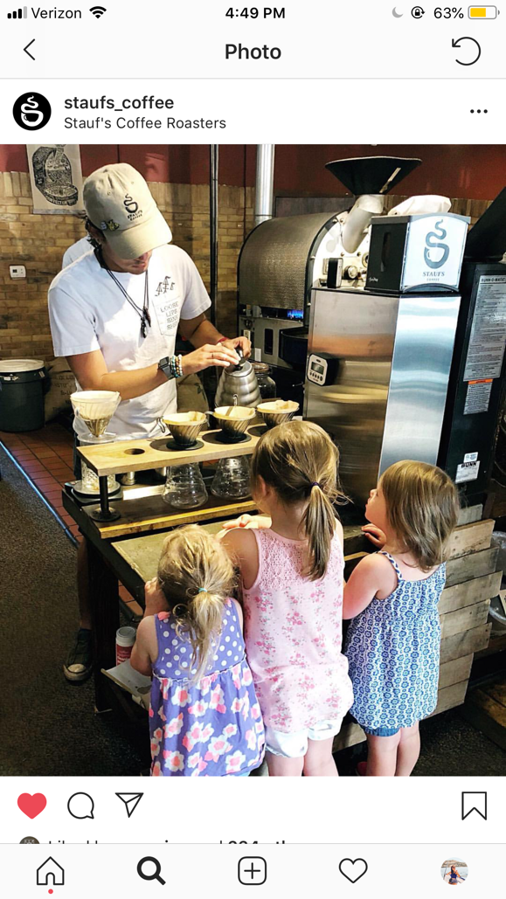**The Family Man**

Coming in to Stauf’s is like coming home for some people. Young and old can gather, enjoy locally-roasted, award-winning coffee beans and relax with their friends and family. Whether walking down the street to their neighborhood shop early on a Sunday morning or bringing their children in on a Wednesday afternoon to snack on muffins while they catch up with old friends – Stauf’s is a place that fosters friendship and community. The busy atmosphere a perfect spot to engage in conversation and pass some laughs with friends. Recurring visits to the local coffee shop are also a great way to raise your kids to be No. 2, The Columbus Local, and get them on the coffee-drinking train!

1. **The “Staufice” worker**

With businesses allowing employees to work from home more and more frequently, the “Staufice” is getting more and more crowded. So many people come to Stauf’s almost, if not daily, to get their work done. Whether they work remotely, freelance or are just in the business planning phase of their next big idea – The “Staufice” is their place of choice. Stauf’s sets the scene for multiple business meetings every day and is proud to be a little snippet in the scope of the fruition of a great idea.



Let’s get one thing straight, you might confuse The Student and The “Staufice” Worker but typically laptop stickers are a pretty good giveaway of The Student versus a suit and tie that The “Staufice” Worker naturally sports.

1. **The Coffee Connoisseur**

Stauf’s offers very versatile options when it comes to café beverages. Baristas will pass no judgement whether you order a single shot of espresso or a Milky Way Mocha with extra whipped cream. There are countless options for how your drink can be prepared and each barista is happy to discuss and take the time to advise the best brewing methods based on the origin and type of bean. Because of the relaxed and conversational ambience, The Coffee Connoisseur can engage in meaningful banter with any of the knowledgeable baristas. Stauf’s offers an exceptional selection of beans ranging from the rarest single-origin to classic flavors like Highlander Grog that are sure to wow The Coffee Connoisseur.

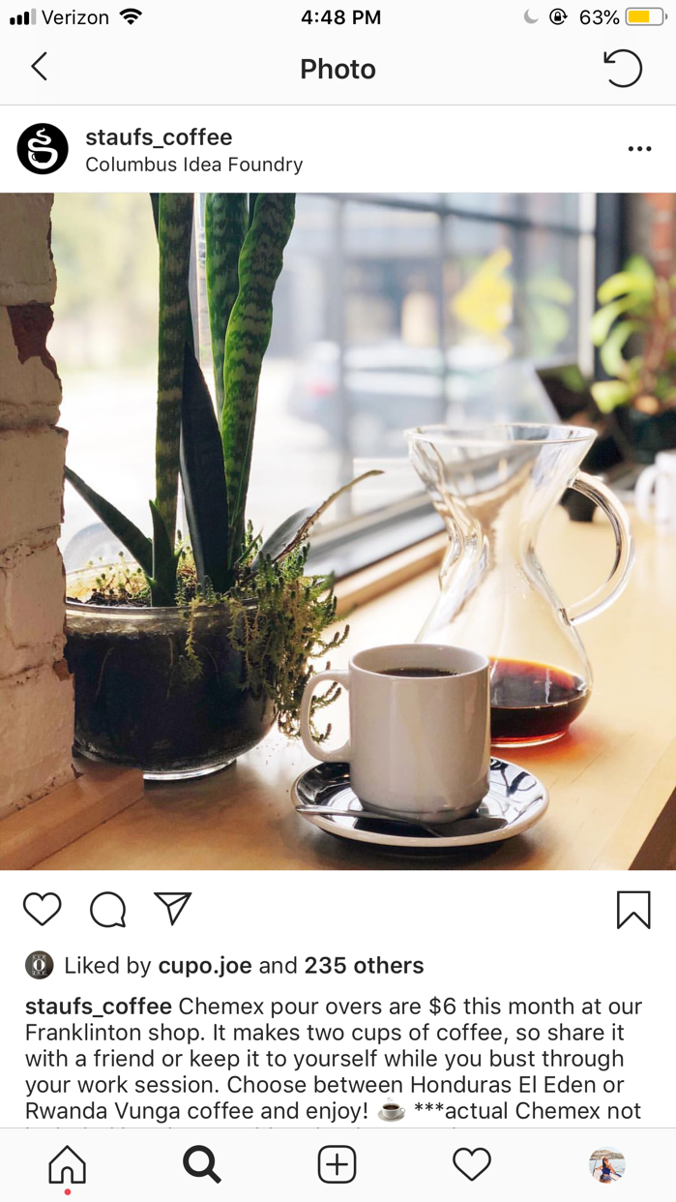

Whether you’re new to Columbus, a born and raised Buckeye or just dropping by, Stauf’s is a haven where you can come enjoy hand-crafted coffee and espresso drinks made with locally-roasted coffee beans. You’ll discover a similar crew where you belong and find yourself coming back time and time again.