**Organization:** The Roosevelt Coffeehouse

**Messaging points:**

1. The Roosevelt Coffeehouse is known for fighting injustices around the world that affect people and their community.
   1. They help fight unclean water, hunger and human trafficking
   2. They partner with a Christian humanitarian non-profit that seeks to create life-sustaining solutions that alleviate global poverty
2. The organization is known for making excellent coffee to help serve people in their local community.
   1. Each local buying their freshly brewed coffee is helping fight injustices in their community
   2. They have a local men’s shelter located next to their location that they help provide for through finances and brewing local coffee.
3. The Roosevelt Coffeehouse brings their community together by helping others in need in their community.
   1. The Coffeehouse is about community corporate philanthropy to help locals In need.
   2. They partner with a few corporate sponsors that help fight injustices such as Salvation Army.

**Keywords:**

**Philanthropy, Community, Injustice, Volunteer**

As a local **community** we strive to help our **community** everyday by providing and donating to services that keep our **community** safe. We have many organizations and businesses that partner to help fight **injustices** that are known in the area. One may ask “how can I Help better my **community**?”. One organization that gives back to our **community** is The Salvation Army.

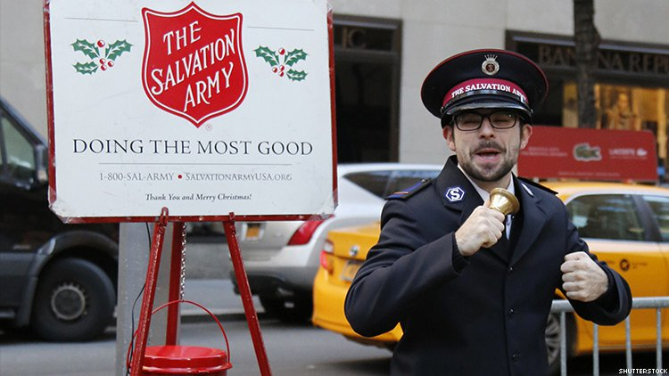

salvation-army-750.JPG

The ringing of each bell, especially around the Holiday season, entices locals to give to a **community** in need. Salvation buckets are setup all over the **community** and gives locals an immediate opportunity to save lives by reaching in their wallet. Everyday **volunteers** are standing out in stores getting you to give your money to what they believe.

The Salvation Army fights for many **injustices** but one that stands out in the Columbus area is human trafficking. Ohio is a top state known for human trafficking and many charities like The Salvation Army are giving back and so should you.

The organization gives many opportunities for the **community** to give back. One opportunity is **volunteering**. Each branch of The Salvation Army allows people with a degree or experience in an area to give their education back to the **community**. For example, you can work as a case study worker in a disaster center or you can help patience that have dealt with Domestic Violence in their past. **volunteering** is known to be the most effective and best way to help those in need.

<https://www.salvationarmyusa.org/usn/plugins/gdosCenterSearch?start=1>

The link above shows examples of how one can **volunteer** at one of The Salvation Army’s locations. As you type in your location, many centers show what spots are open and what **volunteer** positions need to be filled.

These opportunities allow people to entice their local family and friends to give back to what they believe. This also allows people in the **community** to come together and fight for a cause bigger than themselves.

The video below shows how **volunteering** and donating can help those in need around the local **community** of Columbus. In each person you can see the struggle and pain they have each been through as they go on to say what they use to struggle. Each of these patients were helped by their local **community**. Whether it was from **volunteering** at a domestic violence center or donating at a bucket in the grocery store. Each donation went a long way.

<https://www.youtube.com/watch?v=90cfMSqAj0o>

AmazingGrace-ASalvationArmyStory.Mp4

As you know The Salvation Army has a big focus on donating and **volunteering**. One aspect of this organization is **philanthropy**. The Salvation Army partners with many companies and other organizations that give back to their local **community**. The organization will put on events that help benefit those that are in need in the **community**.

<https://www.philanthropy.com/interactives/americas-favorite-charities>

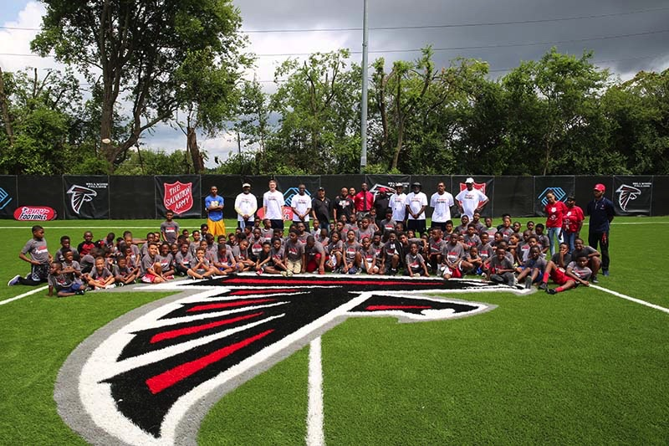As Stated in the title of this article Salvation Army’s **philanthropy** is one of “America’s favorite charities.” The program will continue to be supported by many companies and partnering donor organizations.

SalvationArmy-Bellwood-Field-with-kids.JPG

This Photo represents an event The Salvation Army and The Boys and Girls Club of America. This event consisted of over 150 families that got a chance to hangout out with Falcon’s players and Staffers. The NFL is one of The Salvations Army’s biggest sponsors in the United States and continues to put on amazing events every year.

The Salvation Army puts great emphasis on corporate **philanthropy**. Each corporate sponsorship and each sponsorship gained, gives so much back to a local **community** in need. Local Sponsors have always been a major support for The Salvation Army.

The Roosevelt Coffeehouse is one of Columbus’ biggest donors for local corporate **philanthropy**. The Salvation Army is one of their biggest sponsors. As shown on the website below, the organization brews Coffee for our local **community** here in Columbus. The organization fights **injustices** through its locally brewed coffee and corporate **philanthropy** support.

<https://www.rooseveltcoffee.org/justice/>