Sevant Leadership questioner chapter 10 week 2 journal
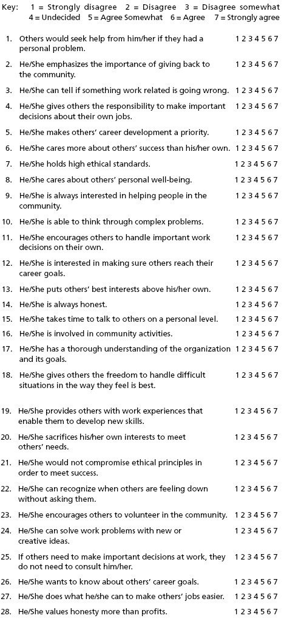

Question Number | My Answer
1 | 5
2 | 5
3 | 5
4 | 2
5 | 4
6 | 2
7 | 6
8 | 7
9 | 5
10 | 5
11 | 4
12 | 5
13 | 2
14 | 6
15 | 5
16 | 2
17 | 4
18 | 4
19 | 4
20 | 4
21 | 5
22 | 5
23 | 4
24 | 4
25 | 4
26 | 4
27 | 5
28 | 4

Scoring
Using the questionnaires on which others assessed your leadership, take the separate scores for each item, add them together, and divide that sum by two. This will give you the average score for that item. For example, if Person A assessed you at 4 for Item 2, and Person B marked you as a 6, your score for Item 2 would be 5.
Once you have averaged each item’s scores, use the following steps to complete the scoring of the questionnaire:
- Add up the scores on 1, 8, 15, and 22. This is your score for emotional healing.
- Add up the scores for 2, 9, 16, and 23. This is your score for creating value for the community.
- Add up the scores for 3, 10, 17, and 24. This is your score for conceptual skills.
- Add up the scores for 4, 11, 18, and 25. This is your score for empowering.
- Add up the scores for 5, 12, 19, and 26. This is your score for helping followers grow and succeed.
- Add up the scores for 6, 13, 20, and 27. This is your score for putting followers first.
- Add up the scores for 7, 14, 21, and 28. This is your score for behaving ethically.
1. = 22
2 .= 16
3. = 18
4. =14
5. =17
6.= 13
7.= 21

Scoring Interpretation
- High range: A score between 23 and 28 means you strongly exhibit this servant leadership behavior.
- Moderate range: A score between 14 and 22 means you tend to exhibit this behavior in an average way.
- Low range: A score between 8 and 13 means you exhibit this leadership below the average or expected degree.
- Extremely low range: A score between 0 and 7 means you are not inclined to exhibit this leadership behavior at all.
The scores you received on the Servant Leadership Questionnaire indicate the degree to which you exhibit the seven behaviors characteristic of a servant leader. You can use the results to assess areas in which you have strong servant leadership behaviors and areas in which you may strive to improve.

Week 2-chapter 9 Authentic leadership self-assessment
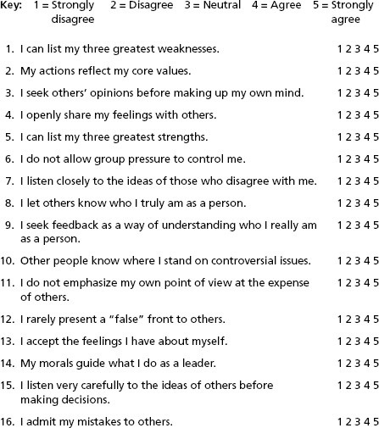

Question Number | My Answer
1 | 5
2 | 3
3 | 4
4 | 4
5 | 4
6 | 3
7 | 3
8 | 3
9 | 4
10 | 4
11 | 4
12 | 3
13 | 4
14 | 4
15 | 4
16 | 4

Scoring
- Sum the responses on items 1, 5, 9, and 13 (self-awareness).
- Sum the responses on items 2, 6, 10, and 14 (internalized moral perspective).
- Sum the responses on items 3, 7, 11, and 15 (balanced processing).
- Sum the responses on items 4, 8, 12, and 16 (relational transparency).

Total Scores
Self-Awareness: 17
Internalized Moral Perspective: 14
Balanced Processing: 15
Relational Transparency: 14

Scoring Interpretation
This self-assessment questionnaire is designed to measure your authentic leadership by assessing four components of the process: self-awareness, internalized moral perspective, balanced processing, and relational transparency. By comparing your scores on each of these components, you can determine which are your stronger and which are your weaker components in each category. You can interpret your authentic leadership scores using the following guideline: high = 16–20 and low = 15 and below. Scores in the upper range indicate stronger authentic leadership, whereas scores in the lower range indicate weaker authentic leadership.

Summary
As a result of leadership failures in the public and private sectors, authentic leadership is emerging in response to societal demands for genuine, trustworthy, and good leadership. Authentic leadership describes leadership that is transparent, morally grounded, and responsive to people’s needs and values. Even though authentic leadership is still in the early stages of development, the study of authentic leadership is timely and worthwhile, offering hope to people who long for true leadership.
Although there is no single accepted definition of authentic leadership, it can be conceptualized intrapersonally, developmentally, and interpersonally. The intrapersonal perspective focuses on the leader and the leader’s knowledge, self-regulation, and self-concept. The interpersonal perspective claims that authentic leadership is a collective process, created by leaders and followers together. The developmental perspective emphasizes major components of authentic leadership that develop over a lifetime and are triggered by major life events.
The practical approach to authentic leadership provides basic “how to” steps to become an authentic leader. George’s approach (2003) identifies five basic dimensions of authentic leadership and the corresponding behavioral characteristics individuals need to develop to become authentic leaders.
In the social science literature, a theoretical approach to authentic leadership is emerging. Drawing from the fields of leadership, positive organizational scholarship, and ethics, researchers have identified four major components of authentic leadership: self-awareness, internalized moral perspective, balanced processing, and relational transparency.
In addition, researchers have found that authentic leadership is influenced by a leader’s positive psychological capacities, moral reasoning, and critical life events.
Authentic leadership has several positive features. First, it provides an answer to people who are searching for good and sound leadership in an uncertain world. Second, authentic leadership is prescriptive and provides a great deal of information about how leaders can learn to become authentic. Third, it has an explicit moral dimension that asserts that leaders need to do what is “right” and “good” for their followers and society. Fourth, it is framed as a process that is developed by leaders over time rather than as a fixed trait. Last, authentic leadership can be measured with a theory-based instrument.
There are also negative features to authentic leadership. First, the ideas set forth in the practical approach need to be treated cautiously because they have not been fully substantiated by research. Second, the moral component of authentic leadership is not fully explained. For example, it does not describe how values such as justice and community are related to authentic leadership. Third, the rationale for including positive psychological capacities as an inherent part of a model of authentic leadership has not been fully explicated. Finally, there is a lack of evidence regarding the effectiveness of authentic leadership and how it is related to positive organizational outcomes.
In summary, authentic leadership is a new and exciting area of research, which holds a great deal of promise. As more research is conducted on authentic leadership, a clearer picture will emerge about the true nature of the process and the assumptions and principles that it encompasses.

