Perioperative Roadshow Program Evaluation

**Executive Summary**

Project Name: Perioperative Roadshow

Definition: The Perioperative Roadshow is an education outreach program developed by the Presurgical Screening (PSS) Department staff at Highland Hospital (HH) for staff members in HH affiliated surgeons’ offices to increase awareness and compliance with PSS and optimization requirements, thus facilitating safe, on-time scheduled surgery.

Program Purpose: A quality improvement initiative designed with a two-fold purpose (a) to improve efficiencies by decreasing day of surgery delays and cancellations and (b) to increase patient safety by decreasing perioperative nurses’ time pressure and burnout associated with last minute efforts to prepare patients for surgery.

Why: PSS is known to be effective in reducing day of surgery delays and cancellations. In addition, mitigating nurses’ time pressure and burnout related to PSS system breakdowns, reduces the likelihood of adverse patient events and improves patient safety. Reaching out to surgical office staff extends the influence of the expertise of PSS staff at HH to streamline and improve the PSS process across organizational entities.

Who: Patients, families, surgeons, perioperative nurses, surgical office staff, PSS staff.

Where: HH-affiliated surgeons’ offices.

What: Deliverables for this project include:

* Learning needs assessment to identify surgeons’ office staff understanding of the importance of PSS and optimization, gaps in knowledge, support and time constraints for education, and preferences for education methods
* Perioperative Roadshow educational outreach program.
* Resource notebook customized to each surgeon’s patient population so there is clear understanding of exactly what is needed for each patient specifically, and the office’s patient population generally (e.g., Copies of pre-op instruction, algorithms for the necessity of EKGs and lab work, contact information for problems)

When: An educational outreach intervention to begin as soon as needs assessment is complete, content is developed, and baseline data have been collected. Target date February 2017

Outcomes:

* Primary outcomes are rates of day-of-surgery delays and cancellations. Secondary outcomes include (a) avoidable versus unavoidable day of surgery delays and cancellations, (b) patient versus hospital related day of surgery delays and cancellations, and (c) registered nurse (RN) staff time pressure/burnout.
* The primary process measure related to Perioperative Roadshow implementation is surgeon office staff knowledge of PSS screening requirements. Secondary process measures include (a) percentage and position of office staff attending the Perioperative Roadshow (i.e., dose assessment) and (b) relevance of Perioperative Roadshow visit/content for office staff.

Perioperative Roadshow Program Evaluation

**Program and Evaluation Description**

The Perioperative Roadshow as is an educational outreach intervention embedded within a quality improvement initiative to be carried out by the staff of Highland Hospital’s Presurgical Screening Department (HHPSSD) personnel. Desired improvements are primarily (a) an increase in office staff knowledge of PSS requirements, (b) a decrease in day of surgery cancellations and delays, and (c) a reduction of preoperative registered nurse (RN) stress levels from time pressure and burnout. The Perioperative Roadshow outreach is a collaborative effort between HHPSSD and the staff in surgeons’ offices, who perform surgery at HH. The face to face educational session format was developed to personalize relationships and to ensure that all entities share understanding of the requirements and information needed for patients to be successfully optimized for surgery resulting in desired program outcomes. “Optimization” is the process of identifying risks and comorbidities that can affect patient surgical outcomes. Optimization aims to prevent postoperative complications, decrease unplanned readmissions after discharge, decrease length of stay, and improve the overall health of the patient.

Lunchtime meetings arranged by program organizers are planned to take place in surgeons’ offices with several main components envisioned: Lunch and social time, educational presentation focused on PSS and optimization requirements, introduction to the “Resource Notebook”, question and answer session followed by learning self-assessment and program visit feedback survey.

Based on past interactions with surgical office staff, this group should be easy to access, as they have been agreeable to collaboration for the sake of quality patient care in the past via email and phone calls. The likelihood of achieving desired outcomes is high with regards to increasing office staff knowledge of PSS and optimization due to the roadshow educational intervention. It is likely for decrease in perioperative e RN time pressure/burnout if the education received in the roadshow education is put into action and may be weak or strong for decreasing delays and cancellations depending on the quality of the collected data.

The Perioperative Roadshow is targeted for implementation in February 2017. The scope of work to be completed prior to implementation includes, developing the roadshow educational content, abstracting secondary data for analyzing baseline rates of surgery cancellations and delays, and conducting pre-intervention staff surveys.

**Program Theory**

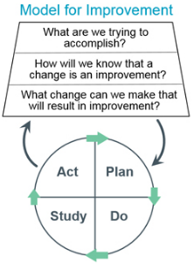The principal theory identified to support change in PSS system performance is the Institute for Healthcare Improvement’s (IHI) Model for Improvement (MFI) (Scoville & Little, 2014). Three important questions are asked to elucidate improvement goals (see Figure 1, for IHI MFI model questions): What are we trying to accomplish? How will we know the change is an improvement? What change can we make that will result in improvement? These questions, in combination with the Plan-Do-Study-Act iterative improvement cycle of small tests of change, help guide focused action based on past experience (Scoville & Little, 2014).

Answers to the three questions for the Perioperative Roadshow are as follows:

1) What are we trying to accomplish? Objectives include improving the efficiency of presurgical screening processes at HH.

Figure 1. Institute for Healthcare Improvement Model for Improvement

2) How will we know that a change is an improvement? A decrease in day of surgery delays and cancellations in addition to a decrease in RN time pressure/burnout would be indicative of changes that are improvements.

3) What change can we make that will result in that improvement? An educational outreach as part of a quality improvement initiative aimed at filling knowledge gaps with regards to PSS requirements in surgical office staff will result in an improvement of the overall process.

4) Plan-Do-Study-Act Components

* + **Plan:** A needs assessment of the current state consisting of a face-to-face meeting with high performing office personnel to assess their interest and identify process problems and knowledge gaps. Individual meetings with perioperative nursing staff to discuss stress from time pressures related to last minute delays and cancellations and their relationship to patients who are not optimized.
  + **Do:** Roadshow intervention meetings, follow up phone calls and distribution of “Resources Binder” for office staff.
  + **Study: Process and impact outcomes (RN time presssure/burnout levels, day of surgery delay and cancellations data, learning self-assessment results).**
  + Act: Based on studied outcome measures, changes to program or additions may be needed and incorporated.

**Implementation Theory**

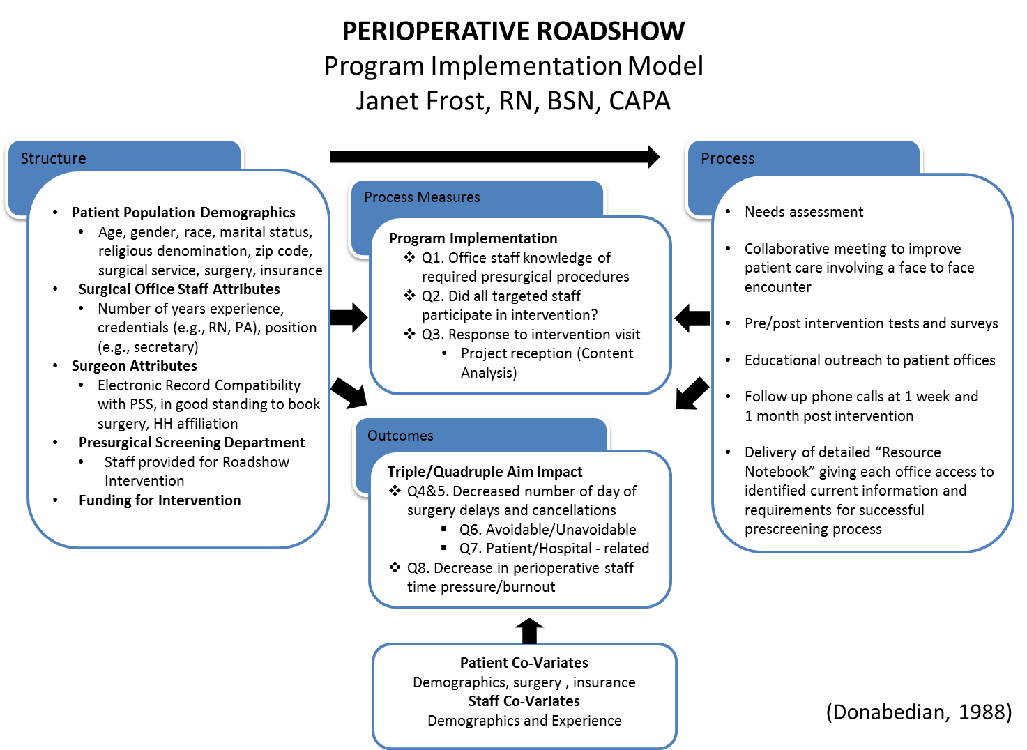The Donabedian (1988) structure-process-outcome model for quality improvement (see Figure 2, for implementation theory) was used to illustrate how the Perioperative Roadshow will be implemented. Operationally speaking, once the baseline data is obtained (patient data, RN time pressure/burnout surveys), the staff of PSS at HH will conduct lunchtime educational outreach interventions in the offices of the surgeons that operate at HH. The target of the educational outreach is the surgical scheduling staff, physician assistants, nurse practitioners and RNs that work with patients to help plan surgery on behalf of the patients.

Figure 2. Perioperative Roadshow Implementation Model

Anticipated difficulties with the implementation plan revolve around obtaining accurate secondary data from Optime reports for HH patients. The Optime system is relatively new, and reasons for delays are not always captured accurately within the system. In addition, outcomes concerning cancellations and delays depend upon identifying and addressing confounding factors (e.g., patient factors, surgeon’s booking late cases, booking errors, etc.).

**Rationale for Program Evaluation Plan**

1. **Needs Assessment**: HH, in conjunction with surgical staff, currently performs between 850 and 900 surgeries per month. The Presurgical Screening (PSS) department is responsible for facilitating proper screening and preparation for surgical cases. In conversations with preoperative day of surgery nursing staff on multiple occasions, themes of lack of patient preparedness resulting in last minute cancellations or delays due to abnormal lab values, misunderstood preoperative instructions, and preoperative workups that are incomplete, lead to time pressure on the day of surgery for RNs as well as inconvenience for both surgeons and patients.

HHPSSD is responsible for phone screening 100% of patients booked for surgery at HH. Approximately 2/3 of those phoned screened will need a “pretesting” in-person appointment with a provider. Of those requiring additional pretesting, 30% are pretested by their surgeon’s offices or personal primary care physician. HHPSSD is responsible for gathering the various required PSS elements for these patients but it does not perform the actual pretesting.

A visit to a high-performing surgeon’s office responsible for pretesting their own patients (for the purpose of better understanding office practices related to PSS), revealed knowledge gaps in the understanding of HH PSS requirements that contribute to a fully prepared patient and on-time surgery.

Table 1 displays data collected November 2016 to examine cancellations and delays. The findings revealed preventable delays and cancellations, but many delays were marked only as “other” and not classified. There is potential to identify many more cases as “preventable” reasons going forward are documentation and data mining improves.

**Table 1**

HH Surgical Cancellations and Delays, November 2016

|  |  |  |  |  |
| --- | --- | --- | --- | --- |
| Adverse Event /System Failure | Total Cases | Total Number of Measured Variable | Identified  Preventable Cases  Total | Identified Preventable Cases  Rate per 1000 cases |
| Cancellations | 1039 | 46 | 6 | 6 |
| Delays | 1039 | 345 | 30 | 3 |

1. **What does HHPSSD want to understand?** HHPSSD is interested in understanding the current effectiveness of the PSS process and what changes are necessary to achieve desired outcomes.

There are three process and five outcome questions, a total of eight questions, to be answered by the Perioperative Roadshow evaluation:

* 1. Was the Perioperative Roadshow effective in increasing surgeons’ office staff knowledge of PSS requirements (primary process)?
  2. What percentage and position of surgeons’ office staff attended the Perioperative Roadshow (secondary process)?
  3. Was the Perioperative Roadshow relevant (visit assessment) for the surgeons’ office staff (secondary process)?
  4. Was the Perioperative Roadshow effective in reducing day of surgery delays (primary outcome)?
  5. Was the Perioperative Roadshow effective in reduction day of surgery cancellations (primary outcome)?
  6. Were the day of surgery delays and cancellations avoidable or unavoidable (secondary outcome)?
  7. Were the day of surgery delays and cancellations patient or hospital related (secondary outcome)?
  8. Was the Perioperative Roadshow effective in reducing perioperative nurses’ time pressure and burnout (secondary outcome)?

1. **Background/Relevant Literature:** The literature search for this project to date focuses on five major areas:

1) Presurgical screening clinics and their known effect on cancellation rates on the day of surgery:

a) “In an era of diminishing health care resources, efficient organization and utilization of those resources available in the preoperative clinic will result in cost savings via reductions in operating room delays and cancellations” (Bader, 1999)

b) Hospital savings are achieved by the presence of preoperative screening clinics by avoiding the loss of an OR setup (supplies and instrumentation), the cost of unused OR time related to unexpected and unused gaps in the OR schedule, and the avoidance of premium pay overtime hours that result in cases that are delayed but not cancelled. Moreover, preoperative clinics have been shown to dramatically decrease system costs related to unnecessary preoperative laboratory and diagnostic testing (St. Jacques and Higgins, 2004)

2) Educational outreach and its impact on improving learning:

a) Educational outreach visits appear to improve the care delivered to patients by means of consistently producing small to moderate changes in the behavior/information being presented and desired (O’Brien, et al., 2007)

b) Interprofessional education offers a possible way to improve interprofessional collaboration and patient care (Reeves et al., 2013)

3) Effective communication, collaboration and teamwork in healthcare:

a) “Professional cultures contribute to the challenges of effective interprofessional teamwork. Insight into the educational, systemic and personal factors which contribute to the culture of the professions can help guide the development of innovative educational methodologies to improve interprofessional collaborative practice” (Hall, 2005)

b) Specific patterns of communication, coordination, and leadership support effective teamwork within healthcare (Manser, 2008)

c) Nurse leaders who are committed to professional development through pursuit of higher degrees, application of evidence-based practice, collaboration with colleagues, and certification show a strong commitment to their profession and serve as role models for staff members (Whiteside, 2016)

4) Performance Improvement using the IHI Model for Improvement:

a) Radiologists found the IHI MFI to be an effective approach to required quality improvement initiatives in their practice (Lee and Larson, 2014)

b) Both Lean methods and the IHI MFI, when used in quality improvement projects in healthcare, contributed to learning what is best for improving value for patients (Scoville and Little, 2014)

c) Industrial process improvement techniques can be successfully deployed in healthcare to streamline processes and improve patient care, and more particularly, have been effectively used to increase efficiency in surgical practice (Reznick et al., 2014) and reduce day of surgery cancellations (Gardner and Bomboy, 2014; Johns, 2004)

5) Patient safety and nurses’ time pressure:

1. Time pressure is a prevalent factor in nursing practice and has been associated with medical errors (Duffin 2003).
2. Similarly, nurses’ burnout results from stressful work environments. Burnout has implications for patient safety in that burnout can contribute to adverse events and compromise the delivery of safe, high-quality patient care (Laschinger and Leiter, 2006).

**Evaluation Context**

HH is a 261 bed community hospital affiliated with the University of Rochester Medical Center (URMC) academic medical center. There are 15 operating room (OR) suites at HH, serving many types of surgical services including orthopedics, neurosurgery, bariatrics, general surgery, urology, gynecology and plastic surgery. The HH PSS department is part of the larger URMC’s Center for Perioperative Medicine (CPM). Organizationally, CPM is the umbrella division overseeing both HH PSS and CPM at URMC’s hospital, Strong Memorial Hospital. The two units function differently and do not share processes.

Each patient having surgery at HH must be screened prior to surgery. The PSS process begins with phone screening for all patients, and a presurgical in-person appointment for those patients with high-risk surgeries or medical problems, to ensure that all required tests and procedures are complete for the successful optimization of the patient for surgery.

Figure 3 (see next page) illustrates the high level process flow map of the HH PSS. The goal of the Perioperative Roadshow collaboration (orange arrow) with the surgeons’ offices and the HHPSSD is to educate office personnel and to ensure that each patient is properly screened, tested and optimized prior to surgery. The relevance of the Perioperative Roadshow program, as planned, will improve the perioperative process that aims to minimize delays and cancellations on the day of surgery due to inefficiencies or a lack of information surrounding the presurgical screening process.

30% screened outside of HHPSSD

Perioperative Roadshow

Intervention

Figure 3. Process Map for the Pre-Admission Phase of Care

Highland Hospital Center for Perioperative Medicine December 2015

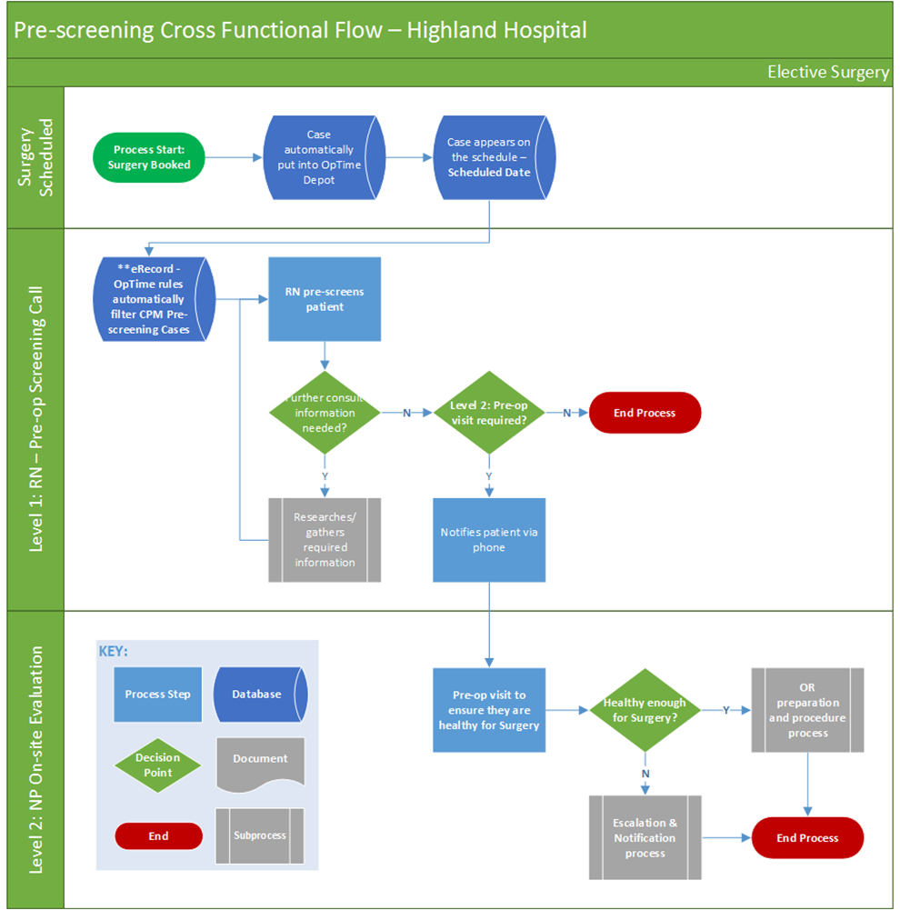

Perioperative Roadshow Intervention

30% of patients screened by surgeon

**Stakeholders of the Perioperative Roadshow Program and Evaluation**

Stakeholders of the Perioperative Roadshow and program evaluation are the same groups, including patients, surgeons, perioperative RNs, HHPSSD personnel, surgical office personnel, and HH Perioperative Director and Manager. The stakeholder analysis displayed in Figure 4 provides information about who the stakeholders are, how much influence they have over the process, and the amount of interest they have in the outcome (Bryson, Patton, Bowen, 2011).

The key stakholders with decision authority over the Perioperative Roadshow program are the “players,” specifically HHPPSD and surgeon office leaders. The program may be strengthened by involving surgeons more directly in the in the PSS process and some point. The perioperative nurisng staff have a large stake in program success in alleviating job related time pressure. Findings from this project may raise greater awareness of the linkages between work environments, system performance, and safe pateint care.

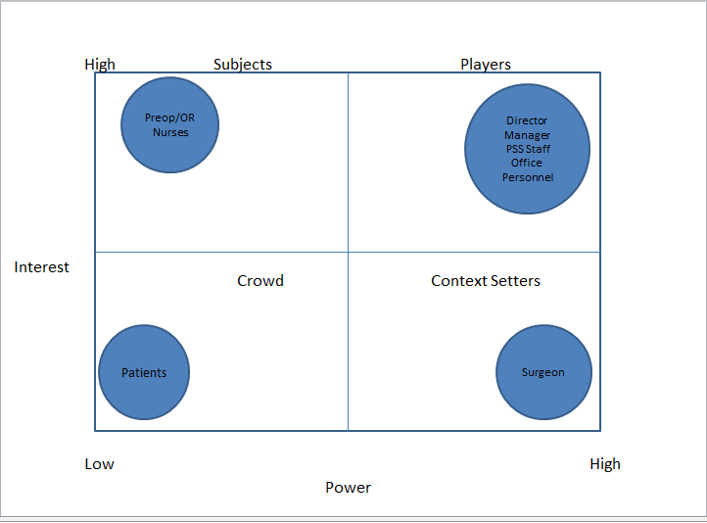

In Table 2, stakeholders are further analyzed as to their particular interest in the program as well as their interest in the evaluation.

Figure 4. Perioperative Roadshow Stakeholder Power versus Interest Analysis

**Table 2**

Perioperative Roadshow Stakeholder Interest in the Perioperative Roadshow Program and Evaluation

|  |  |  |
| --- | --- | --- |
| Stakeholder | Interest in Program | Interest in Evaluation |
| Perioperative Director | Cost Savings, Quality, Patient Experience | Would like to know effects on cost effectiveness, patient experience and quality |
| Perioperative Manager | Cost Savings, Quality, Patient Experience, Staff Satisfaction | Would like to know effects on cost effectiveness, quality, patient experience, and staff satisfaction |
| Presurgical Screening Staff | Cost Savings, Quality, Patient Experience, Staff Satisfaction | Would like to know if intervention is effective and whether or not to continue to direct resources to program. |
| Preoperative RN Staff | Decrease in time pressure/burnout, Quality, Patient safety | Would like to know if program is effective in reducing RN time pressure/burnout |
| Surgical Office Personnel | Quality, Patient Experience, Staff Satisfaction, Surgeon Efficiency | Would be interested to know if delays and cancellations are decreased in order to increase surgeon efficiency and patient satisfaction. |
| Surgeons | Surgeon Efficiency, Patient Experience, Quality | Would be interested in efforts to increase efficiency and quality |
| Patients | Patient Satisfaction, Patient Experience, Quality Care | Would be interested in quality care and experience |

**Evaluation Design**

1. ThePerioperative Roadshow will be evaluated using a mixed-method evaluation design.
2. Quantitative Design and Variables
3. The quantitative elements of the evaluation will be studied using a one group pretest/posttest design. The pretest/posttest design was chosen to eliminate a history threat related to interaction with HHPSSD staff conveying knowledge via phone or email, prior to intervention being implemented (Grembowski, p. 87).
4. The variables measured are as follows:

* + - Surgical delays and cancellations as noted in secondary data via Optime reports
    - Avoidable/unavoidable delays/cancellations will be determined based on information documented in the medical record and clinical judgment
    - Patient or hospital related delays/cancellations will be determined based on information documented in the medical record and clinical judgment
    - Nurses’ time pressure and burnout, as measured by and adapted version of the “Nurse-Experienced Time Pressure, Burnout and Patient Safety Interaction Questionnaire. Survey originated for use in Taiwan, but was reviewed and found to be applicable for use in current program evaluation. Burnout questions modified to include one rating dimension (intensity of feelings) as opposed to both intensity and frequency (Appendix A)
    - Increase in knowledge of surgical office personnel will be assessed by a learning self-assessment developed specifically for the Perioperative Roadshow (Appendix B)
    - Percentage and position of surgeons’ office staff attending the Perioperative Roadshow will be collected by attendance rosters
    - Relevance of the Perioperative Roadshow in meeting the learning need of the surgeons’ office staff will be assessed by program effectiveness survey developed specifically for the Perioperative Roadshow (Appendix B)

1. Qualitative Approaches and Data Collected
   1. Needs Assessment
      * Conversations with high performing surgeon office to identify knowledge gaps in presurgical screening requirements
      * Conversations with perioperative RNs to identify sources of stress and connection to time pressure, burnout and patient safety
   2. Content analysis
      * Learning Self-Assessment details
      * Perioperative Roadshow feedback form
2. The process measures and outcomes are aligned with the Donabedian model and activities to be tracked
   1. Decrease in day of surgery cancellations.
   2. Decrease in day of surgery delays
   3. Decrease in perioperative nurse time pressure and burnout
   4. Increase in surgical office personnel knowledge of PSS requirements

**Methods and Activities**

1. Sample- Target population includes all available:
   1. Perioperative staff- 25 RNs
   2. 50 Surgical offices; the surgical office staff responsible for patient scheduling and pretesting, including secretaries, physician assistants and nurse practitioners where applicable. The actual numbers of targeted staff will be collected on the day the Perioperative Roadshow is provided
2. Baseline data to include:

a) Day of surgery delays and cancellations three months prior to implementation and monthly during intervention

* 1. Patient demographics (Race, marital status, ethnicity, zip code, service line, type of insurance
  2. RN- Experienced Time Pressure, Burnout and Safety Interaction Survey, demographics, and experience

1. Methods to address validity and reliability
   1. Reliability and validity of the RN Experienced Time Pressure, Burnout and Safety Interaction Survey (Appendix A): Items measuring each construct had a Cronbach’s alpha exceeding .79 indicating sufficient reliability. Items measuring each construct had a composite reliability of >.84 and average variance extracted of >.48 indicating that the measures had sufficient reliability (Teng, Shyu, Chiou, Fan, Lam, 2010)
   2. Validity has been established for the office staff learning self-assessment and program effectiveness assessment by experts
   3. Reliability of the office staff learning self-assessment and program effectiveness may be determined at a later time
   4. Please refer to Variable Table (Appendix C) for details on measured variables
2. Costs/benefit of evaluation design:
   1. Program costs will be calculated as PSS staff time to present roadshow, surgeon office staff time to attend, and analyst time for data collection.
   2. Benefit will be estimated as cost of delay and cancellation (e.g., Unused operating room costs estimated at $40-60/minute)

**Data Analysis**

Data collection and database building will begin prior to implementation and continue throughout the duration of scheduled intervention events to surgical office staff (see Table 3, Perioperative Roadshow Data Analytic Table, p. 16).

**Resources and Conditions Necessary for Implementing Evaluation Plan**

Moving forward, a successful implementation of capstone project and time earmarked for PSS personnel to begin educational outreach interventions depends on:

1. A quality needs assessment and data retrieval for most recent three month period necessary prior to moving forward with implementation.
2. Staff necessary to replace PSS the staff performing educational outreach.
3. Funds needed include office supplies to create resource notebooks, as well as funds for food and drinks for during outreach (Provided through PSS budget).

**Limitations**

1. There are confounding factors that contribute to day of surgery delays and cancellations, not related to patient preparedness influenced by proper prescreening, which may contribute to the Perioperative Roadshow outcomes. Plans to overcome the limitations include consulting experts in looking through retrieved data to identify patterns or known behaviors of surgical personnel that might skew data.

**Table 3**

Perioperative Roadshow Data Analytic Table

|  |  |  |  |  |
| --- | --- | --- | --- | --- |
| **Evaluation Question** | **Type of Question** | **Type of Data:**  **Qualitative/Quantitative** | **Description of Data** | **Analytic Method** |
| Q1. Was the Perioperative Roadshow effective in increasing surgeons’ office staff knowledge of PSS requirements? | Process (primary) | Quantitative | Scores on Learner self- assessment completed by program attendees | t-test |
| Q2. What percentage and positions of surgeons’ office staff attended the Perioperative Roadshow? | Process (secondary) | Quantitative | Counts of program attendees | Descriptive statistics, number of participants |
| Q3. Was the Perioperative Roadshow relevant for the surgeons’ office staff (visit assessment)? | Process (secondary) | Quantitative/Qualitative | Scores on post intervention survey plus  three short answer questions completed by program attendees | t-test  Content analysis |
| Q4. Was the Perioperative Roadshow effective in reducing day of surgery delays? | Impact (primary) | Quantitative | Counts of surgical delays (Optime reports) | Descriptive statistics (rate/1000 surgeries)  Descriptive statistics using patient characteristics as co-variates |
| Q5. Was the Perioperative Roadshow effective in reducing day of surgery cancellations? | Impact (primary) | Quantitative | Counts of cancellations (Optime Reports) | Descriptive statistics (rate/1000 surgeries)  Descriptive statistics using patient characteristics as co-variates |
| Q6. Were the day of surgery delays and cancellations avoidable or unavoidable? | Impact (secondary) | Quantitative/Qualitative | Counts of information documented in the medical record and clinical judgment | Descriptive statistics (rate/1000 surgeries)  Descriptive statistics using patient characteristics as co-variates |
| Q7. Were the day of surgery delays and cancellations patient or hospital related? | Impact (secondary) | Quantitative/Qualitative | Counts of information documented in the medical record and clinical judgment | Descriptive statistics (rate/1000 surgeries)  Descriptive statistics using patient characteristics as co-variates |
| Q8. Was the Perioperative Roadshow effective in reducing Preoperative RN time pressure/burnout levels? | Impact (secondary) | Quantitative | Scores on pre/post survey  completed by Preoperative RN staff plus field notes | t-test using RN staff characteristics as co-variates |

**Limitations (continued from p. 15)**

1. Obtaining quality baseline data and ongoing data. Optime reports software is the source of the secondary data. The Optime program went live in May of 2015. There has been an ongoing effort by Erecord/Optime personnel to improve data collection, however there may be an inconsistency in how reasons for delays are labeled within the Optime Reports. Plans to overcome this limitation include time and consulting experts to help identify patterns that might otherwise not be identified as well as contacting and educating nurses responsible for entering comments regarding delays and cancellations into Optime software.

**Dissemination**

1. Once data are analyzed, and results of the evaluation are determined, results will be reported directly to management and administrators of the HH perioperative area.
2. Findings from the program evaluation will inform current policy by using what we learn from the Perioperative Roadshow to adjust how we communicate with surgeon’s offices to improve quality and performance of the prescreening process.
3. Long term plans include publishing results to a nursing or quality improvement journal to share this experience with other interested parties.

**References**

Bader, A.(1999). The preoperative assessment clinic: organization and goals. *Ambulatory Surgery*, *7*(3), 133-138. doi:10.1016/s0966-6532(98)00062-6

Bryson, J.M., Patton, M.Q., Bowman, R.A. (2011). Working with evaluation stakeholders: A rationale, step-wise approach and toolkit. *Evaluation and Program Planning, 34*, 1-12. doi:10.1016/j.evalprogplan.2010.07.001

Donabedian, A. (1988). The quality of care. How can it be assessed? *JAMA: The Journal of the American Medical Association*, *260*(12), 1743-1748. doi:10.1001/jama.260.12.1743

Duffin, C. (2003). Time pressures lead to IV mistakes. Retrieved from https://www.highbeam.com/doc/1G1-100879001.html

Gardner, L.A., & Bomboy, J. (2014). Preoperative screening and the influence on cancellations and transfers: An ambulatory surgical facility collaboration. *Pennsylvania Patient Safety Advisory, 11*, 15-22.

Grembowski, D. (2016). Asking the questions. *The practice of health program evaluation* (2nd ed., p. 51). Thousand Oaks, CA: Sage Publications.

Hall, P. (2005). Interprofessional teamwork: Professional cultures as barriers. *Journal of Interprofessional Care*, *19*(sup1), 188-196. doi:10.1080/13561820500081745

Johns, K. (2004). Reducing avoidable cancellations on the day of surgery. Retrieved from

https://www.isixsigma.com/new-to-six-sigma/dmaic/reducing-avoidable-cancellations-day-surgery/

Knowles, M. S.,Holton, E. F., & Swanson, R. A. (2005). *The adult learner: The definitive classic in adult education and human resource development*. Amsterdam: Elsevier.

Laschinger, H.K.S., & Leiter, M.P. (2006). The impact of nursing work environments on patient safety concerns. *The Journal of Nursing Administration, 36*, 259-267.

Lee, C. S., & Larson, D. B.(2014). Beginner’s Guide to Practice Quality Improvement Using the Model for Improvement. *Journal of the American College of Radiology*, *11*(12), 1131-1136. doi:10.1016/j.jacr.2014.08.033

Macario, A. (2010). What does one minute of operating room time cost? *Journal of Clinical Anesthesia*, *22*(4), 233-236. doi:10.1016/j.jclinane.2010.02.003

Manser, T. (2008). Teamwork and patient safety in dynamic domains of healthcare: a review of the literature. *Acta Anaesthesiologica Scandinavica*, *53*(2), 143-151. doi:10.1111/j.1399-6576.2008.01717.x

Maslach, C., & Jackson, S. E. (1981). The measurement of experienced burnout. *Journal of Organizational Behavior*, *2*(2), 99-113. doi:10.1002/job.4030020205

O'Brien, M. A.,Rogers, S.,Jamtvedt, G., Oxman, A. D., Odgaard-Jensen, J., Kristoffersen, D. T., Harvey, E. (2007). Educational outreach visits: effects on professional practice and health care outcomes. *Cochrane Database of Systematic Reviews*. doi:10.1002/14651858.cd000409.pub2

O'Brien, M. A.,Rogers, S.,Jamtvedt, G., Oxman, A. D., Odgaard-Jensen, J., Kristoffersen, D. T., Harvey, E. (2007). Educational outreach visits: effects on professional practice and health care outcomes. *Cochrane Database of Systematic Reviews*. doi:10.1002/14651858.cd000409.pub2

Reeves, S., Perrier, L., Goldman, J., Freeth, D., & Zwarenstein, M. (2013). Interprofessional education: effects on professional practice and health care outcomes. *Cochrane Database of Systematic Reviews*. doi:10.1002/14651858.cd002213.pub2

Reznick, D., Niazov, L., Holizna, E., & Siperstein, A.(2014). Applying industrial process improvement techniques to increase efficiency in a surgical practice. *Surgery*, *156*(4), 752-759. doi:10.1016/j.surg.2014.06.059

Scoville, R., & Little, K. (2014). Comparing Lean and quality improvement*. IHI White Paper*. Retrieved from Institute of Healthcare Improvement website: http://ihi.org

St. Jacques, P. J., & Higgins, M. S. (2004). Beyond cancellations: Decreased day of surgery delays from a dedicated preoperative clinic may provide cost savings. *Journal of Clinical Anesthesia*, *16*(6), 478-479. doi:10.1016/j.jclinane.2004.07.001

Sullivan,G. M., & Artino, A. R. (2013). Analyzing and interpreting data from Likert-type scales. *Journal of Graduate Medical Education*, 5(4), 541-542. doi:10.4300/jgme-5-4-18

Teng, C., Shyu, Y. L., Chiou, W., Fan, H., & Lam, S. M. (2010). Interactive effects of nurse-experienced time pressure and burnout on patient safety: A cross-sectional survey. *International Journal of Nursing Studies*, *47*(11), 1442-1450. doi:10.1016/j.ijnurstu.2010.04.005

United States Department of health and Human Services. (2016). Plan-Do-Check-Act Cycle | AHRQ National Resource Center; Health Information Technology: Best Practices Transforming Quality, Safety, and Efficiency. Retrieved from https://healthit.ahrq.gov/health-it-tools-and-resources/workflow-assessment-health-it-toolkit/all-workflow-tools/plan-do-check-act-cycle

Van Winkle, R. A., Champagne, M. T., Gilman-Mays, M., & Aucoin, J. (2016). Operating Room Delays. *CIN: Computers, Informatics, Nursing*, *34*(6), 247-253. doi:10.1097/cin.0000000000000233

Whiteside, D. (2016). Perioperative Nurse Leaders and Professionalism. *AORN Journal*, *104*(2), 133-144. doi:10.1016/j.aorn.2016.06.003

Wollak, L. (2013). Day of surgery cancellations -- Are they necessary? *Journal of PeriAnesthesia Nursing*, *28*(3), e24. doi:10.1016/j.jopan.2013.04.074

Appendix A

Perioperative Nurse-Experienced Time Pressure, Burnout, and

Patient Safety Interaction Questionnaire (adapted)

Directions: Please rate each statement as direction in each section:

|  |  |  |  |  |  |  |  |  |  |  |  |  |
| --- | --- | --- | --- | --- | --- | --- | --- | --- | --- | --- | --- | --- |
| **Time Pressure** | **1**  **Never** | **2**  **Almost Never** | | **3**  **Seldom** | **4**  **Sometimes** | | | **5**  **Often** | **6**  **Almost always** | | | **7**  **Always** |
| **Please rate the frequency you relate to the following sentiments:** | | | | | | | | | | | | |
| I feel high time pressure at work. |  |  | |  |  | | |  |  | | |  |
| I feel very busy at work. |  |  | |  |  | | |  |  | | |  |
| I find that the given time at work is very limited. |  |  | |  |  | | |  |  | | |  |
| I always feel in a hurry during work hours |  |  | |  |  | | |  |  | | |  |
| I do not have sufficient time to finish what I should do at work. |  |  | |  |  | | |  |  | | |  |
| **Patient Safety** | **1**  **Never** | **2**  **Almost Never** | | **3**  **Seldom** | **4**  **Sometimes** | | | **5**  **Often** | **6**  **Almost always** | | | **7**  **Always** |
| **In the past year, what was the frequency of the following incidents that involved your clients your yourself?** | | | | | | | | | | | | |
| Patient falls |  |  |  | | |  |  | | |  |  | |
| Medication administration errors |  |  |  | | |  |  | | |  |  | |
| Incomplete or incorrect documentations |  |  |  | | |  |  | | |  |  | |
| Delayed patient care |  |  |  | | |  |  | | |  |  | |
| **Burnout/ Emotional Exhaustion** | **1**  **Never feel this way** | **2**  **Weak** | **3**  **Somewhat Weak** | | | **4**  **Moderate** | **5**  **Somewhat**  **Strong** | | | **6**  **Strong** | **7**  **Very Strong** | |
| **Please rate the strength of your feelings to the following sentiments:** | | | | | | | | | | | | |
| I feel emotionally drained from my work. |  |  |  | | |  |  | | |  |  | |
| I feel used up at the end of the workday. |  |  |  | | |  |  | | |  |  | |
| I feel fatigued when I get up in the morning and have to face another day on the job. |  |  |  | | |  |  | | |  |  | |
| Working with people all day is really a strain for me |  |  |  | | |  |  | | |  |  | |
| I feel burned out from my work. |  |  |  | | |  |  | | |  |  | |
| I feel like I’m at the end of my rope. |  |  |  | | |  |  | | |  |  | |
| I feel I’m working too hard on my job. |  |  |  | | |  |  | | |  |  | |
| **Burnout/**  **Depersonalization** | **1**  **Never feel this way** | **2**  **Weak** | **3**  **Somewhat Weak** | | | **4**  **Moderate** | **5**  **Somewhat**  **Strong** | | | **6**  **Strong** | **7**  **Very Strong** | |
| **Please rate the strength of your feelings to the following sentiments:** | | | | | | | | | | | | |
| I feel I treat some patients as if they were impersonal objects |  |  |  | | |  |  | | |  |  | |
| I’ve become more callous toward patients since I took this job. |  |  |  | | |  |  | | |  |  | |
| I worry that this job is hardening me emotionally |  |  |  | | |  |  | | |  |  | |
| I don’t really care what happens to some patients. |  |  |  | | |  |  | | |  |  | |
| **Burnout/Personal Achievement** | **1**  **Never feel this way** | **2**  **Weak** | **3**  **Somewhat Weak** | | | **4**  **Moderate** | **5**  **Somewhat**  **Strong** | | | **6**  **Strong** | **7**  **Very Strong** | |
| **Please rate the strength of your feelings to the following sentiments:** | | | | | | | | | | | | |
| I have accomplished many worthwhile things in this job. |  |  |  | |  | |  | |  | |  | |
| I deal very effectively with the problems of my patients |  |  |  | |  | |  | |  | |  | |
| I feel I’m positively influencing patients’ lives through my work. |  |  |  | |  | |  | |  | |  | |
| I can easily create a relaxed atmosphere with my patients. |  |  |  | |  | |  | |  | |  | |
| In my work, I enjoy interactions with patients. |  |  |  | |  | |  | |  | |  | |
| In my work, I deal with emotional problems very calmly. |  |  |  | |  | |  | |  | |  | |
| I can easily understand how my patients feel about things. |  |  |  | |  | |  | |  | |  | |
| I have accomplished many worthwhile things in this job. |  |  |  | |  | |  | |  | |  | |
| I deal very effectively with the problems of my patients |  |  |  | |  | |  | |  | |  | |

**Background Information:**

1) Experience:

1. Your current occupation or profession:  RN  Nurse Practitioner
2. Years employed in your current occupation or profession: __________ Years
3. Employment Status: Full-time, Part-time, Other
4. Years at this facility_______________
5. Current job title________________________
6. Years in current position in this facility _________________

2) Education:

1. Highest Education Level

* College Graduate (Associate)
* College Graduate (Baccalaureate)
* Post-Graduate (e.g., MS, MD, PhD)
* Other (specify)___________________________________________________

3) Demographics: (Circle one)

* 1. Age
     + 18 - 29 years
     + 30-39 years
     + 40-49 years
     + 50-59 years
     + 60-69 years
  2. Gender
     + Female
     + Male

**If there is anything else about your work environment that you believe directly affects your level of time pressure, burnout or patient safety, and it was not captured in this questionnaire, please feel free to let us know on this page or on the back.**

**___________________________________________________________________________________________**

**___________________________________________________________________________________________**

___________________________________________________________________________________________

___________________________________________________________________________________________

**___________________________________________________________________________________________**

**___________________________________________________________________________________________**

Adapted from: Teng, C., Shyu, Y. L., Chiou, W., Fan, H., & Lam, S. M. (2010). Interactive effects of nurse-experienced time pressure and burnout on patient safety: A cross-sectional survey. *International Journal of Nursing Studies*, *47*(11), 1442-1450

Appendix B

Perioperative Roadshow Presurgical Screening Program

Visit Assessment and Learning Self-Assessment

**Instructions to Participant:**

Thank you for your participation in the Perioperative Roadshow event. Please respond to all of the evaluation questions below to help us to improve presurgical screening informational materials. In this feedback form, there are no correct answers. We are asking some general information about your background and experience for evaluation purposes only, but you do not need to put your name on this form – your responses are anonymous.

|  |  |  |  |  |  |  |
| --- | --- | --- | --- | --- | --- | --- |
| **For each item below, please circle only a single appropriate response when thinking about the Perioperative Roadshow visit.** | | | | | | |
|  |  | | **RESPONSE** | | | |
|  |  | **NOT AT ALL** | | **SOMEWHAT** | **VERY MUCH** |
| 1. | The visit was well organized. | **0** | | **1** | **2** |
| 2. | The visit was relevant to my needs. | **0** | | **1** | **2** |
| 3. | The presenters were well prepared. | **0** | | **1** | **2** |
| 4. | The presenters were receptive to participant comments and questions. | **0** | | **1** | **2** |
| 6. | There was enough time to cover all materials. | **0** | | **1** | **2** |
| 7. | The information enhanced my knowledge of presurgical screening requirements. | **0** | | **1** | **2** |
| 8. | I expect to use the knowledge gained from this visit. | **0** | | **1** | **2** |

**Please reflect on the information you received and respond to the following:**

1. What new information did you learn that you can apply immediately to your work in preparing patients for surgery?”
2. What part of the visit information was the **least useful** for your work?
3. What information/topics should be added to this roadshow visit?

**Self-Assessment of Learning:** Think about what you already knew and what you learned during this informational session about Highland Hospital Presurgical Screening. Then evaluate your knowledge in each of the following topic areas **Before and After** this session.

|  |  |  |
| --- | --- | --- |
| **1 = No knowledge or skills** | **3 = Some knowledge or skills** | **5 = A lot of knowledge or skills** |

| Before Training | | | | | Self-assessment of Your Knowledge  Related to: | After Training | | | | |
| --- | --- | --- | --- | --- | --- | --- | --- | --- | --- | --- |
| **1** | **2** | **3** | **4** | **5** | Charge Nurse Phone number is 585-233-9982 should be used for any problems or concerns | **1** | **2** | **3** | **4** | **5** |
| **1** | **2** | **3** | **4** | **5** | History and Physicals must be obtained within 30 days of scheduled surgery | **1** | **2** | **3** | **4** | **5** |
| **1** | **2** | **3** | **4** | **5** | EKGS must be obtained within 60 days of scheduled surgery | **1** | **2** | **3** | **4** | **5** |
| **1** | **2** | **3** | **4** | **5** | Required lab tests must be obtained within 40 days of scheduled surgery | **1** | **2** | **3** | **4** | **5** |
| **1** | **2** | **3** | **4** | **5** | Contact information for designated Perioperative Social Worker | **1** | **2** | **3** | **4** | **5** |
| **1** | **2** | **3** | **4** | **5** | Patients are to call 341-6707 Option 1 between the hours of 2pm and 5pm to receive arrival times for surgery. | **1** | **2** | **3** | **4** | **5** |
| **1** | **2** | **3** | **4** | **5** | Process for Nursing home/Group patients who cannot come in for prescreening appointment | **1** | **2** | **3** | **4** | **5** |
| **1** | **2** | **3** | **4** | **5** | Highland Hospital parking information and validation policy | **1** | **2** | **3** | **4** | **5** |
| **1** | **2** | **3** | **4** | **5** | Location of Highland Hospital outpatient pharmacy and operating hours | **1** | **2** | **3** | **4** | **5** |
| **1** | **2** | **3** | **4** | **5** | Information to include on patient’s 975 form if labs are requested | **1** | **2** | **3** | **4** | **5** |

**Background Information:**

1) Experience:

1. Your current occupation or profession: (Circle One)
   * + RN
     + NP/PA
2. Scheduler/Secretary
3. Years employed in your current occupation or profession: __________ Years
4. Employment Status: Full-time, Part-time, Other
5. Years at this facility_______________
6. Current job title________________________
7. Years in current position in this facility _________________

2) Highest Education Level

1. High School Graduate
2. College Graduate (Associate)
3. College Graduate (Baccalaureate)
4. Post-Graduate (e.g., MS, MD, PhD)
5. Other (specify)___________________________________________________

3) Demographics: (Circle one)

* 1. Age
     + 18 - 29 years
     + 30-39 years
     + 40-49 years
     + 50-59 years
     + 60-69 years
  2. Gender
     + Female
     + Male

***Thank you for completing this form!***

***Janet Frost (add title and contact info)***

Appendix C

Variable Table

| Variable | How measured | Data Type | Timing/When Collected | Duration of Measurement | Content | Reliability and Validity | General Concerns | |
| --- | --- | --- | --- | --- | --- | --- | --- | --- |
| **Training** | | | | | | | | |
| Q1. Office staff knowledge of pre-surgical services (PSS) require-ments | Learner self-assessment survey | Primary | Immediately after Roadshow intervention | 10 minutes or less | 9 questions related PSS process | Validity determined by PSS clinical experts. Reliability unknown; may be measured at a later time by test-retest procedures. |  | |
| Q2. Office staff % attendance and position | Counts | Primary | Immediately after Roadshow intervention | 10 minutes or less | * Office staff attending * Total staff needed to attend * Staff position (e.g., PA, NP, Scheduler) | N/A |  | |
| Q3. Perio-perative Roadshow relevance (visit assessment) | Learner visit assessment survey | Primary | Immediately after Roadshow intervention | 5 minutes | 12 questions rating effectiveness of intervention | Validity based on adapting a “gold-standard” education assessment tool. Reliability unknown; may be measured at a later time by test-retest procedures. |  | |
| **System Performance** | | | | | | | | |
| Q4. Number of day of surgery delays related to patient prepared-ness | Optime reports | Second-ary | 3 months prior to initiation of Roadshow intervention and monthly after implemented | Analyst time | Total number of delays filtered by patient preparedness reasons for delay | N/A | Confound-ing factors may be difficult to identify if data not entered correctly into E-Record. | |
| Q5. Number of day of surgery cancellations related to patient prepared-ness | Optime reports | Second-ary | 3 months prior to initiation of Roadshow intervention and monthly after implemented | Analyst time | Total number of delays filtered by patient preparedness reasons for delay | N/A | Confound-ing factors may be difficult to identify if data not entered correctly into E-Record. | |
| Q6. Delays and  cancellations avoidable/  unavoidable | Counts | Second-ary | 3 months prior to initiation of Roadshow intervention and monthly after implemented | Analyst time | Medical record and clinical judgment categorizing related to PSS accuracy and completeness | N/A | Confound-ing factors may be difficult to identify if data not entered correctly into E-Record. | |
| Q7. Delays and cancellation patient or hospital related | Counts | Second-ary | 3 months prior to initiation of Roadshow intervention and monthly after implemented | Analyst time | Medical record and clinical judgment categorizing related to PSS causal factors | N/A | Confound-ing factors may be difficult to identify if data not entered correctly into E-Record. | |
| **Professional Workforce** | | | | | | | | |
| Q8. RN time pressure and burnout | Nurse-Experienced Time Pressure, Burnout and Safety Interaction Questionnaire | Primary | 1 Week Prior to Roadshow  Interventions and  1 month after completion of initial 6 Roadshow visits | 10 minutes or less | 5 Domains   * Time Pressure * Patient Safety * Burnout/Emotional Exhaustion * Burnout/Depersonalization * Burnout/Personal Achievement   29 individual items rated on a scale of 1 (never)-7(always). | Items measuring each construct had a Cronbach’s alpha exceeding .79 indicating sufficient reliability. Items measuring each construct had a composite reliability of >.84 and average variance extracted of >.48 indicating that the measures had sufficient reliability  Teng, C., Shyu, Y. L., Chiou, W., Fan, H., & Lam, S. M. (2010). | | Tool was reviewed and deter-mined appropriate for use without modification. Original tool was developed in Taiwan for use in studies in that country. |
| **Target Population/Covariates** | | | | | | | | |
| Patient Demo-graphics/ Character-istics | McKesson Star Navigator | Second-ary | 3 months of baseline data then monthly after implemented |  | Gender  Age  Marital Status  Race  Ethnicity  Religious Denomination  Zip code  Surgery Service | N/A | Confounding factors may be difficult to identify if the data are not entered correctly into the Electronic Record. | |
| RN Staff Demo-graphics/ Character-istics | Demographic section, survey | Primary | 1 months prior, I month following implemented | 10 minutes or less | Experience, education, demographics | N/A |  | |