Executive Summary

* Project Name: Medical-Surgical Charge Nurse Orientation and Reference Binder
* Definition: This project is a four to six hour charge nurse orientation class specific to the Medical-Surgical service, complete with skills demonstrations, learning activities, and educational information related to charge nurse duties.
* Program Purpose: To create highly skilled and competent charge nurses that demonstrate exceptional leadership and critical thinking skills.
* Why: Currently, new charge nurses at SMH participate in a general orientation to the charge nurse role, but there is no formal service specific charge nurse orientation, resulting in inconsistencies in charge nurses’ practice and in some instances misunderstandings of service specific standards, policies, and procedures.
* Who: Level 2 or higher nurses who qualify for the charge nurse position
* Where: Strong Memorial Hospital, an 830 bed academic medical center located in Rochester, NY providing patient-centered care to the Upstate NY community.
* What: Educational PowerPoints, interactive role playing, and a code simulation. The theoretical basis for orientation and reference binder is the Social Cognitive Theory, widely used to guide the development, implementation, and evaluation of education programs in nursing. Using this theory learning experiences in the charge nurse orientation are based off of observation, imitation, and positive reinforcements
* When: The first Medical-Surgical charge nurse orientation class will be summer 2017
* Outcomes: Resulting from the orientation program, charge nurses will demonstrate effective communication, conflict management skills, increase staff satisfaction and reduce charge nurse stress.

Program Evaluation and Description:

* Program Description
  + The Medical-Surgical Charge Nurse Orientation and Reference Binder Program is a four to six hour interactive workshop designed specifically for the Strong Memorial Hospital Medical-Surgical nursing service, complete with skills demonstrations, learning activities, and educational information related to charge nurse duty responsibilities. There will also be reference binders created and provided to each unit that include Medical-Surgical service specific policies, procedures, and charge nurse resources
  + Nurses targeted to attend the program, include nurses at Level II or higher on the career advancement system, who have not been previously oriented to the charge nurse role.
  + Other populations that will benefit from the creation of a charge nurse orientation include: the medical-surgical service, medical-surgical units, nurse managers, nurse leaders, current charge nurses, staff nurses, and most importantly, patients and their families by having competent charge-oriented nursing staff.
* Social Cognitive Theory
  + There are four steps to the modeling process that is described by Bandura in the social cognitive theory: attention, retention, reproduction and motivation. Bandura states that "the observational learning could not be processed unless the cognitive process was also at work" (McLeod 2011).
  + The first stage of the theory is attention, this stage describes when we as humans are first exposed to a behavior and the resulting observations we have based on this exposure. The attention stage is significant because it will give us an idea of how important a behavior is to an individual and determines their resulting imitation of that behavior. In this stage of the learning process, the participants of the charge nurse orientation will be introduced to each skill: conflict management, communication, code simulation, and stress management.
  + Although the individual may be exposed to a behavior and pay attention to another individual's behavior, they may not retain the behavior, an important step in the social cognitive theory. This behavior must be retaining in order for the individual to imitate it in the future. Therefore, in the learning activities, there will be an open forum for discussion and additional educational opportunities for nurses to further their education on specific skills.
  + The third stage of the social cognitive theory is reproduction, which is the ability for the individual to replicate the behavior based on retention from the earlier steps. Even though we may see a behavior, it may not mean the behavior is important enough to an individual to imitate, or even able to replicate based on physical ability or cognitive ability. In this third stage, the charge nurse orientation will allow for role-playing of crucial conversations, code demonstrations as well as interactive skills demonstrations, to help the skills become habits.
  + The final stage of the theory is motivation, or the will to perform the behavior. In this stage, the individual decides if the behavior is one that comes with rewards or punishments as reviewed by the observer from previous experiences and retention. If the rewards outweigh the consequences the behavior will most likely be imitated by the individual. This fourth stage is demonstrated in positive interactions between charge nurses and patients, as well as with other staff. The charge nurses may show an increase in satisfaction as well as a decrease in stress (Bandura 2001).
  + The program theory was identified with my preceptor Laurel as a theory that would be applicable to my charge nurse orientation and resource binder. This theory is rooted in the fact that behavior is learned through observation, imitation, and positive reinforcements. With that being said, I am planning on creating my program based on this theory of observation, imitation, and positive reinforcement. The new charge nurses will receive education on the charge nurse role including: PowerPoint presentations, code demonstration, leadership skills, crucial conversation role playing, as well as roles and responsibilities of the charge nurse. The nurses will see this educational opportunity as a way to broaden their experience, and rewarding, and thus based on the social cognitive theory, replicate their learning and apply their new skills to the charge nurse role. Through positive interactions with both staff and patients, charge nurses find themselves with positive reinforcements, creating a conducive environment for development and replication of skills (Alaikbari 2015).
  + The social cognitive theory has been used in the field of nursing in several different contexts, through both patient interaction and nurse education. For example, in a study by Whitehead in 2001, the social cognitive theory was used to demonstrate the adoption of behavioral changes more realistic. In another study by Graves, the social cognitive theory was used as the framework to improve quality of life outcomes in implementation of interventions with cancer patients.
  + See appendix A for social cognitive theory model as it relates to the charge nurse orientation
* Goal: The goal of this capstone project is to create competent Medical-Surgical charge nurses at Strong Memorial Hospital through an orientation specific to the Medical-Surgical service, that integrates the social cognitive theory to educate Level II or higher nurses in the career advancement system. The orientation goal is to create charge nurses that are competent in conflict management, communication, code demonstration, stress management, and staff satisfaction.
* Nurses will be exposed to charge nurse knowledge and skills including conflict management, communication, codes, and stress management. They will then be provided with opportunities to retain these behaviors including discussion, PowerPoints, and simulation to further retain these behaviors. The nurses will be rewarded for successfully enacting the charge nurse orientation through interactions with patients and staff.
* Objectives: The foundations of this program, named the Medical-Surgical Charge Nurse Orientation and Resource Guide, are loosely based on the competencies of the previous online education, as well as current evidence found in evidence-based nursing journals. The program will focus on a four hour charge nurse orientation class specific to the Medical-Surgical service, complete with skills demonstrations, learning activities, and educational information related to charge nurse duties that is evidence-based. There will also be resource binders created and provided to each unit including Medical-Surgical service specific policies, procedures, and charge nurse resources. Each unit will then be responsible for adding additional pages to their binders related to unit specific charge nurse duties.
* See Appendix B for outcome measurements
* Evaluation Questions: 1.) What are the essential competencies of a Medical-Surgical nurse to current charge nurses, and nurse managers? 2.) Did the Medical-Surgical charge nurse orientation reduce charge nurses’ stress? 3.) Did the Medical-Surgical orientation increase staff satisfaction? 4.) Were the charge nurses able to achieve competency in conflict management? 5.) Are the charge nurses competent in communication? (see Appendix C)
* Program activities:
  + 3 focus groups held with four charge nurses to see what information is integral to Medical-Surgical charge nurse orientation
  + Baseline survey given before MyPath education to acquire baseline data on competency levels of communication, conflict management, as well as baseline levels of stress and satisfaction
  + Online MyPath education to be completed before future charge nurses attend Medical-Surgical charge nurse orientation.
  + Four to six hour Medical-Surgical charge nurse orientation – PowerPoint presentations, crucial conversations, code demonstrations and role playing
  + Post-survey to be taken 6 month after orientation (OSCE, Charge Nurse Stress Questionnaire).
  + Future goal for charge nurses who have attended the program to “give back” and teach in the program.
* Program results:
  + Focus group results:
    - Excellent communication skills, knowing their resources, clinical competency, stress management, flexibility, ability to make quick decisions
  + Impact Questions: will not have the answers to until capstone/graduation
* Longevity: The current education for charge nurses at Strong Memorial Hospital is a brief online MyPath orientation that reviews conflict management, communication, service recovery, and delegation, leadership, and stress management. The assistant associate medical director determined a need for an in person charge nurse orientation due to inconsistencies in training techniques and expectations, and asked if I would be interested in completing this project for my capstone. This will be a creation of a completely new project for level two nurses who are ready to be oriented to the charge nurse role.
* Logic Model (see appendix D)
  + Inputs: Funding, technology, staff, trainers
  + Outputs: Program planning, stakeholder analysis, pre-training activities, administration of baseline evaluation surveys, program
  + Outcomes: includes short, medium and long term goals
* Rationale for Program Evaluation Plan:
  + The program evaluation plan is necessary to see if there are improvements made in charge nurse levels of competencies, skills, conflict resolution and leadership development
  + The Journal of Nursing Management article written in 2015 by Admi states: “The positive impact of formalized charge nurse training” described a hospital in Texas in which charge nurses are often promoted with little or no formal charge nurse orientation. A unit is designed as the pilot for a forty hour charge nurse orientation class, divided into five 8 hour classes, which included visual, audio and kinesthetic learning tools for nurses. The article also provided several competencies including: self-assessment, leadership, coaching, shared governance, patient safety, beyond the bedside, and regulations and requirements.
  + From the *Nursing Economics Journal,* a 2008 article entitled “Factors influencing work productivity and intent to stay in nursing” Letvak and Buck state that nursing management must place efforts on decreasing nursing stress in the workplace, and improvements to be made on nurses’ ability to provide care, which can lead to increased job satisfaction. This is of note, since a charge nurse orientation will be implemented to help improve patient quality of care and support charge nurses through stressful situations, which the article has shown to be a detractor of the nursing profession.
  + The 2003 article, “Charge nurse leadership development and evaluation,” from the *Journal of Nursing Administration”* by Krugman and Smith, developed a permanent charge nurse role, and performed a research study to evaluate the outcomes of the program. Overall, they found that those who were charge nurse oriented found themselves to have a higher job satisfaction rate, and described themselves as having leadership qualities than staff nurses. The article continues on to perform a literature review of several articles outlining the role of the charge nurse and competencies required for successful charge nurse orientation.
  + See stakeholder chart in appendix E for evaluation needs
  + Stakeholders include: Charge Nurses, Patient and Families, Medical-Surgical Staff Nurses, Associate Directors, Nurse Leaders, Nurse Managers, and Chief Nursing Officer
* What do the customers/organization want to understand?
  + Program outcomes:
    - Did the charge nurses gain competency in communication, conflict management and code demonstration?
    - Are the charge nurses less stressed?
    - Are the charge nurses more satisfied with their jobs?
* Evaluation Context:
  + Information about where the program is located
    - Strong Memorial Hospital- has a budget of almost $2 billion dollars, 830 bed academic medical facility that is a teaching hospital in Rochester NY, and serves the greater upstate NY area. The adult medical-surgical service includes 218 (short stay unit with 20 private beds), 516 (neurology unit with 23 beds), 612 (acute medicine unit with 23 beds), 434 (solid organ- liver and kidney transplant with 25 beds), 534 (orthopedics with 25 beds), 614 (acute medicine with 26 beds), 512 (rehab unit with 20 beds), 536 (neurosurgery with 24 beds), 634 (acute medicine with 23 beds), 514 (acute medicine with 24 beds), and 636 (trauma and colorectal with 24 beds).
* Relevance of the program to organization, local, state, or federal issues
  + - The Joint Commission standard that my capstone project embodies is the standard HR 01.04.01, a standards that holds hospitals accountable for orienting staff to cultural diversity, patient safety, hospital wide policies, patients’ rights and ethical issues. The second standard my capstone project helps meet is HR 01.05.03 that holds hospitals accountable for staff participation in ongoing education and training. My proposed project will meet both of these Joint Commission standards since it will continue on the education nurses received in hospital orientation as they continue to advance their careers as charge-oriented nurses. In the charge nurse orientation, Strong Memorial Hospital Medical-Surgical nurses will receive information on cultural diversity, policies, and how to resolve conflicts, all which meet Joint Commission standards.
* Stakeholders of the program and evaluation
  + Key stakeholders in the project include: current charge nurses, future charge nurses, patients and their families, medical-surgical staff nurses, nurse leaders, nurse managers, associate medical-surgical directors, and the chief nursing officer
  + See appendix
* Evaluation Design
  + Mixed-Method with Pre/Post Survey
  + Content analysis of interviews and focus groups
  + Single site evaluation
  + Measures-measurement table-see appendix
    - Clinical Competency: Conflict management measured by objective structured clinical examination
    - Clinical Competency: Communication, measured by objective structured clinical examination
    - Clinical Competency: Code demonstration, measured by objective structured clinical examination
    - Clinical Competency: Stress management, measured by charge nurse stress questionnaire
    - Clinical Competency: Staff satisfaction, measured by index of work satisfaction and nurses’ comments
* Methods/Activities
  + Sample size
    - Focus Group: Three focus groups with four members
    - First charge nurse orientation: expected 30 nurses
  + Data collection methods (see appendix)
  + Methods to address validity: keeping evaluation questions exactly the same for each survey
  + Anticipated costs
    - To measure the economic implications of the budget of my project, firstly I would think about the resources needed to run the focus group. I would hold the three groups at lunch in order to catch them during work time. Secondly, I would use resources already provided by the University of Rochester, their code simulation equipment, PowerPoint screen, as well speakers from the University of Rochester in order to keep costs at a minimum. I would be able to budget the amount the class would cost the hospital to pay each of these employees based on the four hours they would be in the class session. The binders could be purchased through the Medical-Surgical service and print outs could be completed at the hospital. In terms of the sustainability of the program, I would continue to run this program every six months in order to educate new charge nurses to the role, and to maintain enough participation in the program. There are currently some benchmarks and comparative norms in the literature that I will be comparing my sustainability of my project to (Letvak 2008).
* Length of evaluation
  + - * Focus groups: one to two weeks
      * Pre-test and MyPath educational information: one month before class starts
      * Post-survey: 6 months after medical-surgical orientation
* Resources and Conditions Necessary for Implementing Evaluation Plan
  + What is needed to move evaluation forward
    - Approval of surveys
    - Program staff support-Unit managers to nominate appropriate persons for promotion to charge nurses
    - Medical-Surgical first orientation class to take place in summer 2017
  + What financial, material, and human resources are needed?
    - The orientation class will take place in an educational room at Strong Memorial Hospital, off of the units, as to not have any distractions in the learning setting. As stated above, there will be skills demonstrations (chest tubes, trachs, etc.), PowerPoint slides with charge nurse relevant information, as well as a code simulation with specifics relating to the charge nurse role in a code situation. The reference guide, created with information based on the charge nurse orientation, as well as a quick guide for resources around the hospital will be placed at the nurses’ station on each unit. The class will be provided for nurses two times a year, and those attending the orientation will be based on managers’ discretion for role readiness.
* Limitations
  + Limitations of the program evaluation plan
    - Keeping evaluations consistent, as well as focus groups
    - How to evaluate those nurses who may have already had a charge orientation on their own unit.
* Dissemination
  + Plans for communicating and utilizing evaluation findings
    - Associate Medical Director-Medical-Surgical nurse manager meetings and nurse leader meetings can relate evaluation survey findings and success and/or suggested improvements to be made to program
  + How will program inform policy?
    - Will use evaluation plan to improve program in the future & create better classes.

References

Admi, H., & Eilon-Moshe, Y. (2016). Do hospital shift charge nurses from different cultures experience similar stress? An international cross sectional study. *International Journal of Nursing Studies*. 63 48-57.

Alaikbari, F., Parvin, N., Heidari, M., & Haghani, F. (2015). Learning theories application in nursing education. *Journal of Education and Health Promotion, 4*(2), 1-13.

Bandura A. (1986). *Social foundations of thought and action: A social cognitive theory*. Englewood Cliffs, NJ: Prentice-Hall.

Bandura, A. (2001). Social Cognitive Theory: An Agentic Perspective. *Annual Review of Psychology.* 52: 1-26. doi: 10.1146/annurev.psych.52.1.1

Graves, K. (2003). Social cognitive theory and cancer patients' quality of life: A meta-analysis of psychosocial intervention components. 36:3 417-425. *Health Psychology.*

Muffler, A. & Merrill, K. (2014). Charge Nurse Levels of Stress: A Baseline Assessment. *Journal of Undergraduate Research.* Retrieved from: <http://jur.byu.edu/?p=14759>

Letvak, S., & Buck, R. (2008). Factors influencing work productivity and intent to stay in nursing. *Nursing Economics.* 26(3) 159-165.

Whitehead, D. (2001). A social cognitive model for health education/health promotion practice. *Informing Practice and Policy* *Worldwide through Research and Scholarship.* doi:10.1046/j.1365-2648.2001.01973.

Appendix A

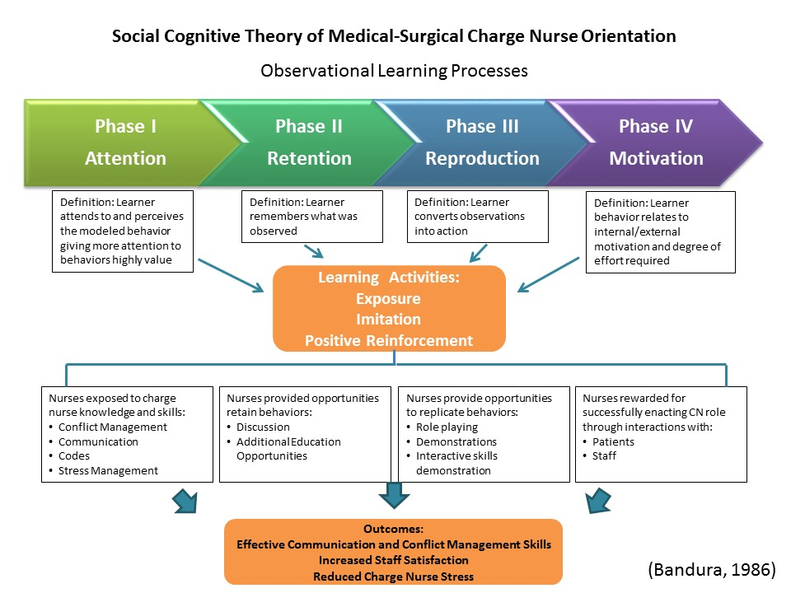

Appendix B – Measurement Table

Measurement Table – Charge Nurse Orientation

|  |  |  |  |  |  |  |
| --- | --- | --- | --- | --- | --- | --- |
|  | **How Measured** | **Data Type and Source** | **Duration of Measurement** | **Content** | **Reliability and Validity** | **General Concerns** |
| **Clinical Competency**  **Conflict Management** | Objective structured clinical examination | Primary data, survey | Post-test after orientation class | 28 statements on a 5-point Likert scale measuring 5 independent dimensions | Adequate reliability and validity  -Survey already used |  |
| **Clinical Competency**  **Communication** | Objective structured clinical examination | Primary data, role playing | During nursing orientation | Role playing with feedback from educators | Substantial evidence to high degree of validity and reliability |  |
| **Clinical Competency Code Demonstration** | Objective structured clinical examination (OSCE) | Primary data, demonstration | During nursing orientation | Skills demonstration with role playing of code in charge nurse role  -Social Cognitive Theory: Replication of actions performed by model | Validity-substantial evidence OSCE can be used to effectively assess a wide variety of competencies  Reliability-trained peers can accurately assess healthcare provider performance | Takes time and resources |
| **Clinical Competency Stress Management** | Charge nurse stress questionnaire (Admi &Moshe-Eilon, 2010 Nursing Economics) | Primary data, survey | Post-test after charge nurse orientation | 59 question assessment on aspects of stress using 5 point Likert scale  -Second part includes demographics | Validity and reliability: previously created survey, high degree of validity and reliability |  |
| **Staff Satisfaction** | Index of Work Satisfaction & Nurses’ comments | Prima data, survey | Pre-test and Post-test before and after nursing orientation | Survey with nursing comments to provide a nurse-sensitive quality indicator data | Validity and reliability are high due to a previously created survey | Able to see job satisfaction and their reactions |

Appendix C – Data Analytic Methods Table

|  |  |  |  |  |
| --- | --- | --- | --- | --- |
| Evaluation Question | Type of Question | Type of data: qualitative  Or quantitative | Description of Data | Analytic Method |
| What are the essential competencies of a Medical-Surgical charge nurse? | Process/Formative Evaluation | Qualitative | Focus groups-current charge nurses  Interviews-Nurse managers and CRNs | Content Analysis |
| Did the Medical-Surgical charge nurse orientation reduce charge nurses’ stress | Impact (Medium/Long) | Quantitative | 5 point Likert scale on aspects of stress-Charge Nurse Stress Questionnaire | Post-test  - Paired T-test (comparison of baseline and outcome scores) |
| Did the Medical-Surgical charge nurse orientation increase staff satisfaction? | Impact | Quantitative | Index of work satisfaction | Pre-test and Post-test  -Paired T-test (comparison of baseline and outcome scores) |
| Were the charge nurses able to achieve competencies in conflict management? | Impact | Qualitative | Objective Structured Clinical Examination (OSCE) | Post-test after orientation  -T-test |
| Are the new charge nurses able to competently communicate? | Impact | Qualitative | Objective Structured Clinical Examination (OSCE) | Content Analysis |

Appendix D

**Program: Medical Surgical Charge Nurse Orientation and Resource Guide**

Situation: Currently, new charge nurses at SMH participate in a general orientation to the charge nurse role, but there is no formal service specific charge nurse orientation. This situation has resulted in inconsistencies in charge nurses’ practice and in some instances misunderstandings of service specific standards, policies, and procedures.

Program Goal: Improve CN preparation for their role by developing and teaching a four to six hour charge nurse orientation class specific to the Medical-Surgical service.

|  |  |  |  |  |  |  |  |  |
| --- | --- | --- | --- | --- | --- | --- | --- | --- |
| **Inputs**  **(What we invest)** |  | **Outputs**  **(What we do and who we do it to )** | |  | **Outcomes – Impact**  **(The incremental events/changes that occur as a result of the outputs)** | | | |
|  | *Activities* | *Participation* |  | *Short* | *Medium* | *Long* | |
| -Funding- money needed for both the program to run and to send charge nurses to orientation  -Technology- Need computers available for PowerPoint presentation, code demonstration.  -Staff- Level 2 or higher nurses who are ready to be oriented to the charge nurse role.  -Trainers-Staff who are running the charge nurse orientation (will be Laurel Pye, RN- Assistant Associate Medical Director) |  | **Program Planning:**  -Needs and Resource Assessment  -Literature Review- recent studies that provide support and supplement evidence based practice for charge nurse orientation  -Identify stressors and barriers to education  -Review of current online MyPath education  **Stakeholder Analysis:**  -Gathering interest in program through Nurse Managers and current charge nurses  -Action Planning: focus group with previous charge nurses to gather baseline data (3 focus groups with 4 nurses in each)  -Interview Nurse Managers and CRN to gather information on their “perfect charge nurse”  **Pre-Training Activities:**  -Online MyPath training  **Administration of Baseline Evaluation Surveys:**  -Evaluation of new nurses: pre-test and post-test  **Program:**  -Four to six hour Medical-Surgical charge nurse orientation | **Stakeholders:**  -Current charge nurses  -Future charge nurses (level 2 or higher)  -Assistant Associate Medical-Surgical Director  -Patients & their families  -Unit Educators  -Nurse Leaders |  | -By spring 2017, the stressors for charge nurses on the Medical-Surgical unit will be identified  --By summer 2017, new charge nurses will have access to the online education through MyPath  -By summer 2017, all new charge nurses will begin the charge nurse orientation as they become eligible for the promotion (level 2 or higher nurses)  -By summer 2017, the charge nurse binder will be available to use as a reference for medical-surgical units | -By completing the charge nurse Medical-Surgical orientation, charge nurses will be clinically competent in conflict management  -OSCE  -Charge nurses will be clinically competent after the charge nurse orientation in communication and code demonstration (measured using the OSCE)  -New charge nurses will take a post-evaluation about the charge nurse orientation that gives qualitative data on program improvements | | -In the year after the charge nurse orientation, nurses will see an improvement in charge nurse satisfaction (index of work satisfaction and nurse comments)  -In the year following the charge nurse orientation, the nurses will see an improvement in charge nurse stress (Charge nurse stress questionnaire)  -In the years following the implementation of the Medical-Surgical charge nurse orientation, charge nurses completing the program will “give back” by teaching in future charge nurse orientation programs |

|  |  |  |
| --- | --- | --- |
| **Assumptions** |  | **External Factors** |
| New level 2 nurses will be open to participation, funding will be adequate and resources for classroom education will be available. | -Job changes-relocated, terminated, etc. may skew data |

Appendix E

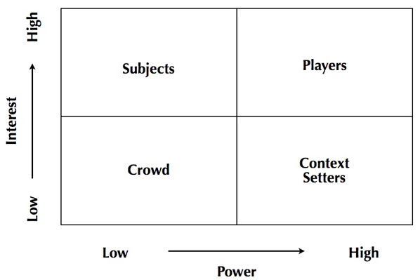

Charge Nurses

Patients & Families

Med-Surge Staff Nurses

Associate Directors 

Nurse Leaders 

Nurse Mangers 

Chief Nursing Officer

Appendix F

|  |  |
| --- | --- |
| **Stake or Interest in the Program:** | **Stake or Interest in the Evaluation:** |
| Charge Nurses   * Improve clinical skills, communication, increased confidence, more resources | Charge Nurses   * Improvement in clinical course and resources to further improve their education |
| Patients and families   * Receive evidence based continuity of care, resources available at all times of the day-situations deescalated | Patients and Families   * Continuously benefitting from program improvement through constant evaluation and implementation improvements. |
| Med-Surge staff Nurses   * Charge nurses with increased knowledge, resources, and education to improve staff education & care provided | Med-Surge staff nurses   * Not a lot of interest in evaluation of process, since they are not able to attend the charge nurse class, however they are benefitting from results of evaluation |
| Associate Med-Surge Directors   * Large interest in the program, in charge of implementation of program & continued success of program | Associate Med-Surge Directors   * Also large interest in evaluation and feedback of program to restructure to make improvements and ensure continued success of program |

|  |  |
| --- | --- |
| **Stake or Interest in the Program:** | **Stake or Interest in the Evaluation:** |
| Nurse Leaders   * Interest in program-well educated charge nurses able to deescalate situations previously left for NL | Nurse Leaders   * Slight interest in evaluation process-should be charge nurses as well so are learning from classes/resources |
| Med-Surge Nurse Managers   * Also interested in program so staff members are more educated, and charge nurses are able to cover difficult situations that are usually recovered by NM & NL | Med-Surge Nurse Managers   * Also slightly interested in the improvement process to make improvements in charge nurse role to unit |
| Chief Nursing Officer   * Interested in program-however may not show great interest in program until results are shown through the evaluation process | Chief Nursing Officer   * Most interested in evaluation and success of program-may become more interested in funding of program once success is shown. We were already orienting charge nurses, why the increase in funding for a new program? |