Dec. 3, 2017 9:00 a.m. ET

Alexandra Wexler

**Supermarket Chain’s Collapse Shows Perils of Africa’s Hottest Retail Market**

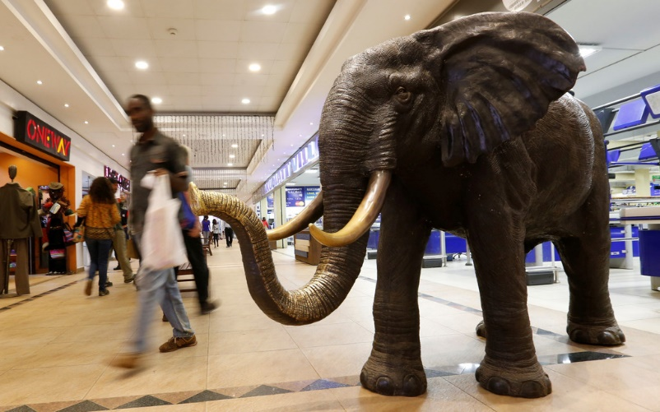Malls have opened at a blistering pace across Nairobi over the past three years, but many of them have struggled to fill space. PHOTO:THOMAS MUKOYA/REUTERS

NAIROBI, Kenya—The near-empty shelves and deserted aisles at a sprawling outlet of Kenya’s homegrown supermarket giant, Nakumatt Holdings Ltd., here are reminders of the risks—and opportunities—presented by East Africa’s biggest retail market.

The family-run retailer was once emblematic of the “Africa Rising” narrative of a rapidly growing urban consumer class and local champions outmaneuvering larger, foreign competitors. At its height in 2014, Nakumatt took over the Tanzanian stores of South Africa-based [Shoprite Holdings](http://quotes.wsj.com/ZA/XJSE/SHP) Ltd. [SHP -0.80%](http://quotes.wsj.com/ZA/XJSE/SHP?mod=chiclets), the continent’s largest retailer.

Then in late October, Nakumatt filed for bankruptcy after a series of ill-fated decisions including the introduction of a private label line, an overreliance on unsecured, short-term debt that dried up after the collapse of three Kenyan banks, and other events including floods and a terrorist attack.

The chain’s demise illustrates the challenges faced by multinational retailers trying to build a presence here. Companies from French retail giant [Carrefour](http://quotes.wsj.com/CRRFY) SA to Wal-Mart Stores Inc.’s [Massmart Holdings](http://quotes.wsj.com/ZA/XJSE/MSM) Ltd. [MSM 1.72%](http://quotes.wsj.com/ZA/XJSE/MSM?mod=chiclets), have grappled with how to gain and maintain a foothold in one of Africa’s most mature consumer markets while navigating the operating and financing pitfalls.

Those challenges deepened in recent months: The International Monetary Fund cut its growth forecast to 5% from nearly 6% amid the [prolonged political turmoil](https://www.wsj.com/articles/tribal-tensions-flare-after-kenya-vote-1509313518) following the [annulment of Kenya’s August presidential elections](https://www.wsj.com/articles/kenya-supreme-court-nullifies-election-calls-for-new-vote-1504260050) and October’s [court-ordered repeat vote](https://www.wsj.com/articles/kenyas-president-re-elected-in-controversial-repeat-vote-1509376908).

Still, with a largely English-speaking population of 48 million, Kenya remains an attractive target for retailers, according to analysts and retailers. They say Nakumatt’s downfall created an opening for multinationals looking to gain entrance—or increase their presence—in Kenya’s retail market, which market-research firm Euromonitor International values at around $12.35 billion.

Carrefour is in the process of taking over two of Nakumatt’s outlets, its third and fourth Kenyan stores in under two years. The French chain’s local franchisee, Dubai-based holding company Majid Al Futtaim Holding LLC, said it continues to seek opportunities to open additional stores in Kenya.

Fertile LandKenya presents an attractive but risky opportunity for large retail multinationals.Retail market size, in billionsTHE WALL STREET JOURNALSource: Euromonitor International

South AfricaNigeriaKenyaTanzaniaUgandaRwanda$0 billion$5$10$15$20$25$30$35$40$45$50$55$60$65Nigeriax$42.40 billion

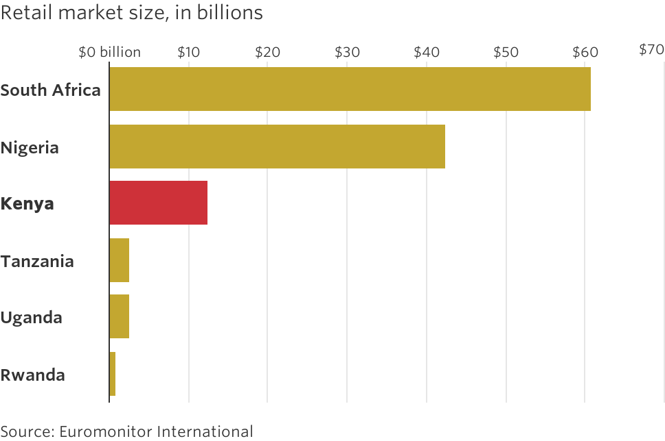

Massmart opened one outlet of its general merchandise and food retailer Game in 2015, and said it doesn’t currently have a second Kenyan store planned. One stumbling block has been a lack of visitors to the mall where Massmart’s store is situated.

“With the proliferation of new malls and multiple international retailers entering Nairobi, consumers are now spoilt for choice,” said Richard Fuller, Game Africa director. “Our biggest challenge with only having one store in the city for now, was to create mass awareness of the Game brand and generate a vast pull factor to get Kenyans to travel from far to our store.”

Malls have opened at a blistering pace across Nairobi over the past three years, but many of them have struggled to fill space.

“The local retailers couldn’t handle the cost of opening multiple branches in those centers within a fairly short period of time,” said Nicholas Corbishley, head of Africa investments at Old Mutual Property, a South African real-estate developer, which is a 50% shareholder in Nairobi’s Two Rivers Mall.

That shouldn’t pose such a challenge for deeper-pocketed multinational retailers, which have access to cheaper financing than a purely homegrown company and can pay more for the prime locations.

Shoprite, which operates some 2,700 stores across Africa, has no presence in Kenya—yet. Analysts say they expect the South African retailer to take over some of Nakumatt’s current stores. Shoprite said it has no confirmed plans for Kenya, but told The Wall Street Journal it “is ready to enter the market if suitable premises become available.”

Analysts say more-specialized stores, such as grocery-focused Carrefour, could be more attractive to Kenya’s growing and increasingly sophisticated middle class, than Nakumatt’s catchall stores where lawn mowers and wedding dresses could be purchased in one place.

Multinationals still will have to deal with the business interruptions faced by Nakumatt, from the recent election-related violence to terrorist attacks to getting goods out of Kenya’s notoriously slow Mombasa port.

Kenyan consumers also can be fiercely loyal to local favorites, a preference that has tripped up foreign consumer companies in the past.

About two decades ago, South African Breweries Ltd.—now part of Anheuser-Busch InBev—entered the Kenyan beer market, sparking what the local media dubbed “the beer wars.” East African Breweries Ltd., which produces Kenya’s No. 1 and No. 2 beers by market share and was acquired by Diageo in 2000, cut costs and spent more on marketing, appealing to Kenyan’s strong sense of nationalism with the slogan for its most popular beer, Tusker: ‘’My country, my beer.’’

SAB eventually pulled out of the Kenyan market.

“You have to take a relatively long-term view,” said Chris Newson, director of private markets at Investec Asset Management in London.

Despite the challenges, “[Local companies] are tough competitors. You have to find a way to be local.”

**Write to**Alexandra Wexler at [alexandra.wexler@wsj.com](mailto:alexandra.wexler@wsj.com) and Matina Stevis-Gridneff at [matina.stevis@wsj.com](mailto:matina.stevis@wsj.com)

|  |
| --- |
| 1. Why did Nakumatt Holdings file for bankruptcy? |
| 2. What challenges face retailers in Kenya? |
| 3. How can multinational retailers create competitive advantage in Kenya? |
| 4. Does the retail industry in Kenya appear to be growing at too fast a pace? Explain your point of view. |