Robert Frost and T.S. Eliot write poems that make use of many different literary devices. Find 4 examples in these poems (2 poems from Frost, 2 poems from Eliot) of literary devices from this list: Alliteration; Allusion; Anaphora; Anthropomorphism; Colloquialism; Euphemism; Hyperbole; Irony; Juxtaposition; Metaphor/Simile; Metonym; Oxymoron; Personification; Symbolism; Synecdoche. (You only have to find 4 total examples, not 4 examples of each of these literary devices.) In your post, explain how Frost and Eliot use these literary devices to help communicate the message of their poems. Answer the questions, “WHAT are Frost’s and Eliot’s messages in these poems, and HOW do Frost and Eliot use these literary devices to communicate those messages?”

**Alliteration**: Alliteration is a series of words or phrases that all (or almost all) start with the same sound. These sounds are typically consonants to give more stress to that syllable. *Example:* "Peter Piper picked a peck of pickled peppers." In this tongue twister, the "p" sound is repeated at the beginning of all major words.

**Allusion:** Allusion is when an author makes an indirect reference to a figure, place, event, or idea originating from outside the text. Many allusions refer to previous works of literature or art.

**Anaphora:** Anaphora is when a word or phrase is repeated at the beginning of multiple sentences throughout a piece of writing.

**Anthropomorphism:** An anthropomorphism occurs when something nonhuman, such as an animal, place, or inanimate object, behaves in a human-like way.

**Colloquialism:** Colloquialism is the use of informal language and slang. It's often used by authors to lend a sense of realism to their characters and dialogue. Forms of colloquialism include words, phrases, and contractions that aren't real words (such as "gonna" and "ain't").

**Euphemism:** A euphemism is when a more mild or indirect word or expression is used in place of another word or phrase that is considered harsh, blunt, vulgar, or unpleasant.

**Hyperbole:** Hyperbole is an exaggerated statement that's not meant to be taken literally by the reader. It is often used for comedic effect and/or emphasis.

**Irony:** Irony is when a statement is used to express an opposite meaning than the one literally expressed by it.

**Juxtaposition:** Juxtaposition is the comparing and contrasting of two or more different (usually opposite) ideas, characters, objects, etc. This literary device is often used to help create a clearer picture of the characteristics of one object or idea by comparing it with those of another.

**Metaphor/Simile:** Metaphors are when an author compares one thing to another. The two things being described usually share something in common but are unalike in all other respects. A simile is a type of metaphor in which an object, idea, character, action, etc., is compared to another thing using the words "as" or "like." Both metaphors and similes are often used in writing for clarity or emphasis.

**Metonym:** A metonym is when a related word or phrase is substituted for the actual thing to which it's referring. This device is usually used for poetic or rhetorical effect.

**Oxymoron:** An oxymoron is a combination of two words that, together, express a contradictory meaning. This device is often used for emphasis, for humor, to create tension, or to illustrate a paradox (see next entry for more information on paradoxes).

**Personification:** Personification is when a nonhuman figure or other abstract concept or element is described as having human-like qualities or characteristics. (Unlike anthropomorphism where non-human figures become human-like characters, with personification, the object/figure is simply described as being human-like.)

**Symbolism:** Symbolism refers to the use of an object, figure, event, situation, or other idea in a written work to represent something else—typically a broader message or deeper meaning that differs from its literal meaning. The things used for symbolism are called "symbols," and they'll often appear multiple times throughout a text, sometimes changing in meaning as the plot progresses.

**Synecdoche:** A synecdoche is a literary device in which part of something is used to represent the whole, or vice versa. It's similar to a metonym (see above); however, a metonym doesn't have to represent the whole—just something associated with the word used.

“The Death of the Hired Man”

**Mary** sat musing on the lamp-flame at the table

Waiting for **Warren**. When she heard his step,

“The Death of the Hired Man” is a poem about *justice* and *mercy*: **Warren** is a farmer who is impatient with **Silas** (his employee—the “hired man”) for his poor work ethic. He wants to punish Silas. Warren’s wife, **Mary**, wants to show mercy to Silas by allowing him to stay at their house as he is sick and dying.

The poem is built around two **allusions** to stories and characters from the Christian Bible. (1) The story of the Prodigal Son, which is about a young man who wastes the money his father gave him as an inheritance, but then returns home to live with his father once his money has all been spent. The Prodigal Son is a story about *mercy*, and Mary’s treatment of Silas **alludes** to this spirit of mercy. (2) The character of Mary is an **allusion** to several different women named Mary in the Christian Bible, including the mother of Jesus, whom Christians revere as a uniquely pure and holy woman.

WHAT is the message? Mercy should outweigh justice.

HOW does he communicate that message? Through **allusions** to the Christian Bible, Robert Frost reminds his readers that ancient teachings about justice and love are still relevant in the modern world, even in as unlikely a situation as the hiring of a farm worker.

She ran on tip-toe down the darkened passage

To meet him in the doorway with the news

And put him on his guard. **‘Silas is back.’**

She pushed him outward with her through the door

And shut it after her. **‘Be kind,’** she said.

She took the market things from Warren’s arms

And set them on the porch, then drew him down

To sit beside her on the wooden steps.

‘When was I ever anything but kind to him?

But **I’ll not have the fellow back**,’ he said.

‘I told him so last haying, didn’t I?

If he left then, I said, that ended it.

**What good is he? Who else will harbor him**

**At his age for the little he can do?**

What help he is there’s no depending on.

Off he goes always when I need him most.

He thinks he ought to earn a little pay,

Enough at least to buy tobacco with,

So he won’t have to beg and be beholden.

“All right,” I say, “I can’t afford to pay

Any fixed wages, though I wish I could.”

“Someone else can.” “Then someone else will have to.”

I shouldn’t mind his bettering himself

If that was what it was. You can be certain,

When he begins like that, there’s someone at him

Trying to coax him off with pocket-money,—

In haying time, when any help is scarce.

In winter he comes back to us. I’m done.’

‘Sh! not so loud: he’ll hear you,’ Mary said.

‘I want him to: he’ll have to soon or late.’

‘He’s worn out. He’s asleep beside the stove.

When I came up from Rowe’s I found him here,

Huddled against the barn-door fast asleep,

A miserable sight, and frightening, too—

You needn’t smile—I didn’t recognize him—

I wasn’t looking for him—and he’s changed.

Wait till you see.’

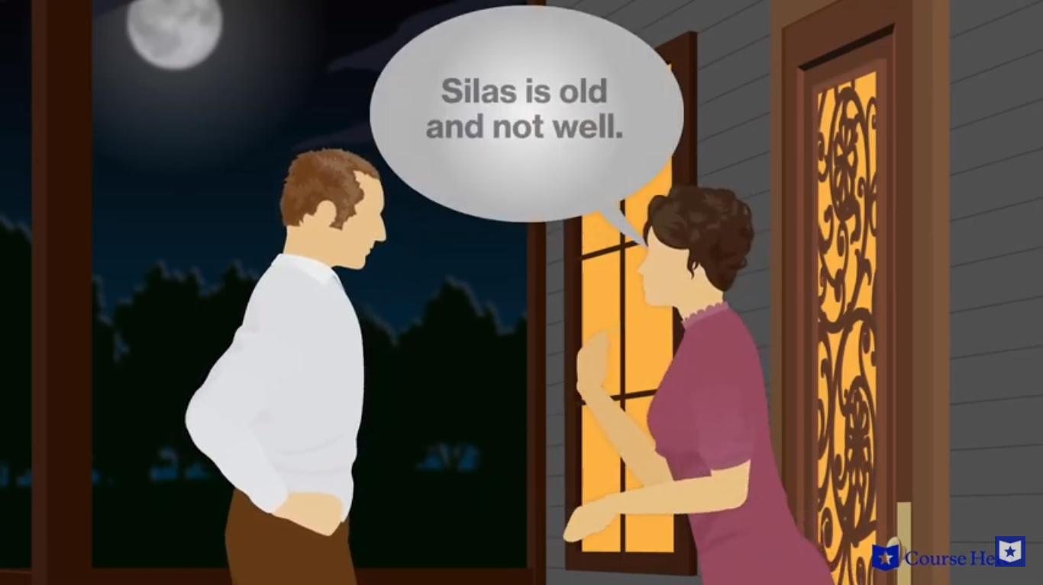                          ‘Where did you say he’d been?’

‘He didn’t say. **I dragged him to the house,**

**And gave him tea and tried to make him smoke.**

**I tried to make him talk about his travels.**

**Nothing would do**: he just kept nodding off.’

‘What did he say? Did he say anything?’

‘But little.’

                ‘Anything? **Mary, confess**

**He said he’d come to ditch the meadow for me.’**

‘Warren!’

              ‘But did he? I just want to know.’

‘Of course he did. What would you have him say?

**Surely you wouldn’t grudge the poor old man**

**Some humble way to save his self-respect.**

He added, if you really care to know,

He meant to clear the upper pasture, too.

…

‘I know, that’s **Silas’ one accomplishment.**

**He bundles every forkful in its place,**

**And tags and numbers it for future reference,**

**So he can find and easily dislodge it**

**In the unloading. Silas does that well**.

He takes it out in bunches like big birds’ nests.

You never see him standing on the hay

He’s trying to lift, straining to lift himself.’

‘He thinks if he could teach him that, he’d be

Some good perhaps to someone in the world.

He hates to see a boy the fool of books.

**Poor Silas, so concerned for other folk,**

**And nothing to look backward to with pride,**

**And nothing to look forward to with hope,**

So now and never any different.’

Part of a moon was falling down the west,

Dragging the whole sky with it to the hills.

Its light poured softly in her lap. She saw it

And spread her apron to it. She put out her hand

Among the harp-like morning-glory strings,

Taut with the dew from garden bed to eaves,

As if she played unheard some tenderness

That wrought on him beside her in the night.

**Warren** describes home as a place of *obligation*: “They have to take you in.” He thinks of home as a place of *duty*.

**Mary** describes home as a place of *mercy*: “Something you somehow haven’t to deserve.” She thinks of home as a blessing that is both undeserved and unearned but that we receive nonetheless. Christians refer to this concept as “grace.”

**‘Warren,’ she said, ‘he has come home to die:**

**You needn’t be afraid he’ll leave you this time.’**

‘Home,’ he mocked gently.

                                       ‘Yes, what else but home?

It all depends on what you mean by home.

Of course he’s nothing to us, any more

Than was the hound that came a stranger to us

Out of the woods, worn out upon the trail.’

**‘Home is the place where, when you have to go there,**

**They have to take you in.’**

**‘I should have called it**

**Something you somehow haven’t to deserve.’**

Warren leaned out and took a step or two,

Picked up a little stick, and brought it back

And broke it in his hand and tossed it by.

…

                                      It hit the moon.

Then there were three there, making a dim row,

The moon, the little silver cloud, and she.

Warren returned—too soon, it seemed to her,

Slipped to her side, caught up her hand and waited.

**‘Warren,’ she questioned.**

**‘Dead,’ was all he answered.**

“Home Burial”

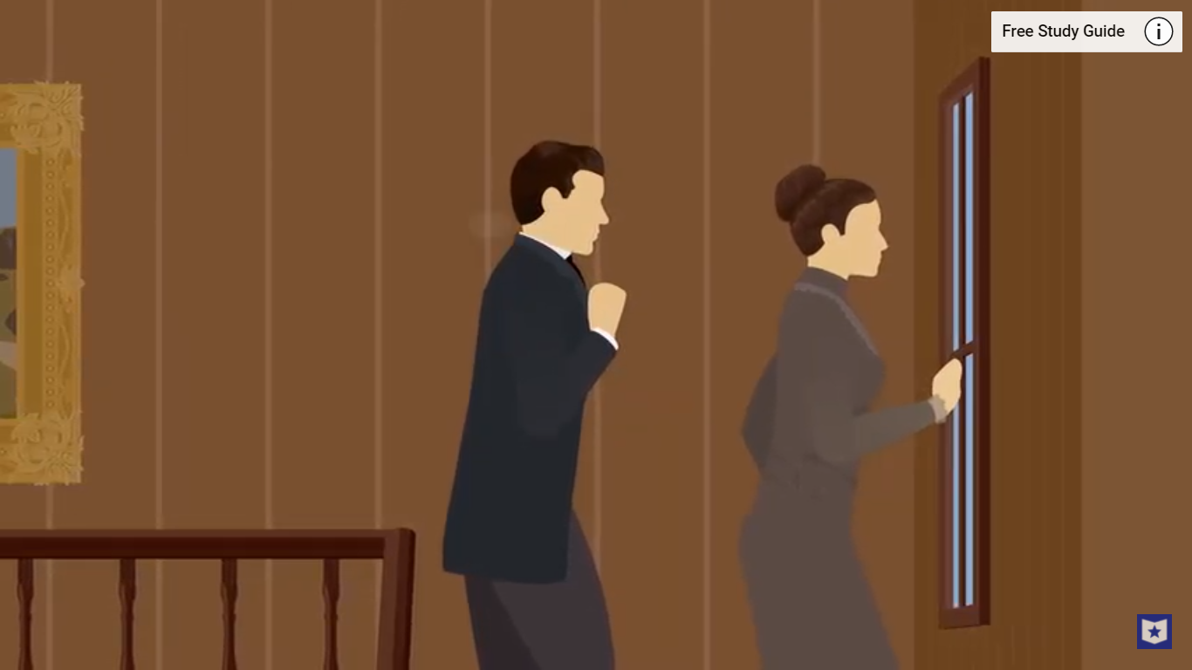**He saw her from the bottom of the stairs**

**Before she saw him.** She was starting down,

Looking back over her shoulder at some fear.

She took a doubtful step and then undid it

To raise herself and look again. **He spoke**

**Advancing toward her: ‘What is it you see**

**From up there always—for I want to know.**’

She turned and sank upon her skirts at that,

And her face changed from terrified to dull.

He said to gain time: **‘What is it you see,’**

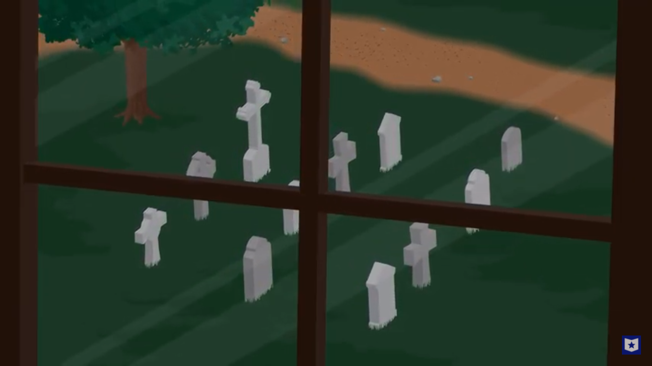Mounting until she cowered under him.

**‘I will find out now—you must tell me, dear.’**

She, in her place, refused him any help

With the least stiffening of her neck and silence.

She let him look, sure that he wouldn’t see,

Blind creature; and awhile he didn’t see.

But at last he murmured, ‘Oh,’ and again, ‘Oh.’

‘What is it—what?’ she said.

                                          ‘Just that I see.’

‘You don’t,’ she challenged. ‘Tell me what it is.’

The poem is a conversation—a dramatic dialogue—between a husband and wife whose child has died. The woman is reminded of her sadness when she sees the child’s grave through the window, and her sadness grows when her husband does not understand her feelings. When she tries to leave the house he asks her to stay and talk about her grief with him. He doesn’t understand her emotions, and she resents him for being unfeeling. The poem does not have a positive resolution as their hurt and resentment toward one another remain.

‘The wonder is I didn’t see at once.

I never noticed it from here before.

I must be wonted to it—that’s the reason.

The little graveyard where my people are!

So small the window frames the whole of it.

Not so much larger than a bedroom, is it?

There are three stones of slate and one of marble,

Broad-shouldered little slabs there in the sunlight

On the sidehill. We haven’t to mind *those*.

**But I understand: it is not the stones,**

**But the child’s mound—’**

**‘Don’t, don’t, don’t, don’t,’ she cried.**

**She withdrew shrinking from beneath his arm**

That rested on the banister, and slid downstairs;

And turned on him with such a daunting look,

He said twice over before he knew himself:

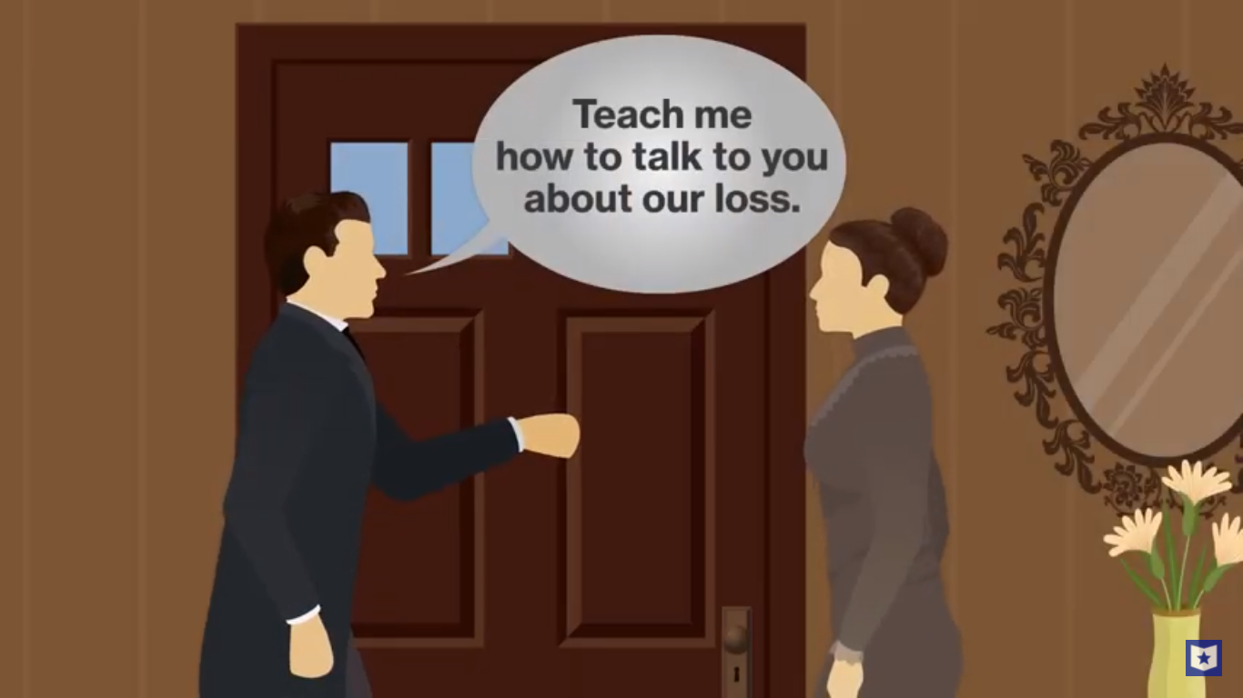**‘Can’t a man speak of his own child he’s lost?’**

‘Not you! Oh, where’s my hat? Oh, I don’t need it!

I must get out of here. I must get air.

I don’t know rightly whether any man can.’

…

**‘My words are nearly always an offense.**

**I don’t know how to speak of anything**

**So as to please you.** But I might be taught

I should suppose. I can’t say I see how.

**A man must partly give up being a man**

**Colloquialism** is the use of informal language and slang. It's often used by authors to lend a sense of realism to their characters and dialogue. Words like “a-mind” and “‘twixt” are examples of **colloquialism**. These words show that the poet is focused on the lives of ordinary people in rural New England.

**With women-folk.** We could have some arrangement

By which I’d bind myself to keep hands off

**Anything special you’re a-mind to name.**

**Though I don’t like such things ’twixt those that love.**

Two that don’t love can’t live together without them.

But two that do can’t live together with them.’

She moved the latch a little. ‘Don’t—don’t go.

Don’t carry it to someone else this time.

Tell me about it if it’s something human.

Let me into your grief. I’m not so much

Unlike other folks as your standing there

Apart would make me out. Give me my chance.

I do think, though, you overdo it a little.

**What was it brought you up to think it the thing**

**Synecdoche** is a literary device in which part of something is used to represent the whole, or vice versa. The wife’s “mother-loss” is a **synecdoche**, because her experience as a mother is seen as part of the larger whole of womanhood/motherhood.

**To take your mother-loss of a first child**

**So inconsolably—in the face of love.**

You’d think his memory might be satisfied—’

‘There you go sneering now!’

                                           ‘I’m not, I’m not!

You make me angry. I’ll come down to you.

God, what a woman! And it’s come to this,

A man can’t speak of his own child that’s dead.’

‘You can’t because you don't know how to speak.

**If you had any feelings, you that dug**

**With your own hand—how could you?—his little grave;**

**I saw you from that very window there,**

**Making the gravel leap and leap in air,**

**Leap up, like that, like that, and land so lightly**

**And roll back down the mound beside the hole.**

I thought, Who is that man? I didn’t know you.

And I crept down the stairs and up the stairs

To look again, and still your spade kept lifting.

Then you came in. I heard your rumbling voice

Out in the kitchen, and I don’t know why,

But I went near to see with my own eyes.

**You could sit there with the stains on your shoes**

The lines "the stains on your shoes / Of fresh earth from your own baby's grave" become a **metaphor** for the wife’s distrust of her husband’s emotions. The “stains on your shoes” are more than just remnants of dirt from the grave; these are moral “stains” on his heart and soul.

**Of the fresh earth from your own baby’s grave**

**And talk about your everyday concerns.**

You had stood the spade up against the wall

Outside there in the entry, for I saw it.’

‘I shall laugh the worst laugh I ever laughed.

I’m cursed. God, if I don’t believe I’m cursed.’

**‘I can repeat the very words you were saying:**

**“Three foggy mornings and one rainy day**

**Will rot the best birch fence a man can build.”**

**Think of it, talk like that at such a time!**

What had how long it takes a birch to rot

To do with what was in the darkened parlor?