**Robert Frost** and T.S. Eliot write poems that make use of many different literary devices. Find 4 examples in these poems (2 poems from Frost, 2 poems from Eliot) of **literary devices from the list below**. In your post, explain how Frost and Eliot use these literary devices to help **communicate the message of their poems**. Answer the questions, “WHAT are Frost’s and Eliot’s messages in these poems, and HOW do Frost and Eliot use these literary devices to communicate those messages?”

**Alliteration**: Alliteration is a series of words or phrases that all (or almost all) start with the same sound. These sounds are typically consonants to give more stress to that syllable. *Example:* "Peter Piper picked a peck of pickled peppers." In this tongue twister, the "p" sound is repeated at the beginning of all major words.

**Allusion:** Allusion is when an author makes an indirect reference to a figure, place, event, or idea originating from outside the text. Many allusions refer to previous works of literature or art.

**Anaphora:** Anaphora is when a word or phrase is repeated at the beginning of multiple sentences throughout a piece of writing.

**Anthropomorphism:** An anthropomorphism occurs when something nonhuman, such as an animal, place, or inanimate object, behaves in a human-like way.

**Colloquialism:** Colloquialism is the use of informal language and slang. It's often used by authors to lend a sense of realism to their characters and dialogue. Forms of colloquialism include words, phrases, and contractions that aren't real words (such as "gonna" and "ain't").

**Euphemism:** A euphemism is when a more mild or indirect word or expression is used in place of another word or phrase that is considered harsh, blunt, vulgar, or unpleasant.

**Hyperbole:** Hyperbole is an exaggerated statement that's not meant to be taken literally by the reader. It is often used for comedic effect and/or emphasis.

**Irony:** Irony is when a statement is used to express an opposite meaning than the one literally expressed by it.

**Juxtaposition:** Juxtaposition is the comparing and contrasting of two or more different (usually opposite) ideas, characters, objects, etc. This literary device is often used to help create a clearer picture of the characteristics of one object or idea by comparing it with those of another.

**Metaphor/Simile:** Metaphors are when an author compares one thing to another. The two things being described usually share something in common but are unalike in all other respects. A simile is a type of metaphor in which an object, idea, character, action, etc., is compared to another thing using the words "as" or "like." Both metaphors and similes are often used in writing for clarity or emphasis.

**Metonym:** A metonym is when a related word or phrase is substituted for the actual thing to which it's referring. This device is usually used for poetic or rhetorical effect.

**Oxymoron:** An oxymoron is a combination of two words that, together, express a contradictory meaning. This device is often used for emphasis, for humor, to create tension, or to illustrate a paradox (see next entry for more information on paradoxes).

**Personification:** Personification is when a nonhuman figure or other abstract concept or element is described as having human-like qualities or characteristics. (Unlike anthropomorphism where non-human figures become human-like characters, with personification, the object/figure is simply described as being human-like.)

**Symbolism:** Symbolism refers to the use of an object, figure, event, situation, or other idea in a written work to represent something else—typically a broader message or deeper meaning that differs from its literal meaning. The things used for symbolism are called "symbols," and they'll often appear multiple times throughout a text, sometimes changing in meaning as the plot progresses.

**Synecdoche:** A synecdoche is a literary device in which part of something is used to represent the whole, or vice versa. It's similar to a metonym (see above); however, a metonym doesn't have to represent the whole—just something associated with the word used.

“The Road Not Taken”

The speaker of the poem wishes that he did not have to choose between taking one road over the other in the lines “And sorry I could not travel both / And be one traveler, long I stood.”

Two roads diverged in a yellow wood,

**And sorry I could not travel both**

**And be one traveler,** long I stood

And looked down one as far as I could

To where it bent in the undergrowth;

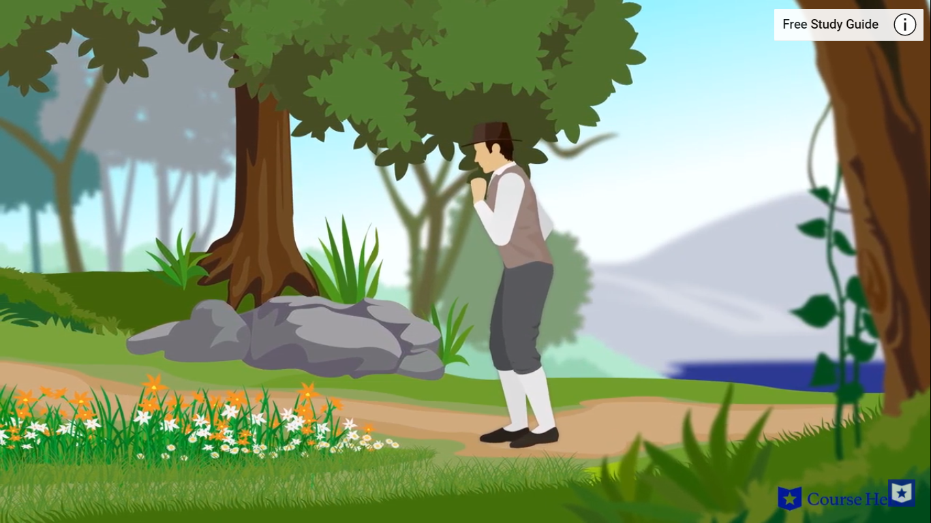Then took the other, as just as fair,

And having perhaps the better claim,

Because it was grassy and wanted wear;

**Though as for that the passing there**

**Had worn them really about the same**,

And **both that morning equally lay**

In leaves no step had trodden black.

Oh, I kept the first for another day!

Yet knowing how way leads on to way,

I doubted if I should ever come back.

“I took the one less traveled by, / And that has made all the difference” is an example of **hyperbole**: an exaggerated statement used for emphasis.

WHAT is the message? That our daily choices determine who we are.

HOW does he communicate that message? Through **hyperbole** by exaggerating how a small decision to take a different path “made all the difference,” even though both paths were basically the same.

I shall be telling this with a sigh

Somewhere ages and ages hence:

**Two roads diverged in a wood, and I—**

**I took the one less traveled by,**

**And that has made all the difference.**

“Mending Wall”

**Something there is that doesn't love a wall,**

That sends the **frozen-ground-swell** under it,

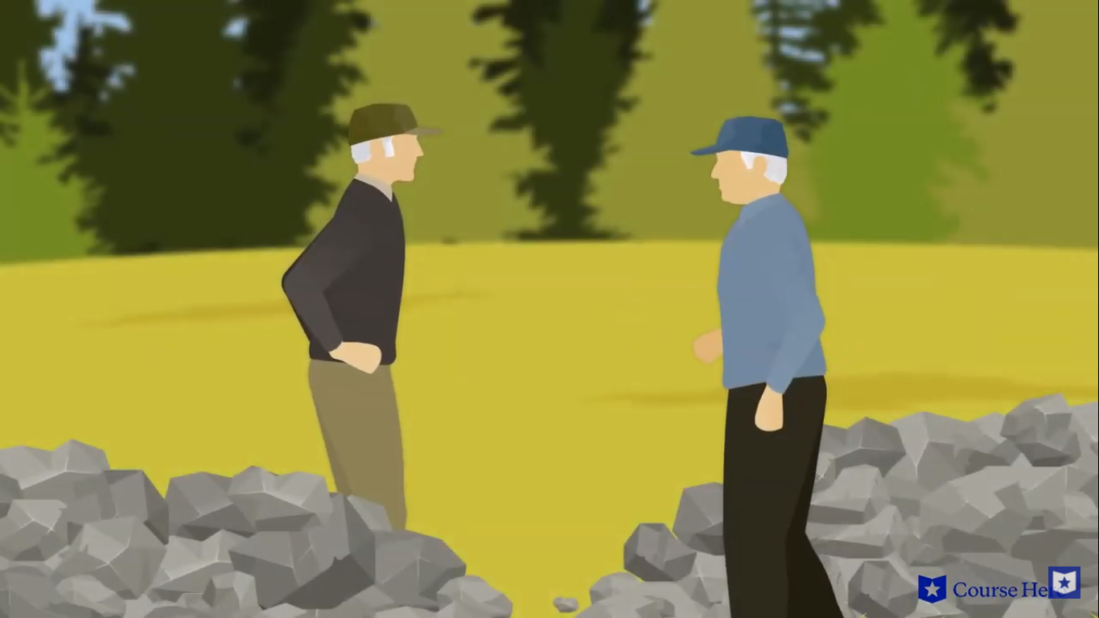And spills the upper boulders in the sun;

And **makes gaps** even two can pass abreast.

The **work of hunters** is another thing:

I have come after them and made repair

Where they have left not one stone on a stone,

But they would have the rabbit out of hiding,

To please the yelping dogs. The gaps I mean,

No one has seen them made or heard them made,

But at spring mending-time we find them there.

**I let my neighbor know beyond the hill;**

**And on a day we meet to walk the line**

**And set the wall between us once again.**

The line “Good fences make good neighbors” is an example of **irony**, because fences separate people rather than *bring people together.*

WHAT is the message? People should not put arbitrary barriers between them; people should look for ways to create unity, not division.

HOW does he communicate that message? The ironic statement “Good fences make good neighbors” says the opposite of what it means: fences mean that people *don’t* trust each other and *don’t* want to be close to one another.

We keep the wall between us as we go.

To each the boulders that have fallen to each.

And some are loaves and some so nearly balls

We have to use a spell to make them balance:

‘Stay where you are until our backs are turned!’

We wear our fingers rough with handling them.

Oh, just another kind of out-door game,

One on a side. It comes to little more:

There where it is we do not need the wall:

He is all pine and I am apple orchard.

My apple trees will never get across

And eat the cones under his pines, I tell him.

He only says, **‘Good fences make good neighbors.’**

Spring is the mischief in me, and I wonder

If I could put a notion in his head:

‘Why do they make good neighbors? Isn't it

Where there are cows? But here there are no cows.

Before I built a wall I'd ask to know

What I was walling in or walling out,

And to whom I was like to give offense.

Something there is that doesn't love a wall,

That wants it down.’ I could say ‘Elves’ to him,

But it's not elves exactly, and I'd rather

He said it for himself. I see him there

Bringing a stone grasped firmly by the top

In each hand, like an old-stone savage armed.

He moves in darkness as it seems to me,

Not of woods only and the shade of trees.

He will not go behind his father's saying,

And he likes having thought of it so well

He says again, ‘Good fences make good neighbors.’

“The Gift Outright”

“The Gift Outright” is a poem about the United States’ territorial claims in North America.

The lines “**W**e **w**ere **w**ithholding from our **l**and of **l**iving / And **f**orthwith **f**ound **s**alvation in **s**urrender” are examples of **alliteration.**

WHAT is the message? American colonials needed to embrace the land they were living, and claim it as their own—or let the land claim them as its own.

HOW does he communicate that message? The repeated sounds of **alliteration** suggest that these words *naturally belong together*, just like the American colonials *naturally belong* to the land, and the land *naturally belongs* to them.

**The land was ours before we were the land’s.**

She was our land more than a hundred years

Before we were her people. She was ours

In Massachusetts, in Virginia,

But we were England’s, still colonials,

Possessing what we still were unpossessed by,

Possessed by what we now no more possessed.

Something we were withholding made us weak

Until we found out that it was ourselves

**We were withholding from our land of living,**

**And forthwith found salvation in surrender.**

Such as we were we gave ourselves outright

(The deed of gift was many deeds of war)

To the land vaguely realizing westward,

But still unstoried, artless, unenhanced,

Such as she was, such as she would become.

“Out, Out-”

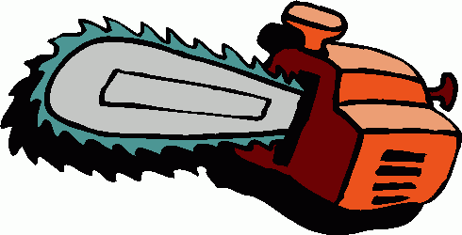**The buzz saw snarled and rattled in the yard**

And made dust and dropped stove-length sticks of wood,

Sweet-scented stuff when the breeze drew across it.

And from there those that lifted eyes could count

Five mountain ranges one behind the other

Under the sunset far into Vermont.

**And the saw snarled and rattled, snarled and rattled,**

As it ran light, or had to bear a load.

And nothing happened: day was all but done.

Call it a day, I wish they might have said

To please the boy by giving him the half hour

The poem uses **personification** to give human characteristics to the chainsaw the boy is using.

WHAT is the message? Tragedy can come suddenly and unexpectedly to even the most innocent people.

HOW does he communicate that message? The use of **personification** to give the chainsaw human characteristics (it “snarled and rattled” and “Leaped out at the boy’s hand”) helps to explain in some way why this unexpected tragedy happened. It is too terrifying to think that this accident was merely random, so thinking of it as having a conscious agency behind it—even a malevolent agency—is comforting.

That a boy counts so much when saved from work.

His sister stood beside him in her apron

To tell them ‘Supper.’ At the word, the saw,

**As if to prove saws knew what supper meant,**

**Leaped out at the boy’s hand, or seemed to leap—**

He must have given the hand. However it was,

Neither refused the meeting. But the hand!

The boy’s first outcry was a rueful laugh,

As he swung toward them holding up the hand

Half in appeal, but half as if to keep

The life from spilling. Then the boy saw all—

Since he was old enough to know, big boy

Doing a man’s work, though a child at heart—

**He saw all spoiled. ‘Don’t let him cut my hand off—**

**The doctor, when he comes. Don’t let him, sister!’**

So. But the hand was gone already.

The doctor put him in the dark of ether.

He lay and puffed his lips out with his breath.

And then—the watcher at his pulse took fright.

No one believed. They listened at his heart.

Little—less—nothing!—and that ended it.

No more to build on there. And they, since they

Were not the one dead, turned to their affairs.

“Design”

The poem uses **similes** to describe different elements of this scenario about a white spider that killed a white moth on a white flower (a “heal-all” flower).

WHAT is the message? The poem asks, What are the forces in the universe in control of—or “designing”—things like spiders, moths, and flowers? Is the world we live in completely random, or carefully designed by some higher power?

HOW does he communicate that message? The poem uses **similes** to describe how carefully things like spiders, moths, and flowers have been created as a way to help us think about how these things have been purposefully designed.

I found a dimpled spider, fat and white,

On a white heal-all, holding up a moth

**Like a white piece of rigid satin cloth**--

Assorted characters of death and blight

Mixed ready to begin the morning right,

**Like the ingredients of a witches' broth--**

A snow-drop spider, **a flower like a froth,**

And dead wings carried **like a paper kite.**

What had that flower to do with being white,

The wayside blue and innocent heal-all?

What brought the kindred spider to that height,

Then steered the white moth thither in the night?

**What but design of darkness to appall?--**

**If design govern in a thing so small.**

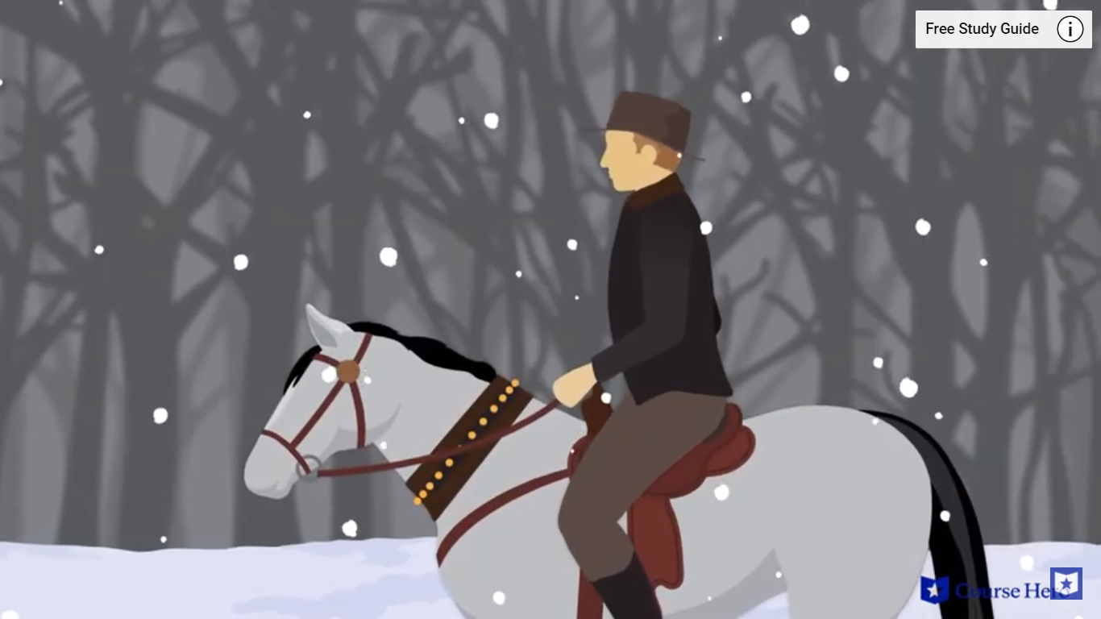“Stopping by Woods on a Snowy Evening”

**Whose woods these are I think I know.**

His house is in the village though;

**He will not see me stopping here**

To watch his woods fill up with snow.

**My little horse must think it queer**

To stop without a farmhouse near

Between the woods and frozen lake

The darkest evening of the year.

**He gives his harness bells a shake**

**To ask if there is some mistake.**

The only other sound’s the sweep

The poem uses **anthropomorphism** to give the horse human qualities in the lines, “My little horse must think it queer / To stop without a farmhouse near” and “He gives his harness bells a shake / To ask if there is some mistake”?

WHAT is the message? All human beings have an intimate connection to the natural world, regardless of who legally owns a part of that world (like “the woods” owned by the villager).

HOW does he communicate that message? The **anthropomorphic** qualities of the horse suggest that human beings can connect with the natural world in the same way that they connect with other human beings.

Of easy wind and downy flake.

The woods are lovely, dark and deep,

But I have promises to keep,

And miles to go before I sleep,

And miles to go before I sleep.