Dec 9, 2020

Abstract
Your abstract should be one paragraph and should not exceed 120 words. It is a summary of the most important elements of your paper. All numbers in the abstract, except those beginning a sentence, should be typed as digits rather than words. To count the number of words in this paragraph, select the paragraph, and on the Tools menu click Word Count.
Introduction
Consumers from different backgrounds and ethnicities share a common ideal and expectation when shopping, that is that the establishment will go above and beyond to provide quality customer service upon each encounter. Industries such as the food and beverage, and the retail industry are dedicated to providing exceptional service to their constituents which will create business for them and hopefully multiply the number of customers visit their establishment. The retail industry has made adequate changes of the years to lure consumers and help develop their businesses. Strategies in marketing have helped create business opportunities for retail stores such as social media presence, paid advertisements, creative storefront displays, as well as through pricing strategies which have helped create opportunities to grow their businesses. This assignment is dedicated to analyzing and understanding the causes and effects of customer service on consumers in the retail industry.
In this assignment we intend to address how retail stores can create a more pleasurable customer service experience within their stores. Certain factors that play a role in improving customer satisfaction such as internet availability, customer outreach, cleanliness, product quality, as well as technological advancements. All of these factors play a significant role in determining the satisfaction that a customer experiences during their visit to that retail store.
Moreover, there are issues that affect the consumer during their visit which tend to cause a negative impact on the satisfaction of the experience that these consumers have. Issues such as miscommunication, poor business marketing can impact the experience of a consumer creating an environment for them not be comfortable in. Miscommunication through tone and failure to properly address questions asked by a customer can create a negative customer service experience and lower satisfaction levels. Poor business marketing such as a faulty slogan or failure to address a certain demographic can create a negative customer service experience which can lead to customers reevaluating if they want to do business with you. These issues are important to consider because they affect customers and people who are familiar with your business; as negative news usually spreads faster than great news experiences.
The aforementioned issues relate to the course content because they all resonate with the importance of treating the customer with an upright value and creating a business that welcomes people regardless of demographics. Therefore, the importance of good customer service in retail is puissant and can develop or destroy a business. However, through development of marketing, proper training, and customer outreach these issues can be resolved and the customer service experience can be improved.
Retail Customer Service Satisfaction
Consumer satisfaction has been one of the most important aspects of business which has helped businesses thrive over the years from the beginning of brick and mortar stores to today’s online businesses. Consumer satisfaction has fluctuated amongst businesses over the years which has caused an unstable market, damaged reputation of businesses, poor employee retention, as well as a negative value in the value of the company. The reputationof a company plays an intricate part of the business that helps develop profits as well as how the consumer perceives the business. A negative consumer experience does more than resonate with the affected customer but can be spread through word-of-mouth that can also affect several other consumers. In a recent study, 95% of respondents said they usually tell at least one other person about a bad customer experience with a company, while 54% of others said they share it with at least 5 other people (Vujasin, 2020). Therein, it is very important to consider how a business executes the satisfaction of its customers in order to allow a positive outlook for the business for current and future proceedings. Using qualitative analysis, this paper would identify consumer experience and how it related to business in retail industry.
Problem Statement
Consumer satisfaction is an important factor in the business of customer service. Consumer satisfaction plays a part in customer service because it allows opportunities for the business to improve where they lack, as well as for the consumer to receive the product served in the most desirable way to them. In order to develop consumer satisfaction there needs to be clear cut communication between employees of the said business as well as clear communication to the consumer of their product. Communication can be improved from business to the consumer through marketing, store display, as well as consumer outreach. Business marketing plays an important role by fostering to a certain demographic through a slogan, discount/sale, or even through celebrity advocacy. These tools help communicate the importance of the business’s product to the consumer in hopes they will consider purchasing the product. Moreover, businesses practice consumer satisfaction through responsibility, patience and empathy. These characteristics provide humility to the consumer and allow them to view the business as more than just a business but rather a safe haven for the product they require. The customer service experience can be tarnished through these same characteristics as well. Customer satisfaction serves as the dependent variable while customer service experience serves as the independent variable.
According to a recent poll; 89% of consumers have switched to doing business with a competitor following a poor customer experience. Therefore, it takes great valor for a business to develop a positive customer service experience and find ways that keep them connected to theconsumer. Businesses can improve upon the customer service experience through being patient with the customer and understanding their needs which may be complicated at times; however, they reflect the interest that they have with the business. Being patient, polite, and understanding helps the customer feel welcome and embraced; 68% of customers believe the key to great customer service is a polite customer service representative. In addition, 70% of buying
experiences are based upon how the customer feels they are being treated (McKinsey &amp; Company). By this, it is meaningful to improve customer satisfaction through the aforementioned characteristics which will develop the customer’s experience overall.
While it’s true that a tarnished reputation could lead to a loss of customers, it’s also true that a good customer support reputation could actually attract new business. That means that by making sure your support services are in tip-top shape, you have the potential to gain new customers and make more money, just based on word of mouth advertising alone. In fact, three out of five people say that they’d happily swap companies in search of a better service experience. Improve your bottom line through retention by providing a good support experience, but also let your reputation rise and help you bring in new customers too (Geraghty, 2014) . Eighty-one percent of people are more likely to work with a business after good service. Increasing customer retention by five percent can increase your profits up to 125 percent. Loyal customers are worth ten times as much as their first purchase on average companies who make customer service a priority make 60 percent higher profits than rivals
One of the most important aspects that helps a business or firm grow is customer satisfaction. Variation in customer satisfaction for a firm may bring about consequences like a damaged reputation and unstable market, which are obstacles to business growth (Patel, 2020). Most customers share their bad experiences hence chasing potential clients; hence proprietors should be extra careful when handling customers from enquiries to complaints and feedback. Consumer satisfaction can only be achieved when there is a smooth flow of information between employees and customers with appropriate service and etiquette taken into consideration. Accompanying customer service with sales, slogans and use of celebrities or social media influencers helps attract more clients.
Additionally, the use of virtues like patience, responsibility and empathy helps the customer view the business as a haven that can provide solutions to their needs. On the contrary, some vices also contribute to destroying the business reputation like being inefficient in communication and irresponsibility that discourages consumers from seeking services from the firm again (Patel, 2020). Also, being persuasive can help improve the customer experience. Persuasiveness is an art of changing want to a need hence making the consumer make a purchase. Moreover, luring clients helps businesses rise above competitors as customers become fascinated about new products improving the businesses sales.
Moreover, some of the few managerial abilities that improve customer satisfaction include persuasiveness, display and presentation, care, respect, understanding and use of influencers are among the key managerial skills needed (Vujasin, 2020). Convincing customers to purchase goods not planned for is an art that is used to make more sales and attract potential customers. Presentation and use of attractive displays lure the consumers’ interest in the products while proper communication ability enables a consumer to make purchases and retain clients (Vujasin, 2020). The other managerial skill is the ability to evaluate and plan through a quantitative analysis that helps find solutions to problems faced in the business.

RESEARCH DESIGN/METHODOLOGY

Our target market is largely consumer ages 15-45. This target market includes primarily women, young athletes and runners. Nike is expanding women’s apparel, especially sports bras and tights. Kids who play sports are a growing part of Nike’s business. Much of Nike’s innovation efforts are focused in the running category.
Our samples will be collected through surveying friends, family members, as well as friends of friends and co-workers. We will seek to gather information from consumers who buy athletic gear such as sneakers and others athletic apparel. We will develop questions that evaluate their experiences during visits to Nike stores or online.
Our target population are both men and women athletes equally and as well as increasing focus on tweens and teens that will build long-term loyalty. By addressing the segment by deploying marketing campaigns about young adults striving to be like their athlete idols,
One possible source of error in sampling are biased consumers. This includes those who let things such as third-party shipping companies having an impact on their customer services ratings of the company. Another possible source of error would be a customer who has shopped at Nike in the past (More than 10 years ago) but has not shopped with this company in the recent years. One other possible source of error will be shopping produced to international stores in other countries to get a higher customer satisfaction and having option to choose from our international stores and as well regulation with other countries policies.
Research design is the strategy of performing research for a study (Christensen et al, 2011). Different components of research are arranged in a logical sequence to arrive at an answer. Many methods of the survey have different styles used to implement. However, research, in general, has specific steps that are employed whatever the strategy used. The first stage is selecting or identifying the area of study. After the identification of the area for the research, the next step is identifying the objective of the research, the research should have a purpose of reasons for doing it. The third step of a research design is reviewing the different researches that have been conducted about the topic being researched. A literature review helps in knowing the results of previous researches prompting the study underway. Thereafter, a method of research is chosen depending on the nature of the study. The fifth step is normally collecting the data during the survey and finally analyzing the data that will inform the conclusions and recommendations of the research.
Method
A cross-sectional study was applied to contain persons who were identified as recent shoppers of retail stores from the period of May 25- October 25, 2020. Simple random sampling was used for this study while each person identified as a recent shopper at a retail store for the mentioned period. The sample was made random by using every other completed survey for study analysis.
Instrument
The instrument used to collect the data received was a survey that consisted of six questions developed for gathering required information about the factors that contribute to customer satisfaction. The survey employed a 5-point Likert scale designed to obtain attested feedback to measure the factors that influence customer service satisfaction. The available responses were (1) Strongly Disagree, (2) Disagree, (3) Neutral, (4) Agree, and (5) strongly agree.
The three researchers involved in this group surveyed 100+ participants to determine what the most important factor affecting customer service is. Two additional questions gathered demographic information designed to reflect the nature of the subjects of the population surveyed.
Table 1: Variables/ Survey Question Chart
(Y1) Customer Satisfaction
(X1) Internet Availability
(X2) Consumer Outreach
(X3) Cleanliness
(X4) Product Quality
(X5) Technological Advancements

Table 2: Variable/ Literature Review Chart
Validation
The survey design was validated by comparison with existing customer survey instruments currently in use at most retail store sites. The survey was approved by Najat Amachki in survey collection, data research, and statistical analysis. She evaluated the survey for all considerations as well as helped inform and educate the three researchers about the importance of ethics and values when distributing the instruments used in this study.
Data
Primary data was collected via the survey instrument, which was distributed to all participants via the three researchers. The three researchers distributed this data to participants from a large variety that fit the criteria of shopping at a retail store within the aforementioned period. Secondary data to support the hypothesis was obtained through an extensive literature review.
Fieldwork
The survey instrument was distributed to approximately 130 participants via the three researchers which included family, friends, co-workers, associates, and many other participants who fit the required criteria of at least 18 years of age or older that have shopped at a retail store within the aforementioned period. During the week of collecting the surveys from all participants. All three researchers had received 90 surveys and having to reject only 8 surveys among the three researchers and having a total of 82 survey that were analyzed by the researchers. The surveys were collected and compiled for data analysis for this SMAC and other educational purposes. Three field agents participated in this study; all three of these agents received the suggested training on ethical components of data collection and storage
Sample
This study’s participants consisted of family members, associates, friends, and co-workers of the three field agents. Before the instrument distribution, all participants were questioned if they shopped at a retail store from May 25- October 25, 2020, and to reflect on that experience while answering the questions within the survey. A total of 105 surveys were distributed from October 26, 2020, to November 3rd, 2020. Of the 105 participants, 5 refused to complete the survey, 2 Spanish-language & 1 Haitian-Creole language surveys were disregarded due to ineligibility. Additionally, 2 English-language surveys were disregarded due to the use of profane language with multiple questions unanswered. An eligible sample size of N=90 was obtained, with every other survey selected in this study for a total of N=45 for this study.
Method of Data Collection
The survey was distributed by the three researchers daily to participants who were identified as recent shoppers to retail stores. One Spanish translator was applied to this study that accompanied one of the researchers to translate for Spanish-speaking participants. One Haitian-creole translator was also applied to this study during the distribution of surveys that accompanied one of the researchers to translate for Haitian-creole speaking participants. The three field agents explained the purpose of the survey and collected the survey from the hours of 10 am- 7 pm daily from October 26th- November 3rd. The completed surveys were collected daily and tallied for statistical review. To ensure randomization, every other survey collected was utilized for this study. A total of 105 surveys were completed, and every other survey was selected for use, resulting in N=63 surveys utilized for the study.
Statistical Tests
The study data were analyzed through the use of Microsoft Excel 2016®. Descriptive statistics, correlation analysis, and regression analysis were utilized to determine the relationships between all of the study variables (X1-X-5).
Customer Service Experience (X)
Organizations is an article that details a study of how the role of employees are comparable to consumer satisfaction itself. In this article research was taken to explore the extent by which employee retention can influence customer satisfaction and how it can affect the hospitality industry in Nigeria. Zeithaml et al. (2006), further explained that the people factor in services is a very important element in the evaluation of that service from the company’s personnel to the customers in the service environment (Oki, 2014). Employees represent an interface between the business and the consumers and truly mirror the elegance of the organization as well as the standard they want to present. Therein, it can be recognized that there are a number of factors that contribute to consumer satisfaction, however, through employees and their retention rate we can acknowledge how critical they are to an organization and how truly important they are.
Customer Satisfaction (Y)
This article speaks about how to improve the customer service experience through many tips and just how the proper customer service experience can benefit an organization. Customer service experience can be improved through personalized experiences for each consumer, by calling the consumer by name which tends to humanize the experience. According to research people normally become ecstatic when they hear their name called (Carmody, Lewis, 2006). Additionally, providing support and rewarding loyal consumers also are ways to create a positive consumer satisfaction experience. Data from client loyalty programs show that around 79% of consumers are more satisfied with programs that offer a high degree of personalization (Crowdtwist, 2018). Moreover, the consumer satisfaction experience can be improved through personalized experiences with the customer which evaluates aspects of the experience as well as gathers feedback from the customer at every opportunity necessary.
Conclusion
In conclusion, customer satisfaction is the backbone of every business that is growing or trying to retain market position. Proprietors should ensure they micromanage their juniors and train them virtues like patients and being polite and having the emotional intelligence to deal with a wide variety of clients. Moreover, businesses should value feedback, employee's persuasiveness when selling and ensure they value customer feedback to avoid a bad reputation.
Collecting Data & Drafting Survey
Sampling is a method of picking out characters or individual in a group to deduce properties of an underlying distribution estimating characteristics of the whole population (Dr. Nic's Maths and Stats, 2012). To draw a valid conclusion to their results, they use various sampling types, including probability and non-probability sampling. In this context, therefore, one focuses on the two sampling methods.
Probability sampling entails studying a population from which every member has a chance to be selected. Its primary use is in quantitative research. Results from this method are usually representative of the whole population. It includes simple random sampling that gives each member of the population equal chances. An excellent example of the survey question is the type of food people mostly consume in a given area (Dr. Nic's Maths and Stats, 2012). It is more effective when the population is geographically concentrated. Another method similar to simple random sampling is systematic. Here each member is given a number and chosen at regular intervals instead of generating numbers randomly.
On the other hand, cluster sampling entails dividing the population into subgroups, where each subset should have similar features to the whole group. Mainly suitable for the large and dispersed population. An example is finding the number of employees working in offices of a company with ten offices in the entire country. In stratified sampling, the population is divided into subpopulations that differ in many ways. For instance, where one wants to develop a gender-balanced sample.
Non-probability sampling methods, unlike probability sampling methods, ensure that not everybody has a chance of being included (Dr. Nic's Maths and Stats, 2012). For instance, convenience sampling that engages readily available people. Like in the case where one has the question on student support within his or her school. Here the individual asks his or her classmate regarding the matter of collecting the necessary data.
From the context above, one can conclude that there are various survey errors affecting data collection. For instance, targeting the wrong population. Most people do not want to be screened out in your survey, which is best you let them go. This will not only lead to time consumption but also data that one does not need. Therefore, to minimize this, one has to ensure he or she is surveying the right population.

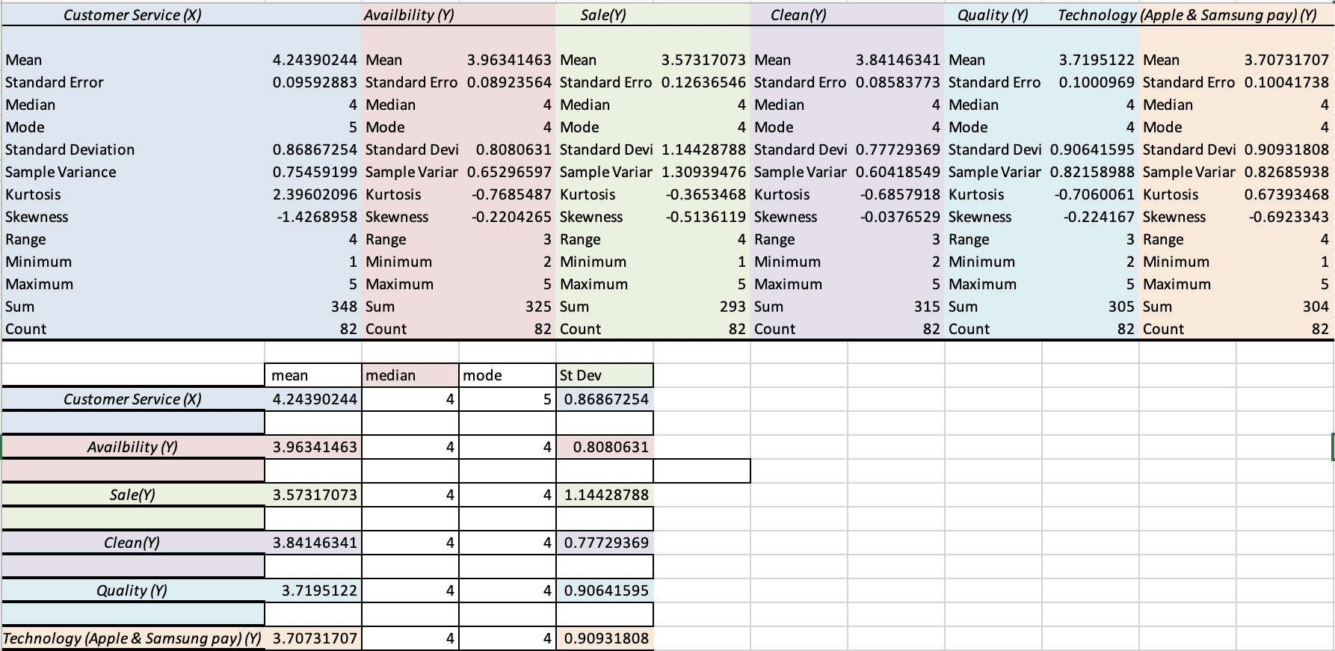

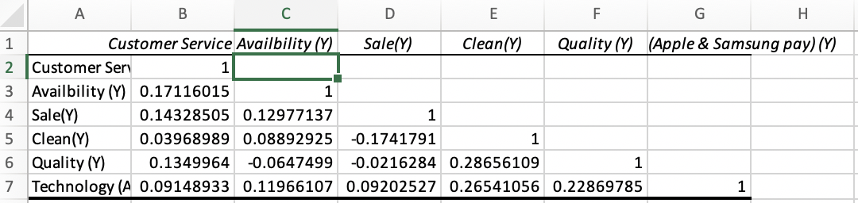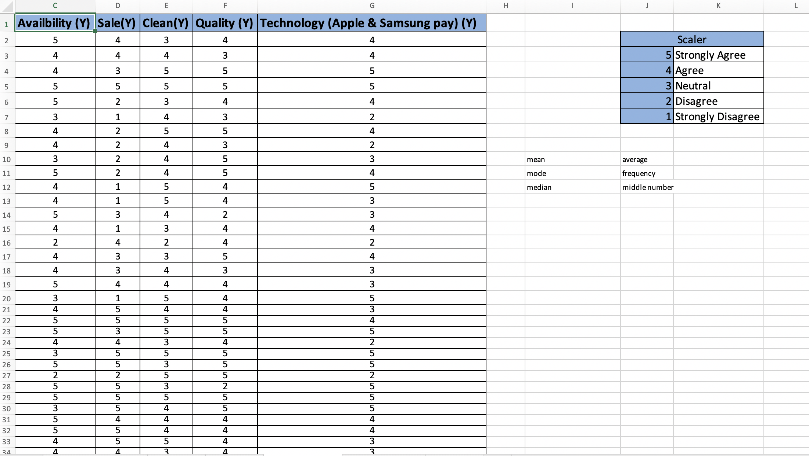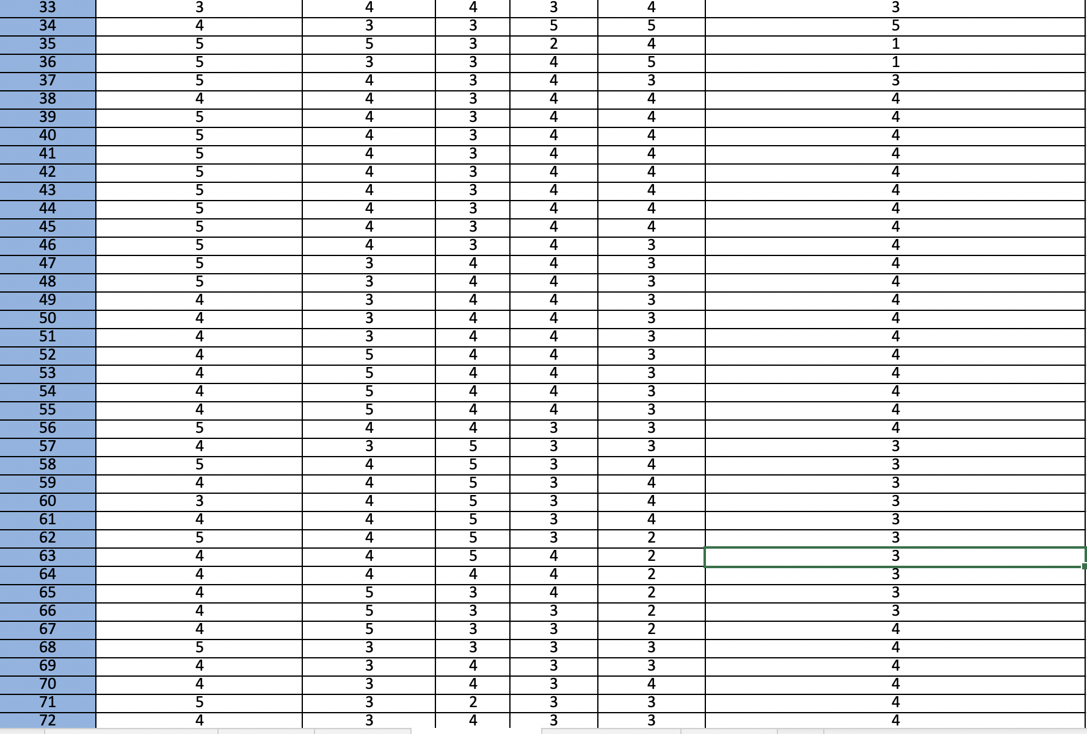
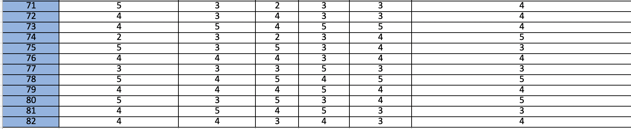
Date Analysis
Data Preparation
The data preparation involves many steps, such as data proofreading, evaluation, data coding and data recording. Three researchers gathered the data; collected the responses, then entered the data in Excel spreadsheets, and then eliminated surveys that were biased. These methods helped ensure that the responses recorded for data collection and evaluation were true and accurate to the study.
Data editing helps increase accuracy and compatibility by checking responses from surveys collected and checking for errors to forfend the reliability of the data, The three researchers examined the responses collected from each survey and made sure that the data was correctly filled and that answers were reliable and fit the criteria of the study. The researchers for example collected the completed surveys of people who shopped in retail stores between May and late October. Upon collection, the researcher was informed of the estimated dates that the participants visited these retails stores; if they did not fit the criteria the surveys were discarded and not recorded. After editing, the researchers coded and tabulated the data.
B. Data Coding
Coding is an important step to facilitate the analysis of the information from the surveys collected. Data coding helped translate the necessary data collected from the surveys to numbers which are understood by computer applications such as Excel.

C. Data Entry
Data entry is important because it develops raw information collected from primary data such as surveys into a program such as Microsoft Excel that facilitates the use and assessment of data by users. After coding, data was prepared and input into Microsoft Excel spreadsheets. The Excel spreadsheet was used to organize, sort, and positively manipulate the data. The three researchers used this application because of its flexibility to compile a variety of information gathered from the surveyed participants. This was the most accessible and efficient tool to enter the data into numbered rows and lettered columns. Moreover, this entry and can be considered a statistical analysis.
Statistical Tools
- Correlation Analysis
Correlation is a type of technique that shows how strongly two pairs of variables are related. Correlation is the association or comparison of two variables. Correlation analysis is aimed at examining the direction and strength of the variables. The intention of this analysis is to allow the researchers to make a prediction about one variable based on what is known about the other variable. In the case, correlation analysis can be made between the two variables customer service and convenience. The convenience of the shopper to access the products they are searching for affect the customer service they receive when shopping.
- Descriptive Statistics
Descriptive statistics can be defined as a method used to assess the many facets of data to create details about the sample and information regarding the population. The descriptive statistics analysis also evaluates variability, skewness, and central tendency. It is used to describe the sample tool from which the data was collected and is also used for summarizing single variable data. The central tendency is composed of the median, mean, and mode; while the variability is the standard deviation. The median can be described as the middle-ranked value in the data. The mean is the average ranked value in the data; and the mode is the most frequent occurring value within the data. The standard deviation can be described as the dispersion of the set of data of the mean and is used to measure the variability of the data.
C. Regression Analysis
The regression analysis helps predict the relationship between an independent and dependent variable. The regression analysis allows the researchers to evaluate the relationship and causes between variables. There are five common measures for regression analysis which include Multiple R, R- square, Adjusted R-square, P-value, and Significance f.
R-Square can be defined as a value that helps measure the proportion of variation in the dependent variable and is also explained by the independent variable. The number value must be between 1.00 and 0.00, it is often expressed in percentage.
The Adjusted R-Square can be defined as a value that tells the researcher if he has a biased R-square. If the number is higher than 0.05, then there is an information bias in the data. If the number is less than 0.05, it means that there is little or no information bias in the data.
The Multiple-R signifies the strength of the relationship between the X and Y variable. When the number is closer to 0.00 it signifies a weak relationship between the independent and dependent variable. Also, the closer the number is to 1.0, the stronger the relationship.
Finally, the P-value is the probability of observing a sample value as extreme as the value actually observed. The significant f and the p-value are commonly the same number on the regression output. If the p-value is less than 0.05, it means that the X-variable is significant to the Y-variable. These values help inform the researchers if the independent variable surfaced by chance and if the variable has an authentic relationship. Moreover, the significant f tells if the variable fits into the regression model. When the significant f is less than 0.05, this means that the variable can fit into the regression model.
- Hypothesis Testing
Hypothesis testing is used to test if the proposed hypothesis should be rejected or not. During hypothesis testing, two hypotheses are created; the alternative hypothesis testing and the null hypothesis statement. With the measurements collected from the descriptive statistics analysis which includes the standard deviation, mean, and population size the hypothesis test is realized. A confidence level of 5% is utilized in hypothesis testing. Consequently, the hypothesis testing for a sample mean (left-tail, right tail or two-tailed) is created for the researchers.

Research Findings-Descriptive Statistics
Descriptive statistics is an important concept for any form of analysis. This type of analysis involves summarizing datasets, which can either be a representation of the sample population or the entire population. Descriptive statistics are divided into two categories, which include the measures of central tendency and the measures of variability. The most commonly used measures are the measures of central tendency, which include the mean, the median, the mode, and the standard deviation. Descriptive statistics also present data graphically using different types of graphical presentations such as pie-charts, bar graphs, histograms, and many others. For the data presented from the survey on retail customer satisfaction, descriptive statistics will be used to summarize the demographic data and the ordinal data showing the sufficient levels of different customers.
Summaries of the Demographic Data
The demographic data from the surveys consist of different variables, such as gender, age, and race. All these variables have been presented for all 82 participants. These variables will be presented in tables showing the measures of central tendency to show the diversity of data collected. More so, the variables will be presented in different graphical interpretations figures for interpretations.
Participants’ Gender Distribution
The majority of the study participants as represented in the table and pie-chart below were females accounting for 65.7% (N = 54) while the male gender accounted for 34.1% (N = 28).
Gender
 |  | Frequency | Percent | Valid Percent | Cumulative Percent
Valid | Female | 54 | 65.9 | 65.9 | 65.9
 | Male | 28 | 34.1 | 34.1 | 100.0
 | Total | 82 | 100.0 | 100.0

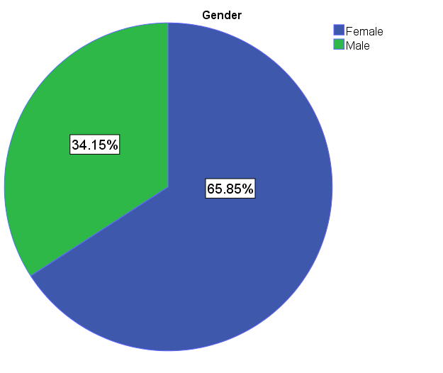
Participants Age Distribution
As illustrated in the table and chart below, the highest frequency by age bracket was those aged 40 – 50 years with a percentage of 34.1% (N = 28) followed closely by those aged between 29years and 40 years at 30.5% (N = 25) and those below 28 years to 18 years representing 22.0% (N= 18). The aged groups were lowly represented with only 11% (N = 9) for the age bracket 50-60 years and 2.4% (N = 2) for those aged above 60 years.

Age
 |  | Frequency | Percent | Valid Percent | Cumulative Percent
Valid | 18 - 28 | 18 | 22.0 | 22.0 | 22.0
 | 29 - 40 | 25 | 30.5 | 30.5 | 52.4
 | 40 - 50 | 28 | 34.1 | 34.1 | 86.6
 | 50 - 60 | 9 | 11.0 | 11.0 | 97.6
 | +60 | 2 | 2.4 | 2.4 | 100.0
 | Total | 82 | 100.0 | 100.0
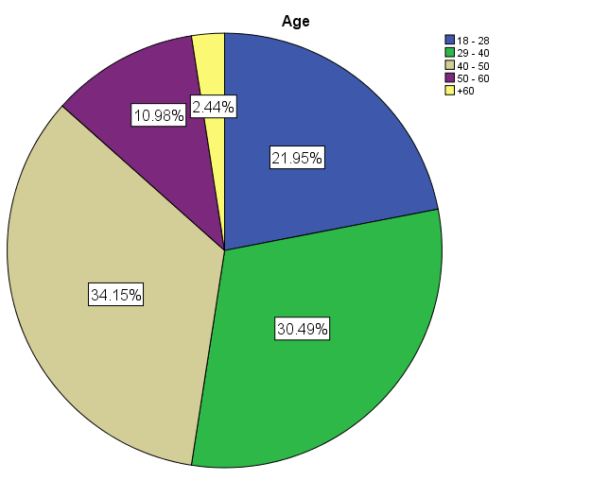
Distribution of Participants by Race
In terms of race, the participants from different races, as presented in the bar graph and the frequency tables, present the measures of central tendency for the presented data. Most of the participants in the study were Black Americans. One common thing from the demographic data is that all participants in the study took part in the retail customer survey.
Race
Mean | 3.02439
Standard Error | 0.152245
Median | 2
Mode | 2
Standard Deviation | 1.378634
Sample Variance | 1.900632
Kurtosis | -0.86913
Skewness | 0.563754
Count | 82
Confidence Level (95.0%) | 0.302919

Descriptive Analysis of the Ordinal Data
The variables in the ordinal data include the customer service, the availability, the sale, the quality, the cleanliness, and the availability of technology paying methods. In this case, the customer service is the independent variable, while other variables are the dependent variables. The data was also collected based on the Likert scale, where participants had to make a decision based on the level of agreement on a scale of 1-5. The discussion of the findings is broken into the six themes assessed.
Satisfaction with Customer Service
The respondents included in the survey were asked to rate their level of satisfaction with the recent purchases made from the evaluated store. In response, the majority of the respondents were confirmed being satisfied with the customer services they received. As shown in the chart below, 43.9% (N = 36) agreed and the same proportion also strongly agreed (43.9%, N = 36) being satisfied with the services. 1.2% (N = 1) strongly disagree, 4.9% (N = 4) disagree, and 6.1% (N = 5) were not sure how they would rate their level of satisfaction.

Customer_satisfaction
 |  | Frequency | Percent | Valid Percent | Cumulative Percent
Valid | Strongly Disagree | 1 | 1.2 | 1.2 | 1.2
 | Disagree | 4 | 4.9 | 4.9 | 6.1
 | Neutral | 5 | 6.1 | 6.1 | 12.2
 | Agree | 36 | 43.9 | 43.9 | 56.1
 | Strongly Agree | 36 | 43.9 | 43.9 | 100.0
 | Total | 82 | 100.0 | 100.0

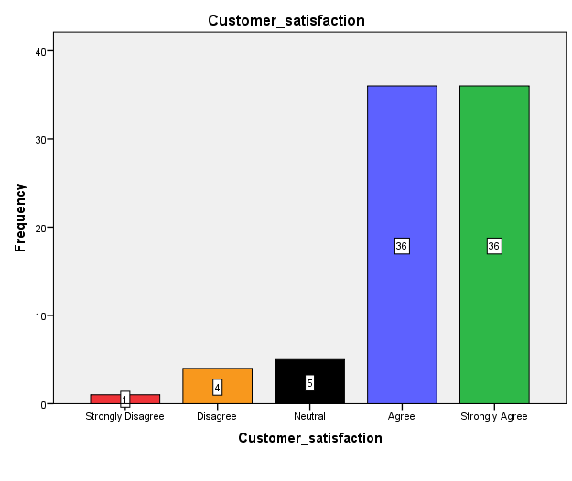
Availability of Online Services
In assessing the ability of the customers to access the purchasing services via the online platforms, they were asked to rate their ease of ordering the products from the store’s website. As illustrated in the chart below, 42.7% (N= 35) agree with 28% (N = 23) strongly agreeing which indicates the availability of favorable online services. Only 2.4% (N = 2) disagree while 26.8% (N = 22) were not sure.

Ability_to_order_products_online
 |  | Frequency | Percent | Valid Percent | Cumulative Percent
Valid | Disagree | 2 | 2.4 | 2.4 | 2.4
 | Neutral | 22 | 26.8 | 26.8 | 29.3
 | Agree | 35 | 42.7 | 42.7 | 72.0
 | Strongly Agree | 23 | 28.0 | 28.0 | 100.0
 | Total | 82 | 100.0 | 100.0

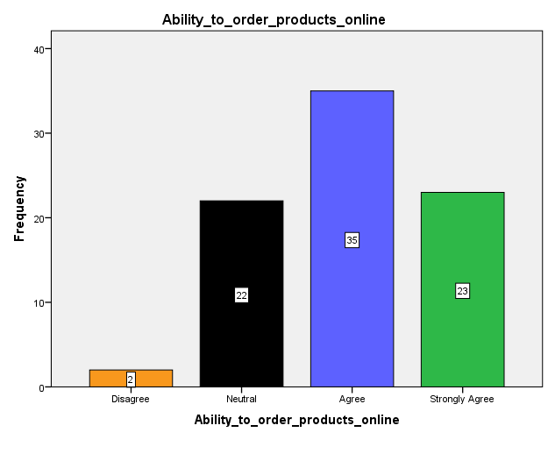
Access to Customer Promotion and Offer Services
Several retail businesses do have practices that are meant to attract more customers, increase customer loyalty, and boost sales. In reference to this course, the participants were asked to rate their ability to access discounts, gifts cards, and other deals. Although the response was skewed to the positive end with 30.5% (N = 25) agreeing and 24.4% (N = 20) strongly agreeing, there was a high proportion of those who were not sure (29.3%, N = 24) they can access the promotion services. This could be due to a gap in marketing. Significantly, 15.9% (N = 13) either disagreed or strongly disagreed with the notion of being able to access the promotion services from the store. The findings are illustrated in the chart below.

Access_to_discount_giftcard_other_benefits
 |  | Frequency | Percent | Valid Percent | Cumulative Percent
Valid | Strongly Disagree | 5 | 6.1 | 6.1 | 6.1
 | Disagree | 8 | 9.8 | 9.8 | 15.9
 | Neutral | 24 | 29.3 | 29.3 | 45.1
 | Agree | 25 | 30.5 | 30.5 | 75.6
 | Strongly Agree | 20 | 24.4 | 24.4 | 100.0
 | Total | 82 | 100.0 | 100.0
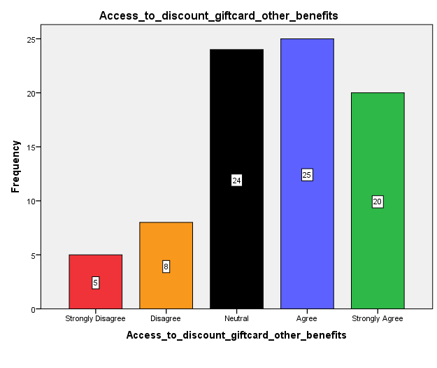
Clean and Approachable Store
One of the motivating factors in gaining a sizable customer base in brick-and-mortar retail settings is the orderliness and accessibility of the shop. Those who participated in the study were asked to rate the store in terms of being very clean and approachable. The majority of them (45.1%, N = 37) agreed, 20.7% (N= 17) strongly agreed, but there was a significantly high proportion of those who were neutral (31.7%, N= 26) as shown in the chart below. Evidently, only 2.4% (N = 2) disagreed that the store was very clean and approachable.

Clean_and_approachable_store
 |  | Frequency | Percent | Valid Percent | Cumulative Percent
Valid | Disagree | 2 | 2.4 | 2.4 | 2.4
 | Neutral | 26 | 31.7 | 31.7 | 34.1
 | Agree | 37 | 45.1 | 45.1 | 79.3
 | Strongly Agree | 17 | 20.7 | 20.7 | 100.0
 | Total | 82 | 100.0 | 100.0
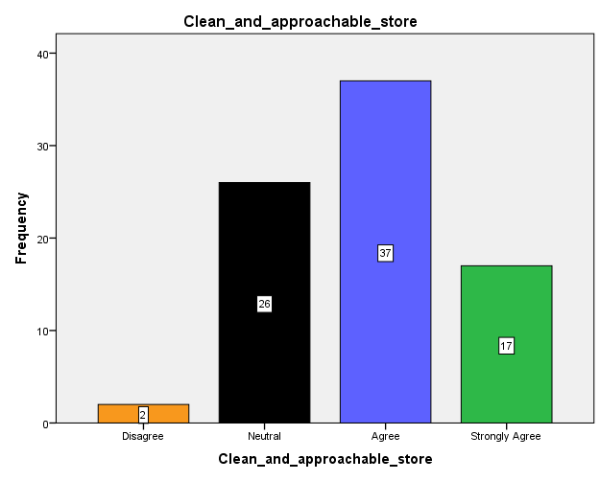
Quality of the Products
The respondents were asked to rate the statement that they enjoy the quality of the product they purchase from the store. Only 9.8% (N = 8) disagreed enjoying the quality of the products from the store with another 29.3% (N = 24) not sure. Impressively, the majority of the participants confirmed enjoying the quality of the products from the store with 40.3% (N = 33) agreeing and 20.7% (N = 17) disagreeing.

Quality_of_the_products
 |  | Frequency | Percent | Valid Percent | Cumulative Percent
Valid | Disagree | 8 | 9.8 | 9.8 | 9.8
 | Neutral | 24 | 29.3 | 29.3 | 39.0
 | Agree | 33 | 40.2 | 40.2 | 79.3
 | Strongly Agree | 17 | 20.7 | 20.7 | 100.0
 | Total | 82 | 100.0 | 100.0

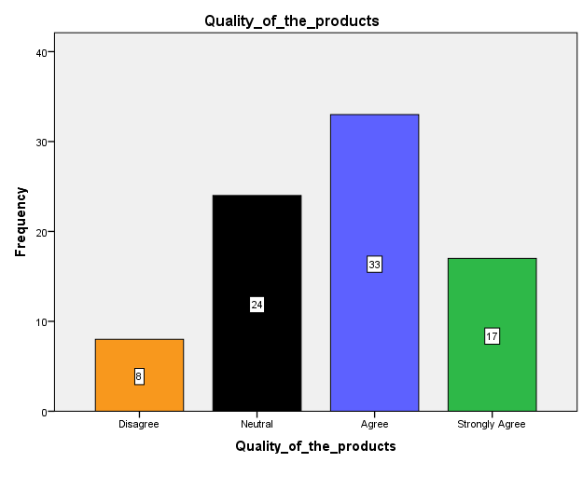
Ability to Pay Using Technology App
In the era of technology, customers are presented with a variety of payment options they can use. The participants in this survey were asked to rate the ability to use a variety of payment methods, in particular using Apple Pay and Samsung Pay. As shown in the chart below, over half of the respondents confirmed they could pay using the two payment methods with 47.6% (N = 39), agreeing and 17.1% (N = 14) strongly agreeing. Also, 26.8% (N = 22) did not agree or disagree while 6.1% (N = 5) disagree and 2.4% (N = 2) strongly disagreeing.

Technology_Pay_using_Apple_or_Samsung_Pay
 |  | Frequency | Percent | Valid Percent | Cumulative Percent
Valid | Strongly Disagree | 2 | 2.4 | 2.4 | 2.4
 | Disagree | 5 | 6.1 | 6.1 | 8.5
 | Neutral | 22 | 26.8 | 26.8 | 35.4
 | Agree | 39 | 47.6 | 47.6 | 82.9
 | Strongly Agree | 14 | 17.1 | 17.1 | 100.0
 | Total | 82 | 100.0 | 100.0

