Robert Frost and T.S. Eliot write poems that make use of many different literary devices. Find 4 examples in these poems (2 poems from Frost, 2 poems from Eliot) of **literary devices** from the list below. In your post, **explain how Frost and Eliot use these literary devices to help communicate the message of their poems**. Answer the questions, “WHAT are Frost’s and Eliot’s messages in these poems, and HOW do Frost and Eliot use these literary devices to communicate those messages?”

**Alliteration**: Alliteration is a series of words or phrases that all (or almost all) start with the same sound. These sounds are typically consonants to give more stress to that syllable. *Example:* "Peter Piper picked a peck of pickled peppers." In this tongue twister, the "p" sound is repeated at the beginning of all major words.

**Allusion:** Allusion is when an author makes an indirect reference to a figure, place, event, or idea originating from outside the text. Many allusions refer to previous works of literature or art.

**Anaphora:** Anaphora is when a word or phrase is repeated at the beginning of multiple sentences throughout a piece of writing.

**Anthropomorphism:** An anthropomorphism occurs when something nonhuman, such as an animal, place, or inanimate object, behaves in a human-like way.

**Colloquialism:** Colloquialism is the use of informal language and slang. It's often used by authors to lend a sense of realism to their characters and dialogue. Forms of colloquialism include words, phrases, and contractions that aren't real words (such as "gonna" and "ain't").

**Euphemism:** A euphemism is when a more mild or indirect word or expression is used in place of another word or phrase that is considered harsh, blunt, vulgar, or unpleasant.

**Hyperbole:** Hyperbole is an exaggerated statement that's not meant to be taken literally by the reader. It is often used for comedic effect and/or emphasis.

**Irony:** Irony is when a statement is used to express an opposite meaning than the one literally expressed by it.

**Juxtaposition:** Juxtaposition is the comparing and contrasting of two or more different (usually opposite) ideas, characters, objects, etc. This literary device is often used to help create a clearer picture of the characteristics of one object or idea by comparing it with those of another.

**Metaphor/Simile:** Metaphors are when an author compares one thing to another. The two things being described usually share something in common but are unalike in all other respects. A simile is a type of metaphor in which an object, idea, character, action, etc., is compared to another thing using the words "as" or "like." Both metaphors and similes are often used in writing for clarity or emphasis.

**Metonym:** A metonym is when a related word or phrase is substituted for the actual thing to which it's referring. This device is usually used for poetic or rhetorical effect.

**Oxymoron:** An oxymoron is a combination of two words that, together, express a contradictory meaning. This device is often used for emphasis, for humor, to create tension, or to illustrate a paradox.

**Personification:** Personification is when a nonhuman figure or other abstract concept or element is described as having human-like qualities or characteristics. (Unlike anthropomorphism where non-human figures become human-like characters, with personification, the object/figure is simply described as being human-like.)

**Symbolism:** Symbolism refers to the use of an object, figure, event, situation, or other idea in a written work to represent something else—typically a broader message or deeper meaning that differs from its literal meaning. The things used for symbolism are called "symbols," and they'll often appear multiple times throughout a text, sometimes changing in meaning as the plot progresses.

**Synecdoche:** A synecdoche is a literary device in which part of something is used to represent the whole, or vice versa. It's similar to a metonym (see above); however, a metonym doesn't have to represent the whole—just something associated with the word used.

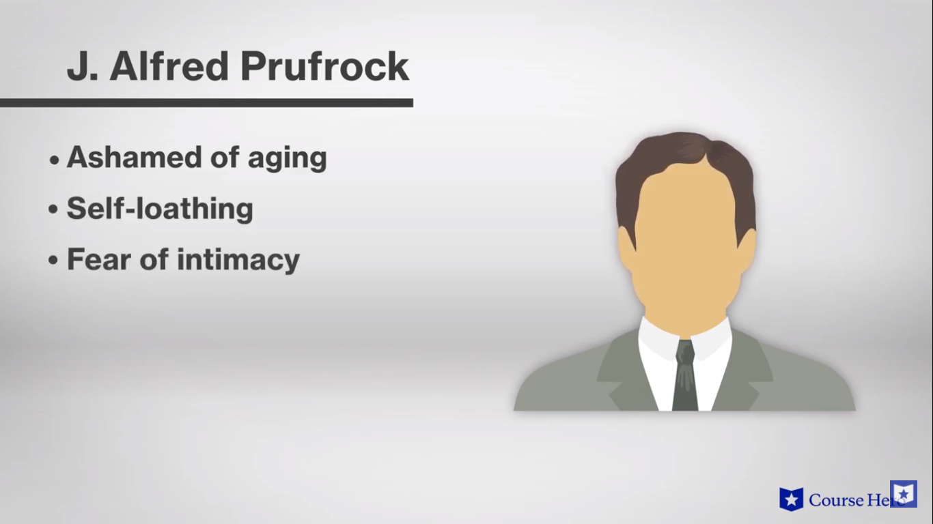

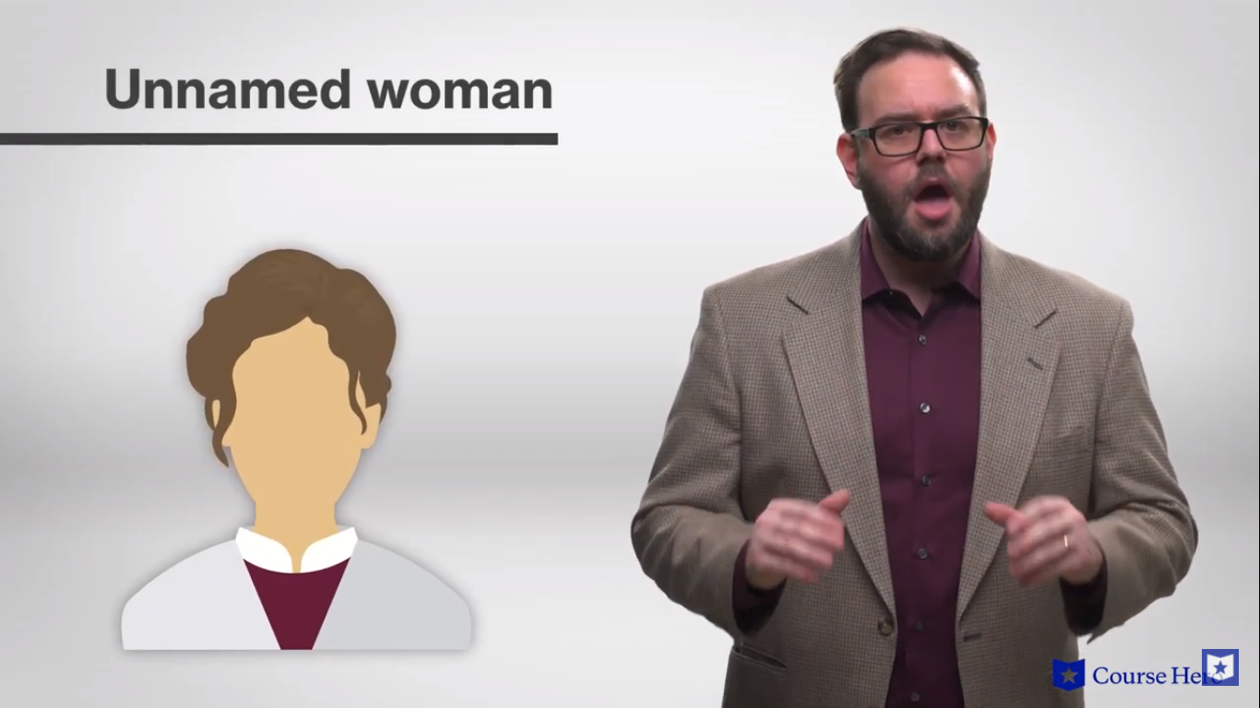

The plot of the poem follows **Prufrock’s self-pity** as he feels himself to be **unloved by the women** in society. There appears to be one **unnamed woman** in particular whose affection he craves.

**Allusion** to Dante’s *Inferno*

“If I but thought that my response were made to one perhaps returning to the world, this tongue of flame would cease to flicker. But since, up from these depths, no one has yet returned alive, if what I hear is true, I answer without fear of being shamed.”

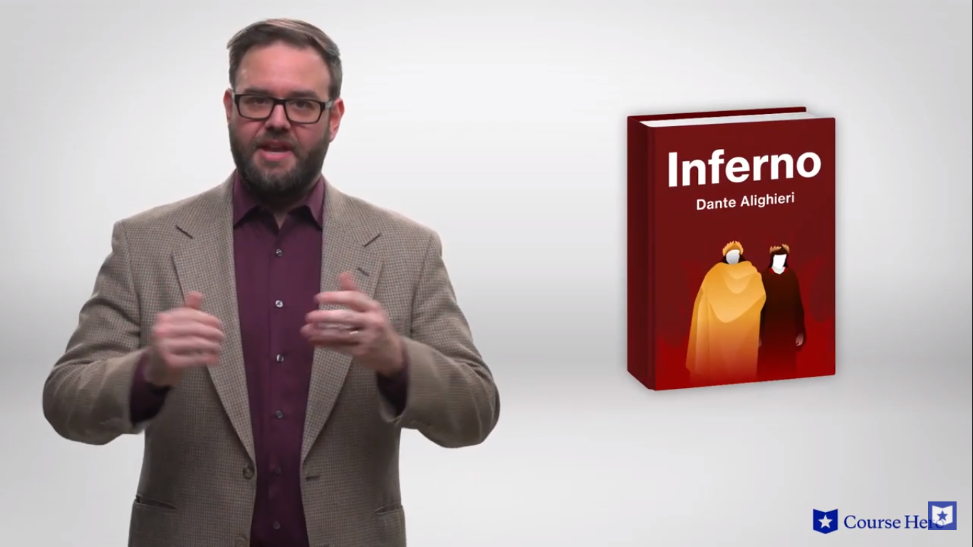*S’io credesse che mia risposta fosse  
A persona che mai tornasse al mondo,  
Questa fiamma staria senza piu scosse.  
Ma percioche giammai di questo fondo  
Non torno vivo alcun, s’i’odo il vero,  
Senza tema d’infamia ti rispondo.*

Let us go then, you and I,

**When the evening is spread out against the sky**

**Like a patient etherized upon a table;**

Let us go, through certain half-deserted streets,

Eliot uses **similes** in the lines: “When the evening is spread out against the sky / **Like a patient** etherized upon a table” and “Streets that follow **like** **a tedious** argument / Of insidious intent.”

The muttering retreats

Of restless nights in one-night cheap hotels

And sawdust restaurants with oyster-shells:

**Streets that follow like a tedious argument**

**Of insidious intent**

To lead you to an overwhelming question ...

Oh, do not ask, “What is it?”

Let us go and make our visit.

The image of the “yellow fog” has all the characteristics of a house cat: “rubs its back,” “rubs its muzzle,” “licked its tongue,” “curled once about the house, and fell asleep.”

In the room the women come and go

**Talking of Michelangelo.**

**The yellow fog** that rubs its back upon the window-panes,

The yellow smoke that rubs its muzzle on the window-panes,

Licked its tongue into the corners of the evening,

Lingered upon the pools that stand in drains,

Let fall upon its back the soot that falls from chimneys,

Slipped by the terrace, made a sudden leap,

And seeing that it was a soft October night,

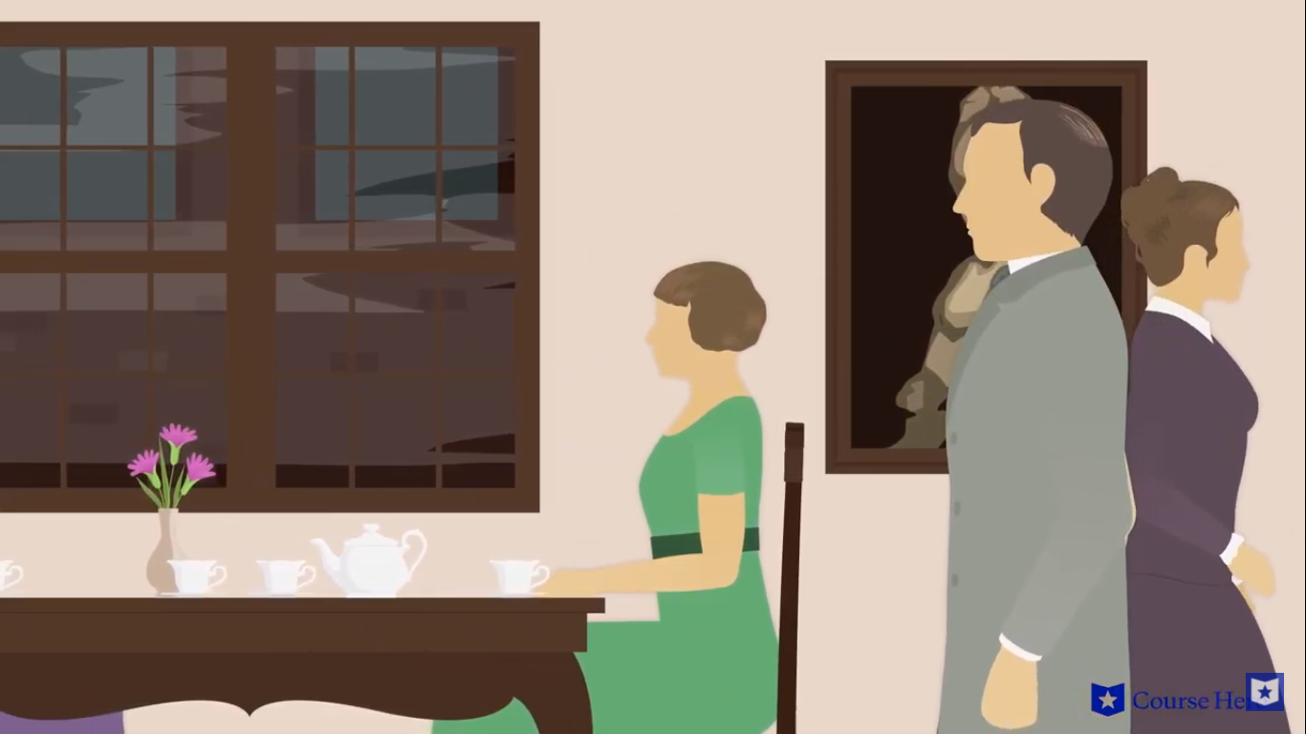Curled once about the house, and fell asleep.

And indeed there will be time

For the yellow smoke that slides along the street,

Rubbing its back upon the window-panes;

**There will be time, there will be time**

**To prepare a face to meet the faces that you meet;**

There will be time to murder and create,

And time for all the works and days of hands

That lift and drop a question on your plate;

**Time for you and time for me,**

**And time yet for a hundred indecisions,**

And for a hundred visions and revisions,

**Before the taking of a toast and tea.**

In the room the women come and go

Prufrock would like to be brave enough to approach the women of society (“Do I dare?”), but he is too self-conscious. Prufrock mentions that he is going bald frequently throughout the poem. He is very self-conscious about his physical appearance in general, and his balding head is his greatest concern.

**Talking of Michelangelo.**

And indeed there will be time

**To wonder, “Do I dare?” and, “Do I dare?”**

Time to turn back and descend the stair,

**With a bald spot in the middle of my hair —**

**(They will say: “How his hair is growing thin!”)**

My morning coat, my collar mounting firmly to the chin,

My necktie rich and modest, but asserted by a simple pin —

(They will say: “But how his arms and legs are thin!”)

**Do I dare**

**Disturb the universe?**

In a minute there is time

For decisions and revisions which a minute will reverse.

For I have known them all already, known them all:

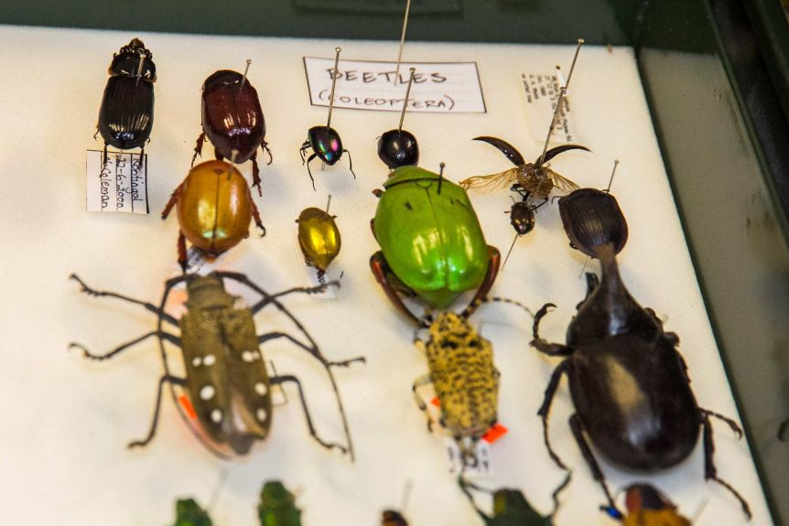Have known the evenings, mornings, afternoons,

I have measured out my life with coffee spoons;

I know the voices dying with a dying fall

Beneath the music from a farther room.

               So how should I presume?

And I have known the eyes already, known them all—

The eyes that fix you in a formulated phrase,

**And when I am formulated, sprawling on a pin,**

**When I am pinned and wriggling on the wall,**

Then how should I begin

To spit out all the butt-ends of my days and ways?

               And how should I presume?

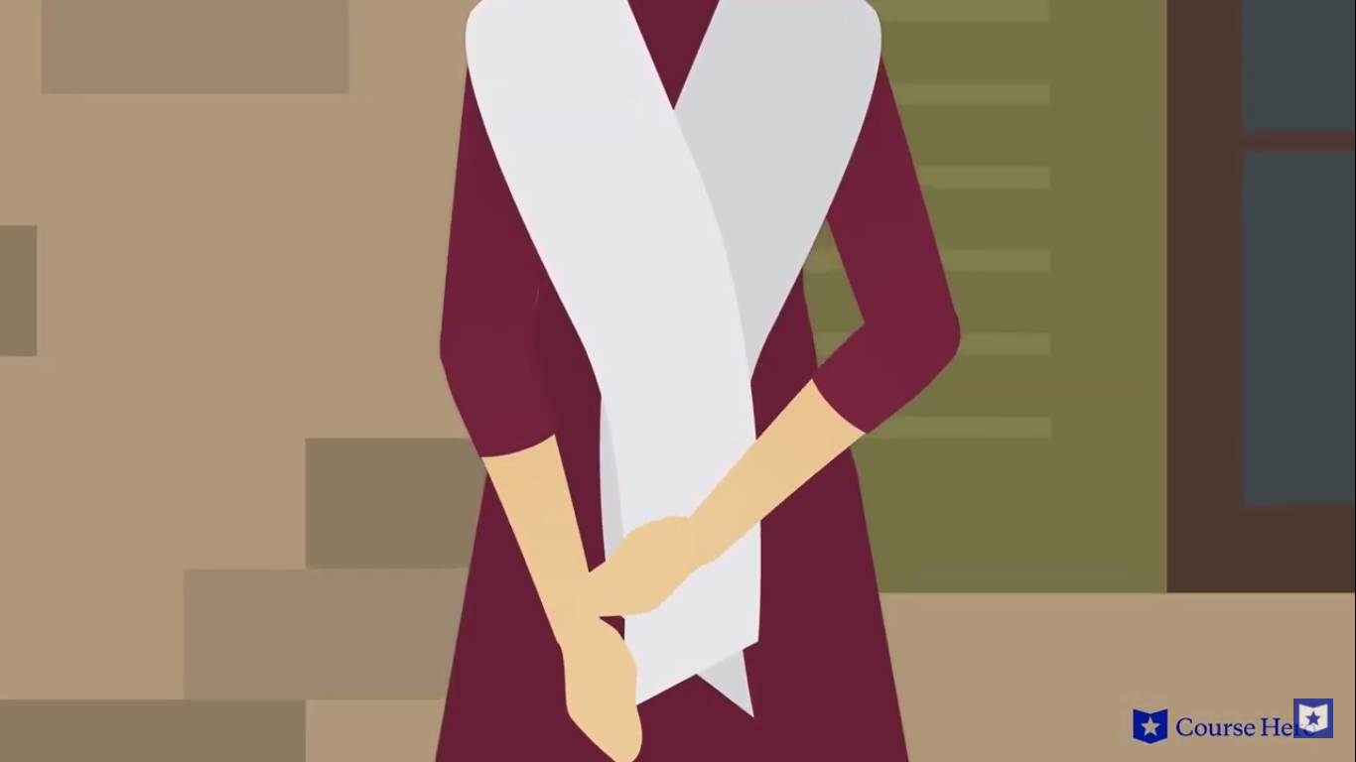

And I have known the arms already, known them all—

**Arms that are braceleted and white and bare**

**(But in the lamplight, downed with light brown hair!)**

Is it perfume from a dress

That makes me so digress?

Arms that lie along a table, or wrap about a shawl.

**And should I then presume?**

**And how should I begin?**

Shall I say, I have gone at dusk through narrow streets

And watched the smoke that rises from the pipes

Of lonely men in shirt-sleeves, leaning out of windows? ...

**I should have been a pair of ragged claws**

**Synecdoche:** I should have been a pair of ragged claws / Scuttling across the floors of silent seas.

**Allusion:** The bible tells the story of Lazarus, who was resurrected from the dead by Jesus.

**Hyperbole:** Hyperbole is an exaggerated statement that's not meant to be taken literally by the reader. It is often used for comedic effect and/or emphasis.

**Scuttling across the floors of silent seas.**

…

And would it have been worth it, after all,

After the cups, the marmalade, the tea,

**Among the porcelain, among some talk of you and me,**

Would it have been worth while,

To have bitten off the matter with a smile,

To have squeezed the universe into a ball

To roll it towards some overwhelming question,

**To say: “I am Lazarus, come from the dead,**

**Come back to tell you all, I shall tell you all”—**

If one, settling a pillow by her head

**Should say: “That is not what I meant at all;**

**That is not it, at all.”**

And would it have been worth it, after all,

Would it have been worth while,

After the sunsets and the dooryards and the sprinkled streets,

After the novels, after the teacups, after the skirts that trail along the floor—

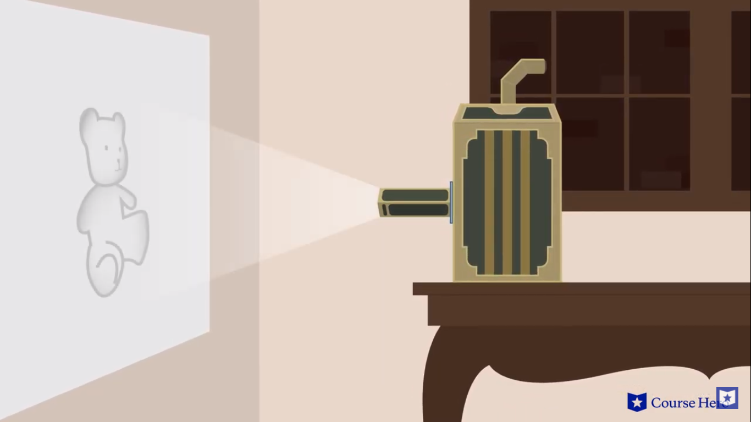And this, and so much more?—

It is impossible to say just what I mean!

**But as if a magic lantern threw the nerves in patterns on a screen:**

Would it have been worth while

If one, settling a pillow or throwing off a shawl,

And turning toward the window, should say:

**“That is not it at all,**

**That is not what I meant, at all.”**

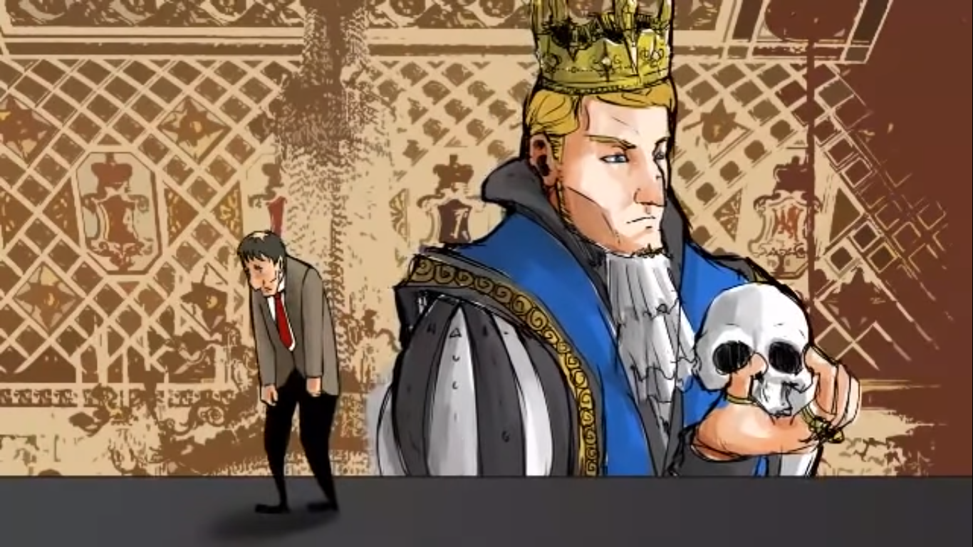No! I am not Prince Hamlet, nor was meant to be;

Am an attendant lord, one that will do

To swell a progress, start a scene or two,

Advise the prince; no doubt, an easy tool,

Deferential, glad to be of use,

Politic, cautious, and meticulous;

Full of high sentence, but a bit obtuse;

At times, indeed, almost ridiculous—

Almost, at times, the Fool.

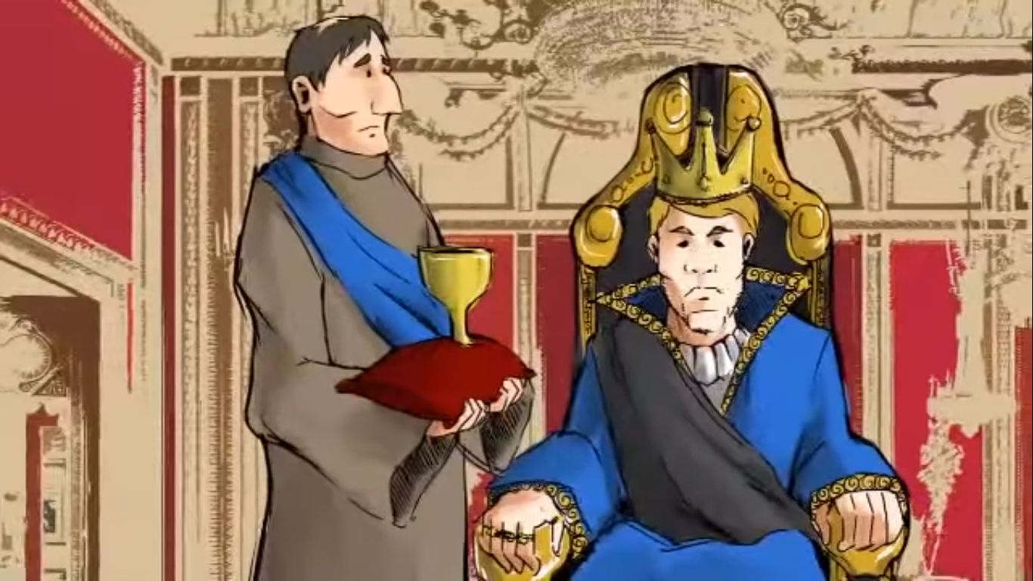

I grow old ... I grow old ...

I shall wear the bottoms of my trousers rolled.

Shall I part my hair behind?   Do I dare to eat a peach?

I shall wear white flannel trousers, and walk upon the beach.

**I have heard the mermaids singing, each to each.**

**I do not think that they will sing to me.**

**Allusion:** Shakespeare wrote the play *Hamlet*, about the prince of Denmark. Prufrock admits in his self-pity that he could never play the lead in this play. He could only have a small part.

He also pities himself to say that mermaids could never love him, just as women of society do not love him.

I have seen them riding seaward on the waves

Combing the white hair of the waves blown back

When the wind blows the water white and black.

We have lingered in the chambers of the sea

**By sea-girls wreathed with seaweed red and brown**

**Till human voices wake us, and we drown.**

