9 Vegetarian Charcoal Grill Recipes to Try This Summer

It’s summertime. The sun is beating down, the kids are splashing around in the pool and the smoky smell of a backyard BBQ fills the air. Now most of the time grilling and meat are synonymous in people’s heads, but this summer try something different.

Although it may be hard to pass up the classic baby back ribs or T-bone steak, give one of these tasty vegetarian recipes a try:

1. Fire Roasted Salsa

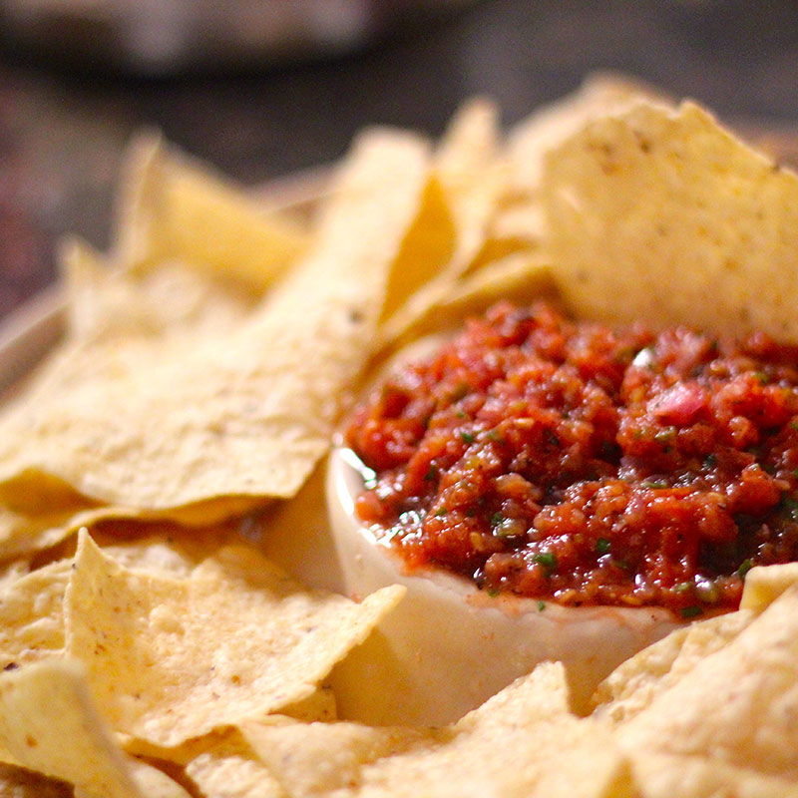

Charcoal grilling is an art and so is making salsa. Taking the time to char the tomatoes and vegetables gives the salsa a sweet, smoky taste that is well worth the wait. You can try it with homemade tortilla chips or quesadillas. Check out the recipe [here](https://www.kingsford.com/recipe/fire-roasted-salsa/#jIsXMXxHXIL3O0mV.97).

2. Elote (Mexican Grilled Corn)

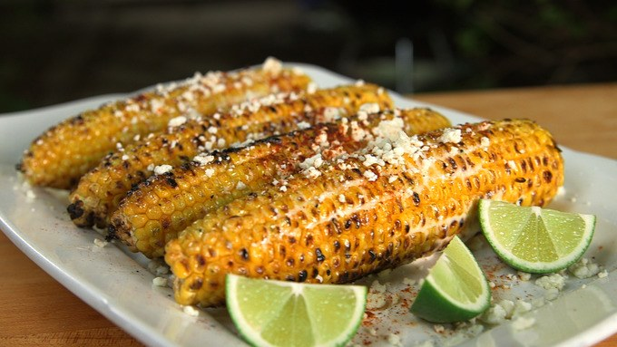

The popular Mexican street food is easy to make in your own backyard. It’s often served family style, so grill them up and then let your guests decide how to top them.

The most common Elote toppings are salt, chile powder, butter, cotija, lemon juice or lime juice or mayonnaise, but you can also experiment and try something new. Find the recipe [here.](https://www.kingsford.com/recipe/elote-grilled-mexican-street-corn/#JCRvr3uMDKwSAglf.97)

# 3. Grilled Endive and Romaine Salad

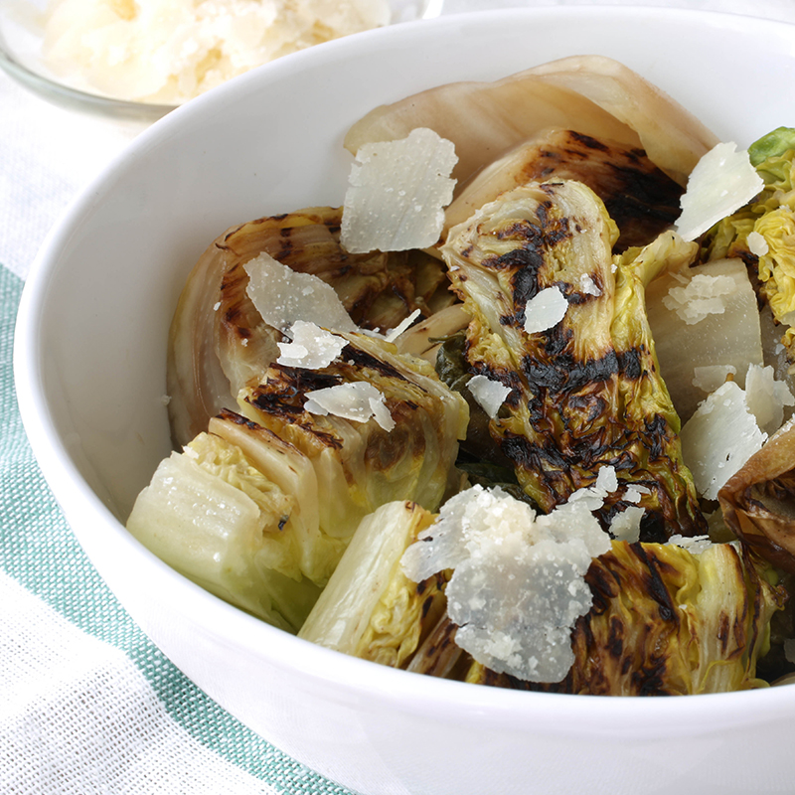

Impress your dinner guests with his new take on salad that tops the traditional garden salad. Start by grilling the endives and baby romaine to add extra flavor and then finish it off with some freshly grated Parmesan. Click [here](https://www.kingsford.com/recipe/2462/grilled-endive-and-romaine-salad) for the recipe.

# 4. Grilled Cheese-Stuffed Jalapenos

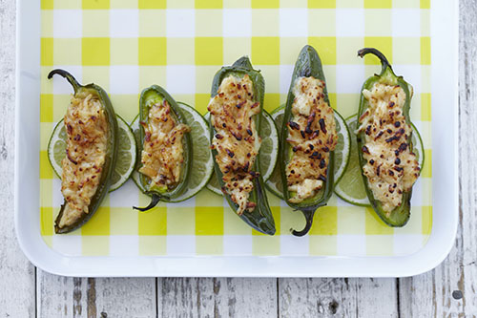

With ooey-gooey cheese and the spicy Kingsford Honey Jalapeno Mesquite Barbecue Sauce these jalapenos will be irresistible. They are perfect for an appetizer or just a quick summertime snack. Find the recipe [here](https://www.kingsford.com/recipe/2076/grilled-cheese-stuffed-jalapenos).

# 5. Grilled and Chilled Vegetable Pasta

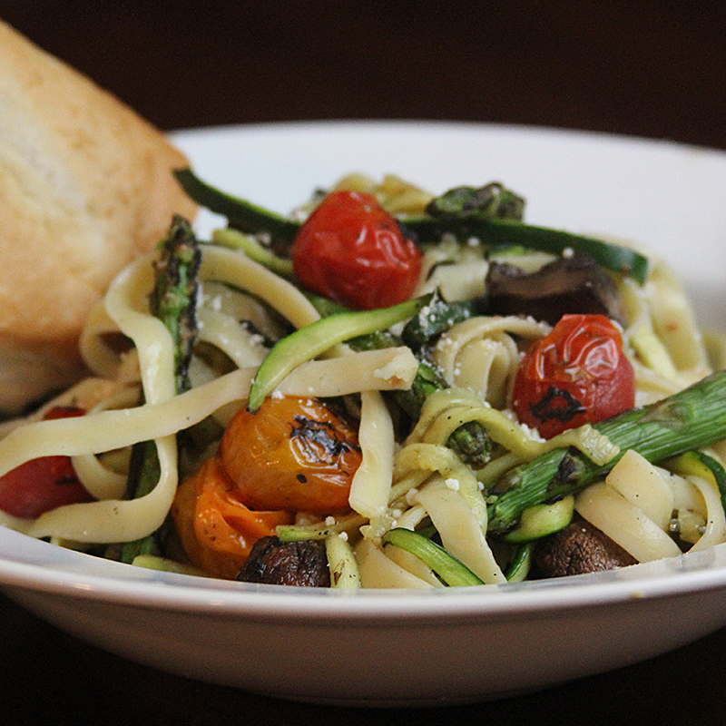

Looking for a quick and healthy meal? Then try the grilled and chilled vegetable pasta. This meal only takes 25 minutes to cook and prepare. It’s made with zucchini, cherry tomatoes, asparagus and bella mushrooms. These ingredients are full of nutritious values and great taste. Find the recipe [here](https://www.kingsford.com/recipe/grilled-and-chilled-vegetable-pasta/#Eh9KrkzfsdpBtPDM.97).

6. Stuff and Grilled Eggplant

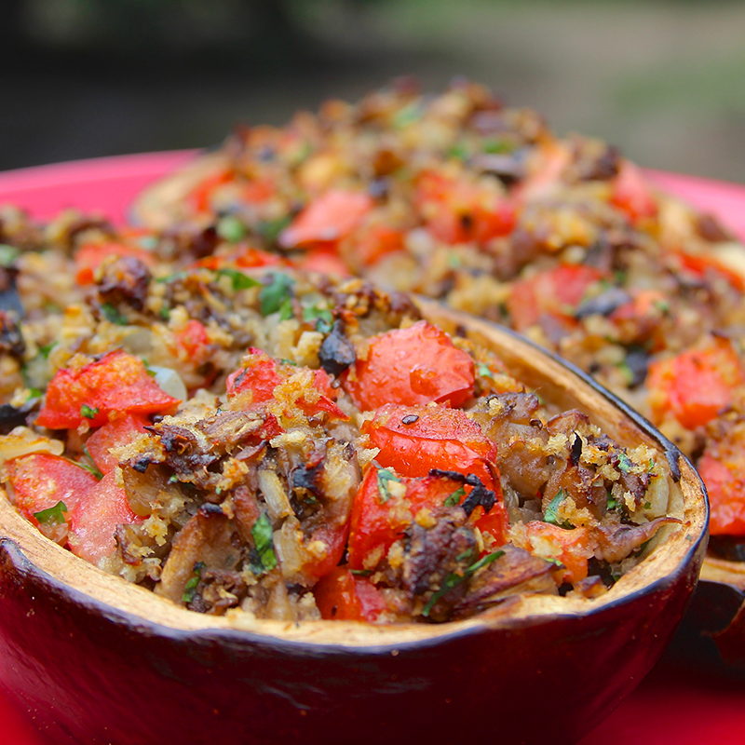

For this recipe you may want to raid the garden or visit a farmers market for some fresh ingredients. The eggplants are stuffed with tomatoes, white button mushrooms and Parmesan cheese and roasted to create an unforgettable taste. Click [here](https://www.kingsford.com/recipe/stuffed-and-grilled-eggplant/#MTslD12Ht6TAtOJP.97) for the recipe.

# 7. Grilled Falafel Sandwich

# 

# Biting into this traditional Middle Eastern meal you’ll get the taste of far off places. So take an adventure in your own back yard by giving this recipe a try.

# Falafel is made from chickpeas, fava beans or both, so it’s 100 percent vegetarian and a good substitute for the time-honored hamburger. Find the recipe [here](https://www.kingsford.com/recipe/3316/grilled-falafel-sandwich).

# 8. Grilled Lemonade

# 

# Grilled Lemonade brings a new edge to the staple of all summer drinks. Grilling the lemons adds a smoky taste and the herby, sweet rosemary syrup builds the perfect summertime sipper.

# Want to add a kick to your evening? Mix in a little of your favorite hooch (tastes best with Bourbon, Gin or Vodka). Check out the recipe [here](https://www.kingsford.com/recipe/grilled-lemonade/#cIftFERWWV6swCfg.97).

# 9. Grilled Pizza Margherita

# 

The Grilled Pizza Margherita recipe calls for fresh basil and mozzarella making the pizza burst with Italian flavor. You’ll need a Kingsford KettlePizza Oven insert to grill the pizza. The recipe maybe time consuming but not difficult and worth it if you want an unforgettable meal. Find the recipe [here](https://www.kingsford.com/recipe/grilled-pizza-margherita/#Atuz2m0heFS7Hd12.97).

# 

# Are you hungry yet? A good cookout doesn’t just have to have meat, substitute one of these vegetarian recipes or make both. Make sure to gather up your ingredients and pick up a bag of Kingsford Charcoal to have the best cookout of the summer.