**Glass Boot Pizza Company – Business Plan**

**1.0 Executive Summary**

The Glass Boot Pizza Company is a new enterprise in the restaurant industry.  The Glass Boot is in a stable and familiar collegiate town that has a strong need for entertaining and responsive dining options.  Bolstered by the need for more choices in entertainment-oriented dining experiences, combined with the option for home-delivery, the Glass Boot is positioned to take advantage of the market need and serve the University of Kansas students, families, and selected clubs and organizations in the Lawrence area.

Lawrence’s population is rapidly growing with new subdivisions and young families moving to the rural suburb of the Hewgton area just east of town.  It is Glass Boot Pizza Company’s strategy to exploit the first-mover opportunity and establish itself as the preferred pizza provider to the area.  We believe a locally-owned restaurant is the best option to serve the rapidly growing population with a fresh, unique menu as opposed to a national chain franchise.

This business plan calls for an exciting, profitable start-up year ahead with future forecasted growth as we meet the demands of the community.  In all, this plan describes a healthy company with good growth prospects, looking to manage its orderly growth in the near future.

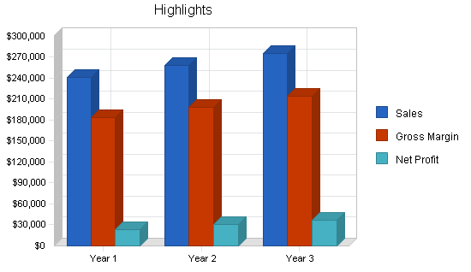

* 1. **Mission**

The Glass Boot Pizza Company offers the best mix of dining entertainment, quality food, and customer service for university students, families, and local clubs and organizations in the greater Lawrence, KS area. The intent for our restaurant is to provide a safe, fun, and accommodating place wherein customers and business partners want to participate in collective social interaction. The intent for our delivery service is to provide fast and dependable home and office food deliveries.

**1.2 Keys to Success**

Our customers are our neighbors as we are residents of our market area.  We create and nurture a healthy, creative, respectful, and fun working environment, in which our business partners are fairly compensated and encouraged to respect the customer and the quality of the product we produce.  Our vested employees are our business partners. We seek fair and responsible profit, enough to keep the company financially healthy for the long term and to fairly compensate owner, investors, and business partners for their investment, risk, and hard work.

The keys to success in this business are:

* Delivering the customer value proposition
  + Fun environment
  + Responsive to local interests
  + Safe and clean
  + Great food value
  + Fast delivery service
* Valuing employees as business partners
* Target marketing to local clubs and organizations
* Product quality and consistency
* Providing entertainment opportunities that have meaning in the community
* College-oriented atmosphere that highlights the local university as well as local clubs and organizations
* Management: fast delivery service; responsiveness to community trends; control costs; customer orientation
* Eye on the profit line
* Reporting and controls in place for inventory and financials
  1. **Goals and Objectives**

Glass Boot Pizza Company goals and objectives are separated into short term and long term interests. Short term interests are those that will be accomplished within 12 months and long term interests will be accomplished within 36-60 months. At times these goals and objectives will carry over from short to long term.

**Short term goals and objectives are:**

**Goal 1:** Create and adopt a business plan – September 30, 2017

Objective 1: Complete business plan - March 1, 2017

Objective 2: Business plan adopted by investors - September 30, 2017

**Goal 2:** Acquire $200,000 in funding – October 31, 2017

Objective 1: Complete funding plan that is adopted by investors by March 30, 2017

Objective 2: Account for investor funding by April 15, 2017

Objective 3: Acquire bank or another investor funding for that portion or the

$200,000 not covered by initial investors by September 1, 2017

**Goal 3:** Acquire business location – August 1, 2017

Objective 1: Describe details of business location requirements including selection

and evaluation criteria - February 1, 2012

Objective 2: Identify at least two possible locations and describe them in terms of the

selection and evaluation criteria - March 1, 2012

Objective 3: Select a business location – April 1, 2012

Objective 4: Lease or purchase property – July 1, 2012

**Goal 4:** Hire business partners – September 30, 2012

Objective 1: Describe corporate positions in terms of competencies, skills,

knowledge, and attributes – March 1, 2012

Objective 2: Describe compensation standards – March 1, 2012

Objective 3: Interview and hire key management positions – September 30, 2012

Objective 4: Interview and hire other business partners – August 15, 2012

Objective 5: Train business partners – August 15-30, 2012

**Goal 5:** Create and execute initial marketing plan

Objective 1: Create initial marketing plan that targets all local high schools, the

University of Kansas housing folks, and at least five other local clubs or

organizations – March 30, 2017

Objective 2: Plan opening day activities and get these activities adopted by the

investors – March 30, 2017

Objective 3: Make positive contact and tacit agreements with targeted clubs and

organizations – April 30, 2017

Objective 4: Execute initial marketing plan – November 30, 2017

**Goal 6:** Acquire business fixtures and tools – October 15, 2017

Objective 1: List business fixtures and equipment required and price them out as part of

This business plan

Objective 2: Acquire all business fixtures and equipment by opening day

**Goal 7:** To establish the market presence needed to support sales objectives and to attract customers sufficient to make the Company show a net profit by each year

Objective 1: After initial purchases for fixtures and equipment, pay cash for all other

purchases

Objective 2: Produce sales in each category in accordance with the matrix in Appendix B

Objective 3: Eliminate sales categories that are not profitable by the end of the first year.

**Long term goals and objectives are:**

**Goal 1:** Create and adopt a business plan – September 30, 2017

Objective 1: Complete business plan - March 1, 2017

Objective 2: Business plan adopted by investors - September 30, 2017

**Goal 2:** To establish the market presence needed to support sales objectives and to attract customers sufficient to make the Company show a net profit by each year

Objective 1: Pay cash for all purchases

Objective 2: Produce sales in each category in accordance with the matrix in Appendix B

Objective 3: Eliminate sales categories that are not profitable at the end of each year

Objective 4: Show a 10% net profit by the end of year three

**Goal 3:** Open at least one new location by the end of year five

Objective 1: Complete expansion plan - March 1, 2019

Objective 2: Expansion plan adopted by investors - September 30, 2019

Objective 3: Open new location

**2.0 Company Summary**

The Glass Boot Pizza Company is a privately-owned pizza company offering a product menu that does not currently exist in the area and the first to offer home or office delivery with very short (10-15 minutes) delivery time.  Our customers are many of the young families and students in the area, but because of our entertainment offerings and location, we will over time also attract some tourist type customer base.

**2.1 Company Ownership**

The Glass Boot Pizza Company will be established as a limited liability company (LLC) with Gimme Pizza as the sole owner.

**2.2 Start-up Summary**

The Glass Boot Pizza Company start-up costs cover the renovation of the occupied restaurant location (currently a warehouse space), professional fees, and expenses associated with opening our first location.  The start-up costs are to be financed by direct owner investment, financial institutions, and private investors.  Of the $200,000 estimated start-up costs, $100,000 will be invested by the owner, $50,000 from private investors, and $50,000 from financial institutions. The assumptions are shown in the following table and illustration.

|  |  |
| --- | --- |
| **Start-up** | |
|  |  |
| Requirements |  |
|  |  |
| Start-up Expenses |  |
| Professional Fees (Legal, Accounting, Consulting) | $1,800 |
| Placemats, Stationery, Business Cards | $1,100 |
| Renovation | $8,300 |
| Marketing | $2,500 |
| Rent | $2,000 |
| Expensed Equipment | $5,000 |
| Insurance | $350 |
| Website Development | $1,000 |
| Misc Expense | $3,800 |
| Total Start-up Expenses | $25,850 |
|  |  |
| Start-up Assets |  |
| Cash Required | $23,100 |
| Start-up Inventory | $6,000 |
| Other Current Assets | $5,250 |
| Long-term Assets | $20,300 |
| Total Assets | $54,650 |
|  |  |
| Total Requirements | $80,500 |

|  |  |
| --- | --- |
| **Start-up Funding** | |
|  |  |
| Start-up Expenses to Fund | $25,850 |
| Start-up Assets to Fund | $54,650 |
| Total Funding Required | $80,500 |
|  |  |
| Assets |  |
| Non-cash Assets from Start-up | $31,550 |
| Cash Requirements from Start-up | $23,100 |
| Additional Cash Raised | $0 |
| Cash Balance on Starting Date | $23,100 |
| Total Assets | $54,650 |
|  |  |
|  |  |
| Liabilities and Capital |  |
|  |  |
| Liabilities |  |
| Current Borrowing | $0 |
| Long-term Liabilities | $25,000 |
| Accounts Payable (Outstanding Bills) | $9,500 |
| Other Current Liabilities (interest-free) | $0 |
| Total Liabilities | $34,500 |
|  |  |
| Capital |  |
|  |  |
| Planned Investment |  |
| Investor 1 | $15,000 |
| Owners | $30,000 |
| Additional Investment Requirement | $1,000 |
| Total Planned Investment | $46,000 |
|  |  |
| Loss at Start-up (Start-up Expenses) | ($25,850) |
| Total Capital | $20,150 |
|  |  |
|  |  |
| Total Capital and Liabilities | $54,650 |
|  |  |
| Total Funding | $80,500 |

**Services**

Glass Boot Pizza Company offers high quality pizza to a growing community that currently has limited availability of restaurants and no availability to delivery.  At start up we will be open for dinner 4 p.m. to 10 p.m. Sunday - Thursday and 3 p.m. to 11 p.m. Friday and Saturday.  We will consider opening earlier and serving lunch if there is a demand, and if forecast and financial analysis can justify the increased costs.

Our menu will include 4 sizes of pizzas with various combinations of toppings.  Predefined, high-margin pizzas will be highlighted on the menu.  Additionally, breadsticks, beer, and soda will be included in the initial menu offerings.

**Market Analysis Summary**

Our primary target market is people who desire a comfortable, family-oriented environment for dine-in pizza.  Our secondary target market also desires a delivery service for pizza, or a take-out approach.  There is overlap of these segments.

Lawrence and its surrounding communities are a growing middle-class area with nearly 14,000 residents.  A majority of these residents are families of four or more.  The boom in the area is primarily in response to an exodus of families moving out of the over-populated areas and into a more rural setting.

According to a Growth Plan Lawrence conducted in 2001, population within Lawrence is expected to increase.  However, the number of persons per household is expected to decline, meaning the need for additional housing in Lawrence will continue to grow.  From the same plan, population is listed as being evenly distributed by age groupings, with approximately 33% of the population being minors.  Another 40% are less than 54 years of age, indicating a major concentration of the Lawrence population being families.  The report forecasts there being nearly 1,900 households in the Lawrence by 2005.  This is driving the need for more quality, family-oriented restaurants.

Additionally, Lawrence residents frequently visit the building in which Glass Boot Pizza Company is located. Tanning and video rental businesses are adjacent to the restaurant, so we are providing a new convenience for families to select a movie and pick up a pizza.

With the expected continued growth in the area, estimated at 7% annually, opportunities to serve Lawrence and its surrounding communities will increase.  The company will sell predominantly to individuals, but it will also accept some catering jobs to individual parties, schools, and company functions in the Lawrence area.

**4.1 Market Segmentation**

Those residents of neighboring communities of Lawrence, including Doughbuoy, d'Ohtown, and Doe Valley are included in the Market Segmentation.  Only those residents of Lawrence are included in the delivery, as delivery radius is limited to a 5-mile radius in the city of Lawrence.  An estimated 53% of Lawrence residents live within the Sanitary District, or within this 5-mile radius.

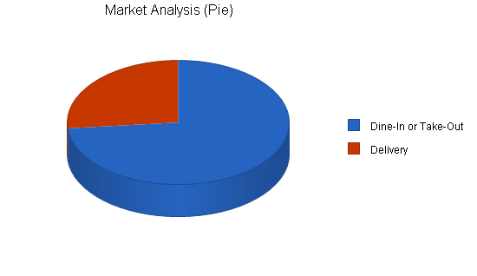

|  |  |  |  |  |  |  |  |
| --- | --- | --- | --- | --- | --- | --- | --- |
| **Market Analysis** | | | | | | | |
|  |  | Year 1 | Year 2 | Year 3 | Year 4 | Year 5 |  |
| Potential Customers | Growth |  |  |  |  |  | CAGR |
| Dine-In or Take-Out | 7% | 13,860 | 14,830 | 15,868 | 16,979 | 18,168 | 7.00% |
| Delivery | 7% | 5,000 | 5,350 | 5,725 | 6,126 | 6,555 | 7.00% |
| Total | 7.00% | 18,860 | 20,180 | 21,593 | 23,105 | 24,723 | 7.00% |

**4.2 Target Market Segment Strategy**

Including Lawrence and its surrounding areas, no pizza establishments exist.  In Lawrence one to two restaurants serve pizza, but not as a primary menu item.  These pizza outlets are in taverns which are not conducive to family-type atmosphere.  No eating establishments in the Lawrence area provide home-delivery service.

**4.3 Service Business Analysis**

Other family-oriented restaurants in the area include:  Subway(R), What's Cookin' diner, and Colonial House supper club.  Subway serves sandwiches, wraps, and salads, none of which are direct competition to the pizza establishment.  The diner is open until 2 p.m. each day and focuses on the breakfast crowd, with a limited sandwich availability for lunch.  The supper club has a Chicken and Pizza buffet once a week for approximately $6; the pizza served as part of the buffet are frozen pizzas.

Other restaurants in Lawrence are taverns and are not conducive to family activities.  One of the bars in Lawrence serves a homemade pizza.

In conversations with an independent pizza operator in Lakeshore Haven, an hour's drive away, he indicated pizza sales in his community are thriving despite competition from 4 other pizza establishments, including Pizza Hut(R).  While exact figures were not shared, he indicated a high level of penetration into the pizza market in his area with profitable margins.  He also provided suggestions and tips to minimize costs, and components of his restaurant he would do differently, including payroll handling, vendors, and layout.

**4.3.1 Competition and Buying Patterns**

There is minimal competition for pizza in the Lawrence area, besides the bar establishments previously mentioned.  The closest locales for pizza to the Lawrence area are Bolingbrooke, Avro, and de Havilland.  None of these competing pizza locations deliver to the Lawrence area.  Additionally, Glass Boot Pizza Company would be the only family-oriented, non-smoking restaurant in Lawrence.

**Strategy and Implementation Summary**

Our strategy is based on delivering a strong customer value proposition in a niche market.  The world is full of small, family-oriented towns that do not have endless opportunities for dining out.  We are looking to offer the Lawrence and its surrounding areas a new choice in food options.

Also:

* What begins as a need to satisfy a need in the community, can eventually turn into a mainstay in the small-town community.
* We are building our marketing infrastructure so that we can eventually reach additional towns with the same offering.
* We focus on satisfying the needs of small towns.

**5.1 Competitive Edge**

Our competitive edge is to be first-to-the-market with pizza in a friendly, non-smoking, family-oriented dine-in experience, and first-to-the-area with food delivery.

Additionally, the location of Glass Boot Pizza Company is crucial as a convenience model to customers.  Lawrence residents frequent the video rental store adjacent to the restaurant.  This location is directly in the center of activity in this rural community--it is within walking distance of the middle and high schools, the local church, and within 2 miles of the existing large subdivisions and apartment complexes in the area.

**5.2 Marketing Strategy**

To drive customers to Glass Boot Pizza Company, we will employ several techniques outlined below.

Advertising in Bolingbrooke Post, de Havilland Buyer's Guide, Lawrence Register, and Lawrence Shopping News will be used to promote the Grand Opening of Glass Boot Pizza Company.  As part of the advertising, a coupon will be available to customers.  Intermittent newspaper advertisements will continue throughout the year to promote upcoming events.  Most initiatives will focus on the local Lawrence papers as the target of these papers is specifically the Lawrence residents.  Additional marketing efforts will come in the form of on-box coupons for future purchases.

Additionally, family-oriented events will be hosted by Glass Boot Pizza Company to attract customers such as trivia nights, birthday parties, and prize giveaways.  Frequent buyer cards will be employed to entice repeat customers.  Glass Boot Pizza Company will also sponsor a local Little League baseball team, and a bowling team to publicize the restaurant within the community events.

Future plans of working in coordination with the adjacent video store to offer "bundle savings" if both pizza and video rentals are purchased will be pursued within the second year of operation.

**5.3 Sales Strategy**

The Lawrence area has expressed its need for additional restaurants, specifically a desire for pizza.  Because of this, there is pent-up demand for pizza in this area.  We will expect a high rate of sales growth within the first 3 months as this customer desire is met.

For the next year, we continue to focus on a growing presence in the community and advertising heavily throughout the community.  As a major convention center and water park open in nearby Fairchild, we will focus our attention on becoming the recognized provider of pizza to that establishment.

**5.3.1 Sales Forecast**

Our sales forecast assumes a modest change in annual costs to accommodate new entry into the market.

We are expecting to increase sales modestly but steadily over the next year, which is a respectable growth rate.  The growth forecast is assumed given this is a new product for the area using new channels of availability.  We are not projecting significant change in the product line, or in the proportion between different lines.

Based on industry averages and the absence of competition for pizza in the Lawrence area, we are predicting an average of 25 pizzas sold each week night (Sunday - Wednesday).  On the weekends (Thursday - Saturday), we are estimating 40 pizzas are sold each day.  Of those pizzas ordered, we are expecting approximately 1/3 to be dine-in customers.  Those customers dining in will most likely order drinks and/or beer (on average 4 for each family).  Additionally, we are estimating that approximately one-third of the pizza orders will be accompanied by an order for breadsticks.  Our estimated average prices for each item are as follows:

* Pizza:  $12
* Breadsticks:  $2.50
* Beer:  $2.50/pint
* Drinks:  $1.70 refillable

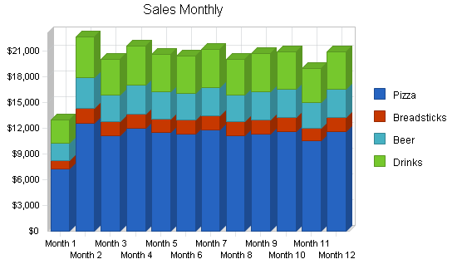

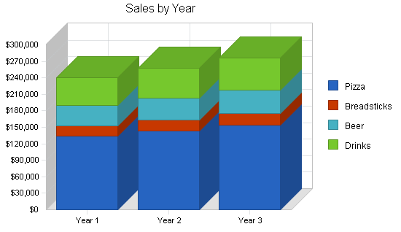

|  |  |  |  |
| --- | --- | --- | --- |
| **Sales Forecast** | | | |
|  | Year 1 | Year 2 | Year 3 |
| Sales |  |  |  |
| Pizza | $133,900 | $143,808 | $153,875 |
| Breadsticks | $18,667 | $19,973 | $21,371 |
| Beer | $37,333 | $39,947 | $42,743 |
| Drinks | $50,773 | $54,327 | $58,130 |
| Total Sales | $240,673 | $258,055 | $276,120 |
|  |  |  |  |
| Direct Cost of Sales | Year 1 | Year 2 | Year 3 |
| Pizza | $42,848 | $44,990 | $47,240 |
| Breadsticks | $3,733 | $3,920 | $4,116 |
| Beer | $7,467 | $7,840 | $8,232 |
| Drinks | $2,539 | $2,666 | $2,799 |
| Subtotal Direct Cost of Sales | $56,587 | $59,416 | $62,387 |

**5.4 Milestones**

The following table lists important program milestones, with dates and managers in charge, and budgets for each.  The milestone schedule indicates our emphasis on planning for implementation.

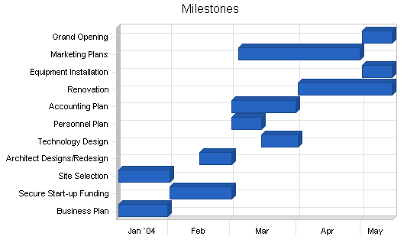

|  |  |  |  |  |  |
| --- | --- | --- | --- | --- | --- |
| **Milestones** | | | | | |
|  |  |  |  |  |  |
| Milestone | Start Date | End Date | Budget | Manager | Department |
| Business Plan | 1/8/2016 | 1/31/2016 | $0 | Jim | Management |
| Secure Start-up Funding | 2/1/2016 | 3/1/2016 | $0 | Jim | Management |
| Site Selection | 1/8/2016 | 2/1/2016 | $0 |  | Operations |
| Architect Designs/Redesign | 2/15/2016 | 3/1/2016 | $500 |  | Operations |
| Technology Design | 3/15/2016 | 4/1/2016 | $5,000 |  | Technical |
| Personnel Plan | 3/1/2016 | 3/15/2016 | $0 |  | Management |
| Accounting Plan | 3/1/2016 | 3/31/2016 | $400 |  | Management |
| Renovation | 4/1/2017 | 5/15/2017 | $7,800 |  | Operations |
| Equipment Installation | 5/1/2017 | 5/15/2017 | $2,000 |  | Operations |
| Marketing Plans | 3/4/2015 | 4/30/2015 | $2,500 |  | Marketing |
| Grand Opening | 5/1/2017 | 5/15/2017 | $2,500 |  | Marketing |
| Totals |  |  | $20,700 |  |  |

**Web Plan Summary**

The Glass Boot Pizza Company website will be the virtual business card and portfolio for the company, as well as its online "home."  It will showcase the history, product information, and offers for Glass Boot Pizza Company.  Special online-only offers will be made available on the website, along with customer's opportunity to sign-up for email news and offers.

The Glass Boot Pizza Company website needs to be a simple yet classy and well-designed website that, at the same time, is in keeping with the latest trends in user interface design.  Customers will be coming to the site for product information, history, and offers.

Future elements of the site can contain online ordering, if customers express an interest in this functionality.

**6.1 Website Marketing Strategy**

Our Internet marketing activities will be focused on product information and offers.  Future opportunities exist in offering online ordering. We need to develop a comprehensive coupon program.

**6.2 Development Requirements**

The Glass Boot Pizza Company website will be initially developed with few technical resources.  A simple hosting provider, Yahoo! Web services, will host the site and provide the technical back end.  The owner's expertise in professional Web development will lead this effort.

The user interface designer will work with a graphic artist to come up with the website logo, and the website graphics.

The maintenance of the site will be done by the owners.  If the website rolls out future development such as newsletters and online ordering, the internal staff at Glass Boot Pizza Company will design, implement, and execute the technology.

**Management Summary**

We are a small company owned and operated by a husband and wife team, as a partnership.  Management style reflects the participation of the owners.  The company respects its community of co-workers and treats all workers well.

The wife is a 1998 graduate of University School of Business with High Honors and Distinction in Business.  Her experience with general business, technology, and operations is a great asset to this venture.

Additionally, Otho Colderobby is an advisor to the owners.  Otho is a 1991 graduate of State College with a degree in Economics.  Furthermore, Otho graduated in 1995 with a Masters in Business Administration from University School of Business with emphases in Marketing and Finance.  Otho held a senior finance management position with Frito Lay for 5 years.  Otho is currently a managing consultant with a marketing strategy firm.  He also spent 5 years in a strategic services consulting practice.

**7.1 Personnel Plan**

The personnel table assumes a level need of employees, and 5% per annum pay raises.  Staffing for a 7-day a week restaurant necessitates two shifts.  In addition to the hours open for serving we anticipate an additional hour before opening for prep and as much as an hour after closing for cleanup.  This is approximately 8 hours of staffing necessary Sunday - Thursday and 10 hours on both Friday and Saturday.

The two kitchen lead positions are part-time, earning $9/hr.  The kitchen leads will serve as the shift leaders of the kitchen/wait staff.  Kitchen staff will serve as the wait staff.  There will be one dedicated dishwashing position per shift.  Wages for kitchen/wait staff, dishwashers, and delivery drivers, who are all part-time, are $6/hr, with opportunities for all to share the combined earn tips.  It is imperative the people serving as the kitchen lead are over 21 and can legally serve alcohol.

Hourly part-time positions as kitchen/wait, dishwashing, and delivery staff average out to be approximately 30 hours per week each.  Delivery staff will work 5 hour shifts each night, with an extra delivery staff member added on Thursdays, Fridays, and Saturdays.  During the week if this person is not delivering, they will work in the kitchen as needed, directed by the kitchen lead.

|  |  |  |  |
| --- | --- | --- | --- |
| **Personnel Plan** | | | |
|  | Year 1 | Year 2 | Year 3 |
| Kitchen Leads | $28,080 | $29,484 | $30,958 |
| Kitchen/Wait | $37,440 | $39,312 | $41,278 |
| Dishwasher | $15,600 | $16,380 | $17,199 |
| Owner | $9,000 | $9,450 | $9,923 |
| Delivery | $15,600 | $16,380 | $17,199 |
| Total People | 12 | 12 | 12 |
|  |  |  |  |
| Total Payroll | $105,720 | $111,006 | $116,556 |

**Financial Plan**

The financial picture is quite encouraging.  We will be slow to take on debt and heavily investing our own assets, but with our increase in sales we do expect to apply for a credit line with the bank, to a limit of $50,000.  The credit line is supported by assets.

**8.1 Important Assumptions**

The financial plan depends on important assumptions, most of which are shown in the following table.  The key underlying assumptions are:

* We assume a fairly high-growth economy for pizza in the Lawrence area, given the lack of competition and interest in having a pizza restaurant available in the area and pent-up demand.
* We assume, of course, that there are no unforeseen changes in technology to make our products immediately obsolete.
* We assume access to equity capital and financing sufficient to maintain our financial plan as shown in the tables.

|  |  |  |  |
| --- | --- | --- | --- |
| **General Assumptions** | | | |
|  | Year 1 | Year 2 | Year 3 |
| Plan Month | 1 | 2 | 3 |
| Current Interest Rate | 6.00% | 6.00% | 6.00% |
| Long-term Interest Rate | 5.00% | 5.00% | 5.00% |
| Tax Rate | 30.00% | 30.00% | 30.00% |
| Other | 0 | 0 | 0 |

**8.2 Break-even Analysis**

Our break-even analysis is based on running costs, the "burn-rate" costs we incur to keep the business running, not on theoretical fixed costs that would be relevant only if we were closing. The essential insight here is that our sales level seems to be running comfortably above break-even.

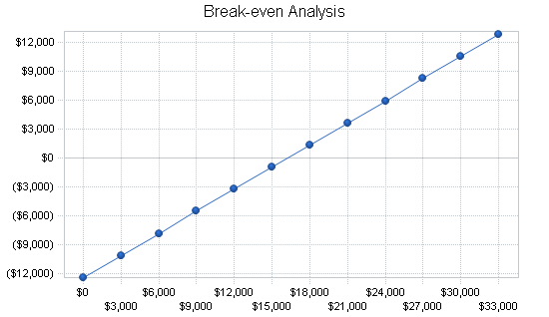

|  |  |
| --- | --- |
| **Break-even Analysis** | |
|  |  |
|  |  |
| Monthly Revenue Break-even | $16,283 |
|  |  |
| Assumptions: |  |
| Average Percent Variable Cost | 24% |
| Estimated Monthly Fixed Cost | $12,454 |

**8.3 Projected Profit and Loss**

We expect to be profitable in the first year, with profits increasing over the next two years, as we establish a loyal customer base.

[http://cache.paswebteam.com/bplans.com/graphical/images/sbp_images/click_to_enlarge.gif](http://www.bplans.com/pizzeria_business_plan/images/64f42925bfcd49138a2cb53f00bfc4c6.png)

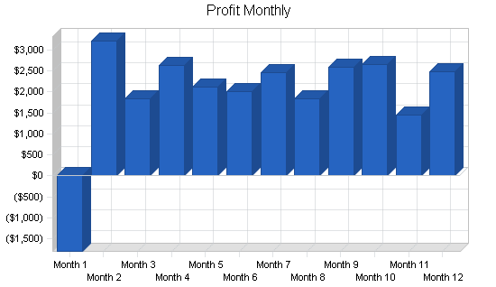

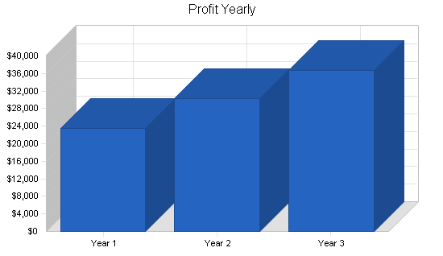

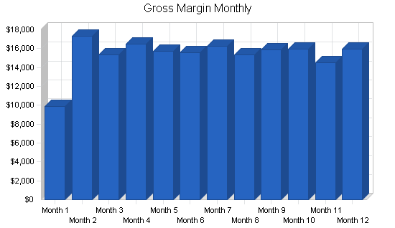

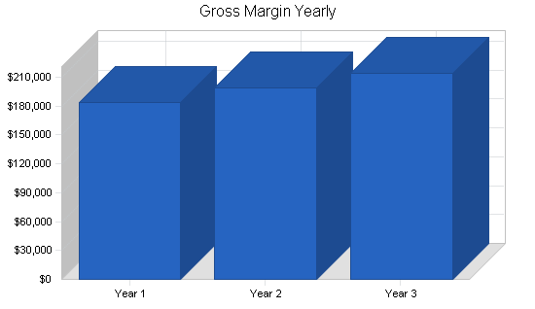

|  |  |  |  |
| --- | --- | --- | --- |
| **Pro Forma Profit and Loss** | | | |
|  | Year 1 | Year 2 | Year 3 |
| Sales | $240,673 | $258,055 | $276,120 |
| Direct Cost of Sales | $56,587 | $59,416 | $62,387 |
| Other Costs of Goods | $0 | $0 | $0 |
| Total Cost of Sales | $56,587 | $59,416 | $62,387 |
|  |  |  |  |
| Gross Margin | $184,087 | $198,639 | $213,733 |
| Gross Margin % | 76.49% | 76.98% | 77.41% |
|  |  |  |  |
|  |  |  |  |
| Expenses |  |  |  |
| Payroll | $105,720 | $111,006 | $116,556 |
| Sales and Marketing and Other Expenses | $7,250 | $7,250 | $7,500 |
| Depreciation | $2,040 | $1,836 | $1,652 |
| Rent | $14,400 | $14,400 | $14,400 |
| Utilities | $7,200 | $7,200 | $7,200 |
| Insurance | $4,200 | $4,500 | $4,800 |
| Payroll Taxes | $8,042 | $8,444 | $8,866 |
| Website Hosting and Maintenance | $600 | $50 | $50 |
| Other | $0 | $0 | $0 |
|  |  |  |  |
| Total Operating Expenses | $149,452 | $154,686 | $161,024 |
|  |  |  |  |
| Profit Before Interest and Taxes | $34,635 | $43,954 | $52,709 |
| EBITDA | $36,675 | $45,790 | $54,361 |
| Interest Expense | $1,088 | $700 | $225 |
| Taxes Incurred | $10,064 | $12,976 | $15,745 |
|  |  |  |  |
| Net Profit | $23,483 | $30,278 | $36,739 |
| Net Profit/Sales | 9.76% | 11.73% | 13.31% |

**8.4 Projected Cash Flow**

The following table and chart is the projected cash flow for three years.

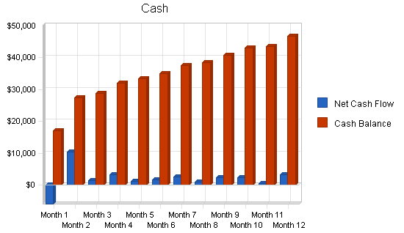

|  |  |  |  |
| --- | --- | --- | --- |
| **Pro Forma Cash Flow** | | | |
|  | Year 1 | Year 2 | Year 3 |
| Cash Received |  |  |  |
|  |  |  |  |
| Cash from Operations |  |  |  |
| Cash Sales | $240,673 | $258,055 | $276,120 |
| Subtotal Cash from Operations | $240,673 | $258,055 | $276,120 |
|  |  |  |  |
| Additional Cash Received |  |  |  |
| Sales Tax, VAT, HST/GST Received | $0 | $0 | $0 |
| New Current Borrowing | $0 | $0 | $0 |
| New Other Liabilities (interest-free) | $0 | $0 | $0 |
| New Long-term Liabilities | $0 | $0 | $0 |
| Sales of Other Current Assets | $0 | $0 | $0 |
| Sales of Long-term Assets | $0 | $0 | $0 |
| New Investment Received | $0 | $0 | $0 |
| Subtotal Cash Received | $240,673 | $258,055 | $276,120 |
|  |  |  |  |
| Expenditures | Year 1 | Year 2 | Year 3 |
|  |  |  |  |
| Expenditures from Operations |  |  |  |
| Cash Spending | $105,720 | $111,006 | $116,556 |
| Bill Payments | $105,383 | $114,835 | $120,750 |
| Subtotal Spent on Operations | $211,103 | $225,841 | $237,306 |
|  |  |  |  |
| Additional Cash Spent |  |  |  |
| Sales Tax, VAT, HST/GST Paid Out | $0 | $0 | $0 |
| Principal Repayment of Current Borrowing | $0 | $0 | $0 |
| Other Liabilities Principal Repayment | $0 | $0 | $0 |
| Long-term Liabilities Principal Repayment | $6,000 | $10,000 | $9,000 |
| Purchase Other Current Assets | $0 | $0 | $0 |
| Purchase Long-term Assets | $0 | $0 | $0 |
| Dividends | $0 | $0 | $0 |
| Subtotal Cash Spent | $217,103 | $235,841 | $246,306 |
|  |  |  |  |
| Net Cash Flow | $23,570 | $22,214 | $29,813 |
| Cash Balance | $46,670 | $68,884 | $98,698 |

**8.5 Projected Balance Sheet**

As shown in the balance sheet in the following table, we expect a healthy growth in net worth.  The monthly projections are in the appendices.

|  |  |  |  |
| --- | --- | --- | --- |
| **Pro Forma Balance Sheet** | | | |
|  | Year 1 | Year 2 | Year 3 |
| Assets |  |  |  |
|  |  |  |  |
| Current Assets |  |  |  |
| Cash | $46,670 | $68,884 | $98,698 |
| Inventory | $1,720 | $1,806 | $1,896 |
| Other Current Assets | $5,250 | $5,250 | $5,250 |
| Total Current Assets | $53,640 | $75,940 | $105,844 |
|  |  |  |  |
| Long-term Assets |  |  |  |
| Long-term Assets | $20,300 | $20,300 | $20,300 |
| Accumulated Depreciation | $2,040 | $3,876 | $5,528 |
| Total Long-term Assets | $18,260 | $16,424 | $14,772 |
| Total Assets | $71,900 | $92,364 | $120,616 |
|  |  |  |  |
| Liabilities and Capital | Year 1 | Year 2 | Year 3 |
|  |  |  |  |
| Current Liabilities |  |  |  |
| Accounts Payable | $9,267 | $9,454 | $9,967 |
| Current Borrowing | $0 | $0 | $0 |
| Other Current Liabilities | $0 | $0 | $0 |
| Subtotal Current Liabilities | $9,267 | $9,454 | $9,967 |
|  |  |  |  |
| Long-term Liabilities | $19,000 | $9,000 | $0 |
| Total Liabilities | $28,267 | $18,454 | $9,967 |
|  |  |  |  |
| Paid-in Capital | $46,000 | $46,000 | $46,000 |
| Retained Earnings | ($25,850) | ($2,367) | $27,911 |
| Earnings | $23,483 | $30,278 | $36,739 |
| Total Capital | $43,633 | $73,911 | $110,649 |
| Total Liabilities and Capital | $71,900 | $92,364 | $120,616 |
|  |  |  |  |
| Net Worth | $43,633 | $73,911 | $110,649 |

**8.6 Business Ratios**

Standard business ratios are included in the following table.  Industry profile ratios are shown for comparison, and are based on Standard Industrial Classification (SIC) code 5812.0600, Pizza Restaurants.  The ratios show a plan for balanced, healthy growth.  Our return on sales and return on assets remain strong in percentage terms.

|  |  |  |  |  |
| --- | --- | --- | --- | --- |
| **Ratio Analysis** | | | | |
|  | Year 1 | Year 2 | Year 3 | Industry Profile |
| Sales Growth | 0.00% | 7.22% | 7.00% | 5.24% |
|  |  |  |  |  |
| Percent of Total Assets |  |  |  |  |
| Inventory | 2.39% | 1.96% | 1.57% | 3.54% |
| Other Current Assets | 7.30% | 5.68% | 4.35% | 34.82% |
| Total Current Assets | 74.60% | 82.22% | 87.75% | 43.85% |
| Long-term Assets | 25.40% | 17.78% | 12.25% | 56.15% |
| Total Assets | 100.00% | 100.00% | 100.00% | 100.00% |
|  |  |  |  |  |
| Current Liabilities | 12.89% | 10.24% | 8.26% | 20.80% |
| Long-term Liabilities | 26.43% | 9.74% | 0.00% | 28.42% |
| Total Liabilities | 39.31% | 19.98% | 8.26% | 49.22% |
| Net Worth | 60.69% | 80.02% | 91.74% | 50.78% |
|  |  |  |  |  |
| Percent of Sales |  |  |  |  |
| Sales | 100.00% | 100.00% | 100.00% | 100.00% |
| Gross Margin | 76.49% | 76.98% | 77.41% | 61.18% |
| Selling, General & Administrative Expenses | 39.83% | 39.27% | 38.77% | 38.56% |
| Advertising Expenses | 0.00% | 0.00% | 0.00% | 2.28% |
| Profit Before Interest and Taxes | 14.39% | 17.03% | 19.09% | 1.44% |
|  |  |  |  |  |
| Main Ratios |  |  |  |  |
| Current | 5.79 | 8.03 | 10.62 | 0.99 |
| Quick | 5.60 | 7.84 | 10.43 | 0.67 |
| Total Debt to Total Assets | 39.31% | 19.98% | 8.26% | 52.80% |
| Pre-tax Return on Net Worth | 76.88% | 58.52% | 47.43% | 2.77% |
| Pre-tax Return on Assets | 46.66% | 46.83% | 43.51% | 5.88% |
|  |  |  |  |  |
| Additional Ratios | Year 1 | Year 2 | Year 3 |  |
| Net Profit Margin | 9.76% | 11.73% | 13.31% | n.a |
| Return on Equity | 53.82% | 40.97% | 33.20% | n.a |
|  |  |  |  |  |
| Activity Ratios |  |  |  |  |
| Inventory Turnover | 31.29 | 33.70 | 33.70 | n.a |
| Accounts Payable Turnover | 11.35 | 12.17 | 12.17 | n.a |
| Payment Days | 30 | 30 | 29 | n.a |
| Total Asset Turnover | 3.35 | 2.79 | 2.29 | n.a |
|  |  |  |  |  |
| Debt Ratios |  |  |  |  |
| Debt to Net Worth | 0.65 | 0.25 | 0.09 | n.a |
| Current Liab. to Liab. | 0.33 | 0.51 | 1.00 | n.a |
|  |  |  |  |  |
| Liquidity Ratios |  |  |  |  |
| Net Working Capital | $44,373 | $66,487 | $95,877 | n.a |
| Interest Coverage | 31.85 | 62.79 | 234.26 | n.a |
|  |  |  |  |  |
| Additional Ratios |  |  |  |  |
| Assets to Sales | 0.30 | 0.36 | 0.44 | n.a |
| Current Debt/Total Assets | 13% | 10% | 8% | n.a |
| Acid Test | 5.60 | 7.84 | 10.43 | n.a |
| Sales/Net Worth | 5.52 | 3.49 | 2.50 | n.a |
| Dividend Payout | 0.00 | 0.00 | 0.00 | n.a |