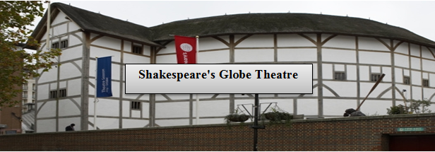 Cover Photo: Panoramic pic

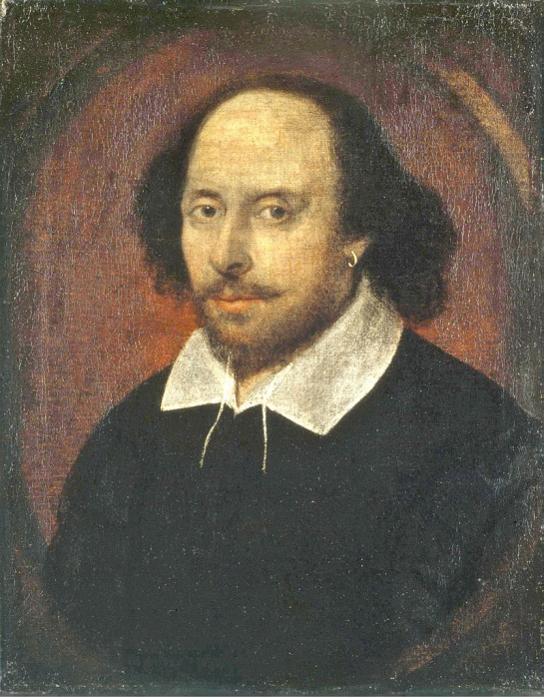

Profile Picture

**William Shakespeare**

**Married to**: Anne Hathaway

**Born on:** April 23rd

**Died in:** 1616

**Studied At**:

**Places Lived**:

**Personal Interests**

**Likes**: What pages would Shakespeare like?

**Music**: What kind of music would Shakespeare like? Possibly High **Renaissance** (1500s) to the **Baroque** period (1600-1750).