**Explanation of mid-point method of computing Price Elasticity of Demand (Dpe)**

Assume that you are selling homemade pies in your bakery. When the price was $10.00 each, you sold 500 pies in a month, when you raised the price to $13.00 each, you sold only 425 pies in a month, and when you raised the price to $16.00 each, you sold only 150 pies in a month.

|  |  |  |  |  |
| --- | --- | --- | --- | --- |
|  | **Price = P** | **Quantity = Q** |  | **Revenue** |
| **1** | **$10.00** | **500.00** |  | **$5,000.00** |
| **2** | **$13.00** | **425.00** |  | **$5,525.00** |

and

|  |  |  |  |  |
| --- | --- | --- | --- | --- |
|  | **Price = P** | **Quantity = Q** |  | **Revenue** |
| **1** | **$13.00** | **425.00** |  | **$5,525.00** |
| **2** | **$16.00** | **150.00** |  | **$2,400.00** |

1. Using the midpoint method, what is the price elasticity of demand between $10.00 and $13.00?

2. Using the midpoint method, what is the price elasticity of demand between $13.00 and $16.00?

The basic computation is to divide the % change in price into the % change in quantity sold for each problem.

The midpoint method creates a double division calculation (quantity on the top division calculation and price on the bottom division calculation).

Remember that in math, do what is inside the parentheses first.

Step 1 inserts the values from the problem (and in the table at the top) into the formula.

Step 2 first adds the values inside the parentheses for the bottom (denominator) of the quantity calculation on the top. Then it adds the values inside the parentheses for the denominator of the price calculation on the bottom. It then subtracts the values in the top (numerator) of the quantity calculations on the top. Finally it subtracts the values in the numerator of the price calculation on the bottom.

Step 3 divides the denominator of the quantity calculation by 2 and divides the denominator of the price calculation by 2 (to get the midpoint of the quantity and of the price).

Step 4 divides the denominator of the quantity calculation into the quantity numerator and then divides the price denominator into the price numerator.

Step 5 does the final division by dividing the price calculation into the quantity calculation.

Step 6 drops the minus sign, leaving just the number

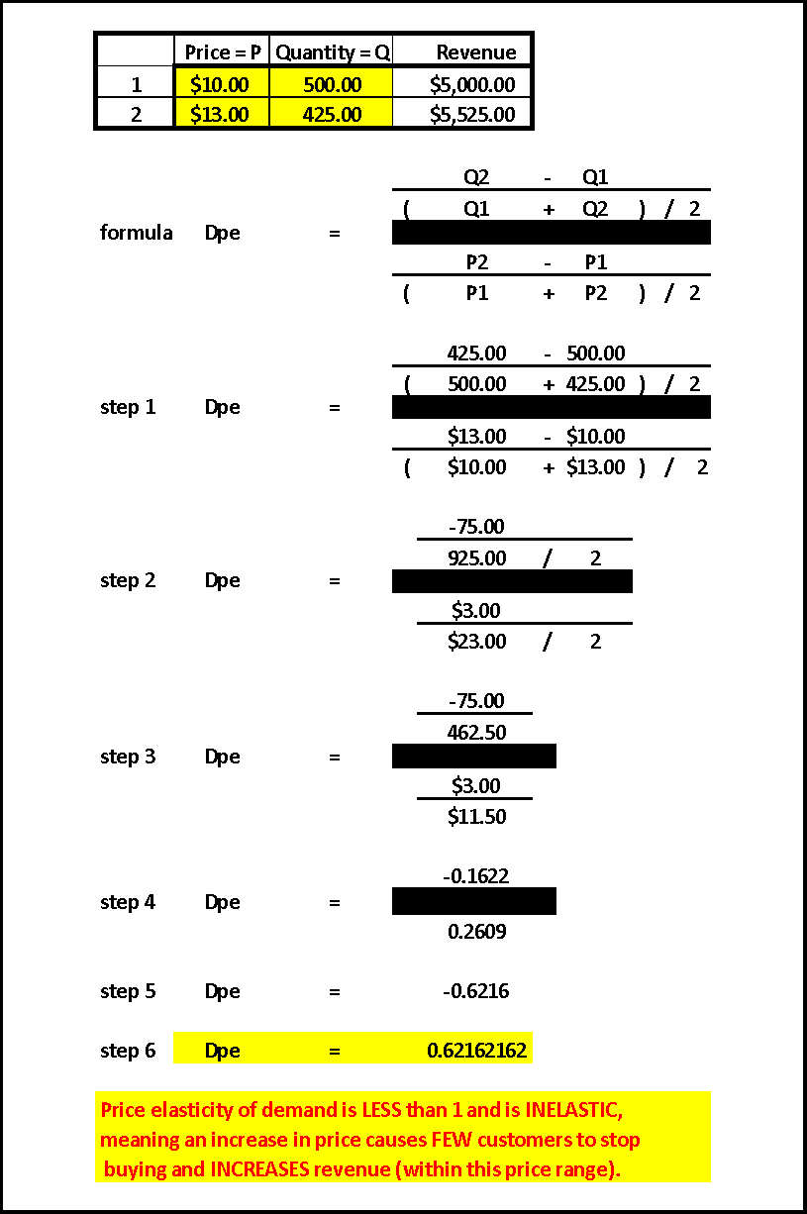

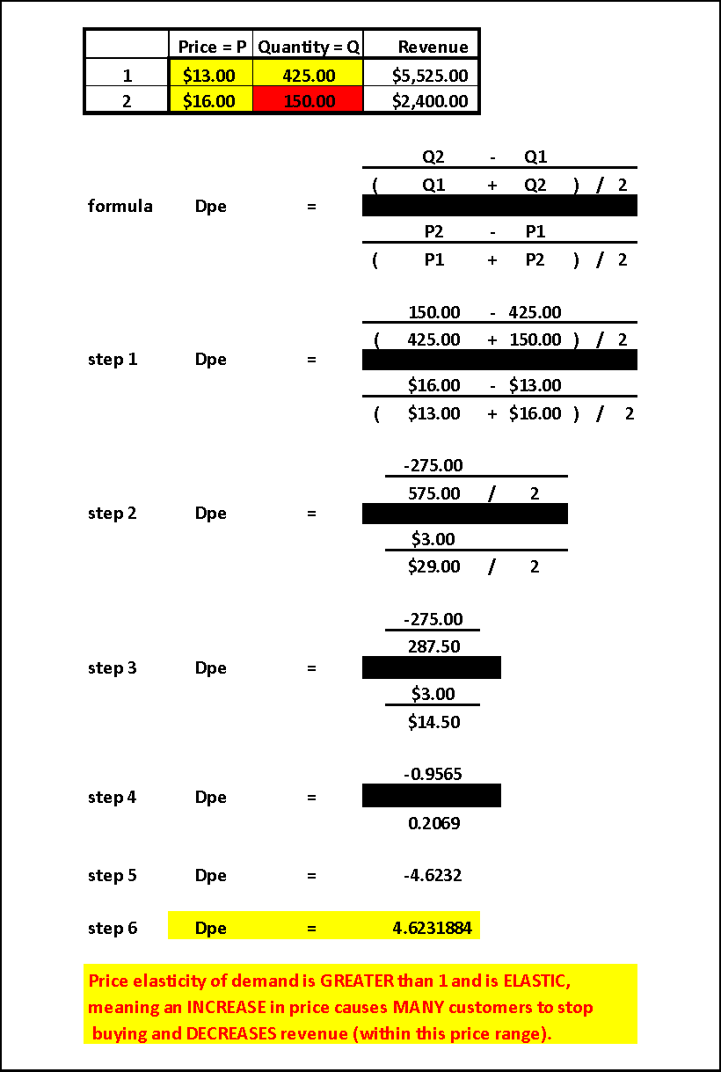

***A price elasticity of demand (Dpe) GREATER than 1 also means that, in the price range being measured, LOWERING prices will result in MANY more sales, thus INCREASING revenues*.**