Hints for part of the Unit 3 Assignment

Remember that the Unit 3 Assignment includes work from both Units 2 and Unit 3.

------------------------

Question 1 is from Unit 2

Question 1a is asking whether or not that level of production can be achieved, given the existing PPF curve, and asks you to explain WHY. Remember what I had people type in during the Seminar about resources?

Question 1b is asking you to compute the marginal opportunity cost of one 200 pound batch of corn (800lbs to 1,000lbs) in pounds of poultry that must be given up to get this batch of corn.

Question 1c is asking you to compute the marginal opportunity cost of a similar 200 pound batch of corn (200lbs to 400lbs) in pounds of poultry that must be given up to get this batch of corn.

* Remember from the Unit 2 Seminar:

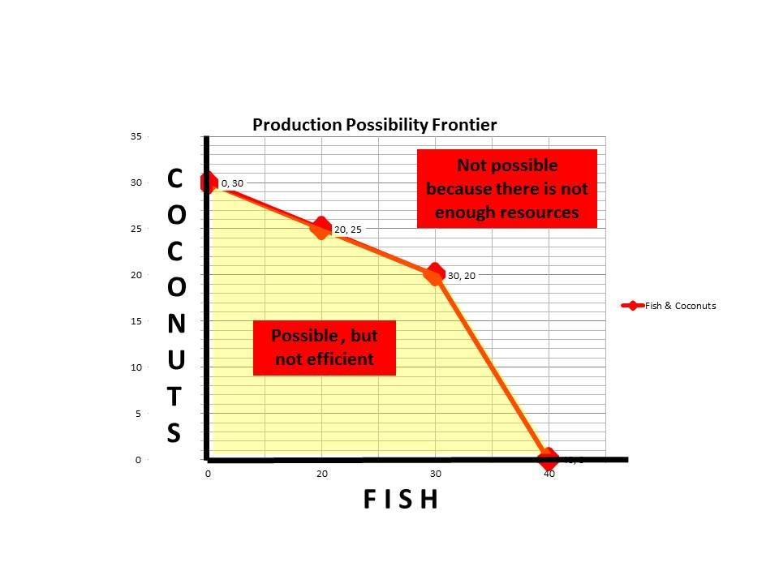

Remember what I had everyone type about resources during the Seminar.

* Also remember how to compute marginal opportunity costs.
  + after catching the FIRST batch of 20 fish Tom would still have enough TIME to get 25 coconuts
  + after catching the SECOND batch of 20 fish Tome would not have any time left to get coconuts, so he would have 0 coconuts.
  + The marginal opportunity cost of the SECOND batch of 20 fish was that Tom had to give up ALL of the remaining 25 coconuts because Tom no longer had time to get them.

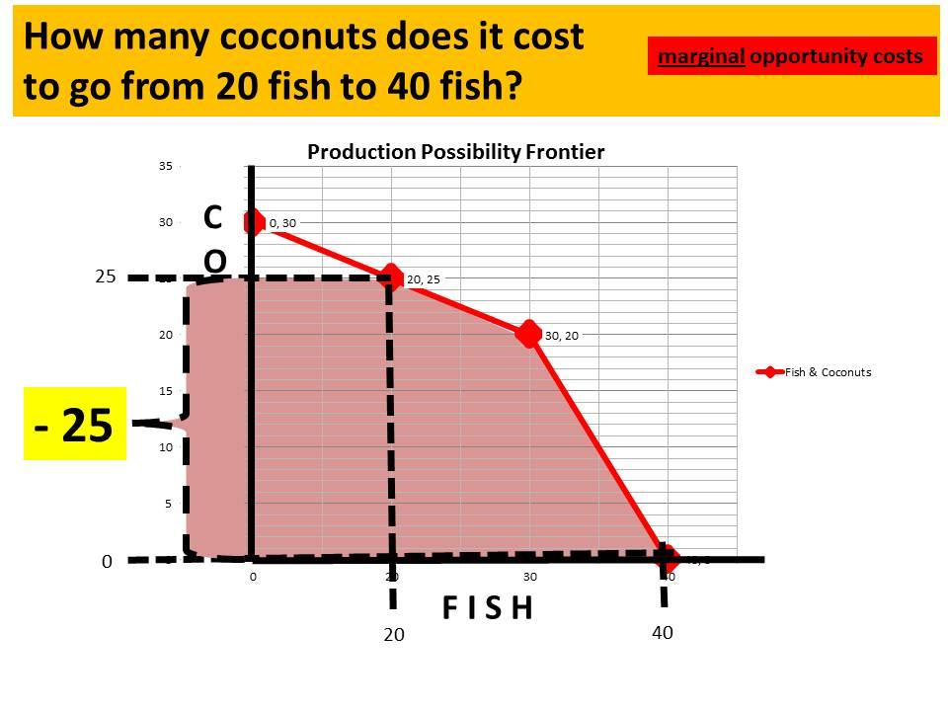

Question 1d asks why these two answers are different and what that implies about the SHAPE of the PPF curve.

Go back and re-listen to the Unit 2 Seminar for a full explanation. Remember the things that I ask students to type in the chat that night during the Seminar.

* Remember that the best resources for producing one thing are used first. If more output of that thing is needed, resources that are not as good must be used, therefore increasing the Marginal Opportunity Costs of the additional output.
  + If the FIRST batch of 20 fish had a marginal opportunity cost of 5 coconuts, and the SECOND batch of 20 fish had a marginal opportunity cost of 25 coconuts, what is happening to the marginal opportunity costs of fish? Are the marginal opportunity costs increasing, staying the same, or decreasing?
  + If Marginal Opportunity costs of additional batches of fish are increasing, what does this imply about the shape of the Production Possibility Frontier curve? (Remember what I had everyone type during the Seminar).

-------------------

Question 2 is from Unit 3 and is a straight Supply and demand question.

Go back and re-listen to the Unit 3 Seminar.

For questions 2 b-e. pay particular attention to the example in the Seminar of selling to the U.S. and then suddenly also being able to sell to Germany (**slides 63-73**). The Assignment question is very similar.

See part 8 and part 9 of the Supply and Demand videos under the Video icon that is under the Unit 3 Reading icon.

Question 2 is like the example that I did in the Seminar. You add the original country's demand to the new country's demand to get a NEW total demand. Then see at what price that New total amount demanded is equal to the same amount that suppliers are willing to supply. That is the new price. Then go back to the original country's demand and see how much they are willing to demand at this new higher price.

* **Did you add your references and coversheet information to the template with your answers?**