Unit 4 Assignment: Elasticity of Demand

**Name:**

**Course Number and Section: BU224–0X**

**Date:**

**General Instructions for all Assignments**

1. Unless specified differently by your course instructor, save this assignment template to your computer with the following file naming format: Course number_section number_Last_First_unit number

2. At the top of the template, insert the appropriate information: Your Name, Course Number and Section, and the Date

3. Insert your answers below, or in the appropriate space provided for in the question. Your answers should follow APA format with citations to your sources and, at the bottom of your last page, a list of references. Your answers should also be in Standard English with correct spelling, punctuation, grammar, and style (double spaced, in Times New Roman, 12–point, and black font). Respond to questions in a thorough manner, providing specific examples of concepts, topics, definitions, and other elements asked for in the questions.

4. Upload the completed Assignment to the appropriate Dropbox.

5. Any questions about the Assignment, or format questions, should be directed to your course instructor.

**Assignment**

In this Assignment, you will focus on marginal utility, Price Elasticity of Demand, and understanding the difference between Price Elasticity of Demand and Income Elasticity of Demand.

We all subconsciously assign “scores” to what we are considering to purchase, based on our expected level of “satisfaction” (Marginal Utility) with that purchase. When making simultaneous pairs of purchases, again we subconsciously compare the amount of “satisfaction” (Marginal Utility) that we will receive from the pair of purchases. To decide on the “ideal” combination of these two purchases, we expect that the last dollar we spend on each of the items will give us the “same” satisfaction per dollar (Marginal Utility per dollar). Further, we know that the MORE of an item that we get, the next one we get will give us LESS “satisfaction” Marginal Utility) than the last one gave us (the Law of Diminishing Marginal Utility). Using what you have learned about Marginal Utility and Marginal Utility per dollar, answer the following questions.

**Questions**

1. Jane has been working all day, missing both her breakfast and lunch. Finally able to leave work, after being required to work a couple of hour’s overtime, she is starving. Jane has $20 in her pocket, so she stops at a local fast food restaurant and orders a grilled chicken sandwich (somewhat healthy) and fries (not so healthy). As she sits down to eat them, a University student approaches her and tells her that she is doing a research project for her microeconomics course, and would like to ask Jane a few quick questions. Jane agrees and the student asks what “score” (Marginal Utility) from 1 to 100 would she give as her satisfaction level with the 1st sandwich and the 1st fries? After eating that order, Jane is still hungry and orders a second chicken sandwich and another fries. Again, the student asks Jane to give her new scores. Since Jane has not eaten all day, she is hungry enough to order a third round of food and again gives “scores” to the inquisitive student.

Below is the University student’s completed experiment tally sheet of Jane’s marginal utility “scores” and the calculation of her marginal utility per dollar, given that each sandwich costs $4.00 and each order of fries costs $2.00, along with her budget of $20. The student filled in the shaded cells based on Jane’s responses, then computed the values in the remaining cells. Using this information, answer the following questions:

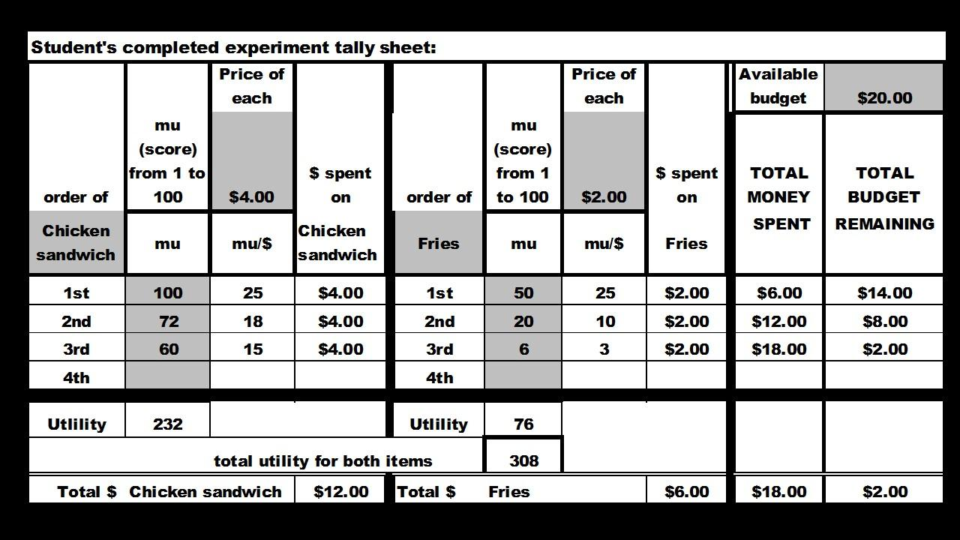

a. Is Jane maximizing her utility? Explain your reasoning and show any calculations.

b. If Jane is not maximizing her utility, remembering the Law of Diminishing Marginal Utility, would she be better off to buy one **less** chicken sandwich **and** one **more** fry? Explain your reasoning and show any calculations.

c. If Jane is not maximizing her utility with the original purchase combination, remembering the Law of Diminishing Marginal Utility, would she be better off buying just one **more** fry? Explain your reasoning and show any calculations.

d. If Jane is not maximizing her utility with the original purchase, remembering the Law of Diminishing Marginal Utility, would she be better off buying one **less** fries **and** one **more** chicken sandwich? Explain your reasoning and show any calculations.

2. Remembering the Learning Practice in Unit 3, in the year 107 WBCE (Way Before the Common Era) the Gondwanaland Chairman of Production reported that the gosum berry growers were able to meet an average demand of 700 barrels of gosum berries per month at an average a price of $70 per barrel.

In the year 108 WBCE the growers were plagued with a gosum berry bug infestation that reduced average output, causing production to fall to only 600 barrels per month, causing the price to rise to $84 per barrel. The following table shows the Chairman’s report:

|  |  |  |
| --- | --- | --- |
| Year (WBCE) | Monthly barrels of gosum berries demanded | Price per barrel |
| 107 | 700 | $70 |
| 108 | 600 | $84 |

a. Using the midpoint method, calculate the price elasticity of demand for Gondwanaland gosum berries. Explain what this price elasticity of demand means?

b. What is the monthly average total revenue for year 107, and the monthly average total revenue for year 108? How do these numbers compare to each other?

|  |  |  |  |
| --- | --- | --- | --- |
| Year (WBCE) | Monthly barrels of gosum berries demanded | Price per barrel | Monthly average total revenue |
| 107 | 700 | $70 |  |
| 108 | 600 | $84 |  |
|  |  | Change in  average total monthly revenue |  |

c. Using your answer to part a. above, how could you have predicted this change in total monthly revenue?

3. The Gondwanaland Chairman of Production reported that the new Altair chariots (most modern, horse drawn family chariot) had a PRICE elasticity of 3 and an INCOME elasticity of 2. The supply of these Altair chariots is elastic. Evaluate the following statements and explain why you think they are true, or false.

a. A 20% increase in the price of the Altair chariot will cause the quantity demanded to fall by an astounding 60%.

b. An increase in Gondwanaland consumers’ incomes will cause prices to rise, but the total quantity demanded will also increase.

**--------------------------------------------**

**References:**

**Unit 4 Assignment: Elasticity of Demand Grading Rubric**

|  |  |  |
| --- | --- | --- |
| **Content** | **Percent Possible** | **Points Possible** |
| **Full Assignment** | **100%** | **40** |
|  |  |  |
| **Overall Writing:** | **20%** | **8** |
| **Correct coversheet information at the top of 1st page** | **5%** | **2.00** |
| **APA format for answers** | **3%** | **1.20** |
| **Correct citations** | **3%** | **1.20** |
| **Standard English, no errors** | **4%** | **1.60** |
| **At least one, or more, references** | **5%** | **2.00** |
|  |  |  |
| **Answers: provides complete information demonstrating analysis and critical thinking:** | **80%** | **32** |
| **Individual Questions:** |  |  |
| **1. a. - Are the utility maximizing quantities 3 sandwiches and 3 fries? Why?** | **5%** | **2.00** |
| **1. b. - Are the utility maximizing quantities 2 sandwiches and 4 fries? Why?** | **5%** | **2.00** |
| **1. c. - Are the utility maximizing quantities 3 sandwiches and 4 fries? Why?** | **5%** | **2.00** |
| **1. d. - Are the utility maximizing quantities 4 sandwiches and 2 fries? Why?** | **5%** | **2.00** |
| **2. a. - What is price elasticity of demand for gosum berries?** | **15%** | **6.00** |
| **2. b. - What is year 107 revenue and the year 108 revenue?** | **10%** | **4.00** |
| **2. c. - Could change in revenue been predicted from elasticity? How?** | **15%** | **6.00** |
| **3. a. - Will quantity of Altair chariots demanded fall by 60%? (true/false) Why?** | **10%** | **4.00** |
| **3. b. - Will quantity of Altair chariots demanded increase? (true or false) Why?** | **10%** | **4.00** |
| **Sub-total for Individual Questions:** | **80%** | **32** |